2025 Rental Market Study

June 2025

Prepared for
Florida Housing Finance Corporation
227 N. Bronough St., Suite 5000
Tallahassee, Florida 32301-1329

Prepared by
Shimberg Center for Housing Studies
University of Florida
P. O. Box 115703
Gainesville, Florida 32611-5703

Contents
1. Introduction and Summary of Key Findings 1
2. Statewide Trends 4
3. County and Regional Rental Housing Needs 14
4. Affordable and Available Rental Units 37
5. Homeless Families and Individuals 78
6. Special Needs Households 91
7. Farmworker Housing Needs in Florida 94
8. Commercial Fishing Workers 115
9. Assisted Housing Supply 117
Index of Tables and Figures 135

Introduction and Summary of Key Findings
The Rental Market Study is prepared for Florida Housing Finance Corporation by the Shimberg Center for Housing Studies at the University of Florida. The report focuses on the housing needs of renter households that are low-income (with incomes at or below 60 percent of area median income, or AMI) and cost burdened (paying at least 40 percent of income toward gross rent).
The report begins with an overview of statewide trends. It then provides 2025 estimates of low-income, cost burdened renter households by county, with additional detail about household size and householder age; a comparison of the number of low-income households with the rental units that are affordable and available to them; sections on the housing needs of persons with special needs, farmworkers, commercial fishing workers, and homeless persons; and an assessment of tenant characteristics and preservation needs in Florida’s assisted rental housing developments.
Additional information is available from the Florida Housing Data Clearinghouse (http://flhousingdata.shimberg.ufl.edu), including datasets on household demographics, population projections, home construction and sales, and the assisted housing inventory.

Key Findings

Statewide Trends
- Florida added over a million households between 2019 and 2023, including nearly 195,000 renter households.
- Household growth was driven by strong in-migration from other states, particularly New York, New Jersey, Illinois, Pennsylvania, and California.
- A group of mid-Florida counties stretching from St. Johns County in the northeast to Lee County in the southwest received the largest inflows. Household growth in these counties was fueled by a combination of out-of-state migration and moves from Florida’s larger urban counties.
- Florida’s multifamily rental supply grew by over 240,000 units between 2019 and 2023. The supply of apartments in 50+ unit buildings grew the fastest. Rentals in single family homes and mobile homes declined.
- Florida’s median gross rent increased from $1,238 in 2019 to $1,719 in 2023, a 39 percent increase.
- Seventy-nine percent of renter households include a working adult. Most non-working renter households are made up of older adults or persons with disabilities.
- Thirty-nine percent of low-income, cost burdened renter households are headed by someone age 55 or older.
- Nearly two-thirds of HUD and USDA multifamily units and over 40 percent of Florida Housing and public housing units serve elder households. Elder set-asides make up just a portion of these units; many 55+ households also live in units designated for families, homeless persons, and persons with disabilities.

County and Regional Rental Housing Needs
- Florida has 904,635 low-income (0-60 percent of AMI), cost burdened (>40 percent of income) renter households. Of these, 64 percent live in large counties, 33 percent in medium counties, and three percent in small counties.
- Most cost burdened renter households are small; 68 percent have just one or two household members.
- Statewide, 73 percent of renters with incomes below 60 percent of AMI are cost burdened, compared to 45 percent of renters at 60-80 percent of AMI, 21 percent at 80-100 percent of AMI, 11 percent at 100-120 percent of AMI, and six percent at 120-140 percent of AMI.

Affordable and Available Rental Units
- An affordable and available rental unit is any market rate, subsidized, or public housing unit for which 1) a household below a certain income level (e.g. 60 percent of AMI) would pay no more than 30 percent of income for gross rent, and 2) the unit is not already occupied by a higher income household; i.e., it is occupied by a household below the income level or is vacant.
- At the 0-30 percent through 0-80 percent of AMI levels, there are more renter households than affordable units. At 0-100 percent and 0-120 percent of AMI, there are more affordable units than renter households, but still deficits of affordable and available units, since many affordable units are rented by households with higher incomes.
- The largest statewide gap between renters and affordable/available units is at the 0-60 percent of AMI level, a deficit of 640,741 units.

Homeless Families and Individuals
- An estimated 29,848 individuals are homeless in Florida. This includes 23,799 sheltered and unsheltered individuals and 6,049 unaccompanied youth doubled up with others and in hotels and motels.
- An estimated 44,234 families with children are homeless. This includes 2,387 sheltered and unsheltered families and 41,847 families doubled up with others and in hotels and motels.

Special Needs Households
- An estimated 92,545 cost burdened renter households receive disability-related Social Security, SSI, and veterans’ benefits statewide.
- Based on service use, an estimated 7,147 survivors of domestic violence and 2,066 youth aging out of foster care are in need of affordable housing.

Farmworkers
- Florida has an estimated 115,328 farmworkers in 101,556 households, including 68,577 unaccompanied workers and 32,978 family households with at least one accompanied worker.
- Miami-Dade, Hillsborough, Gadsden, Manatee, and Glades Counties have the largest needs for beds for unaccompanied farmworkers.
- Miami-Dade, Palm Beach, Gadsden, Hillsborough, and Orange Counties have the largest needs for multifamily farmworker units.

Fishing Workers
- Florida has an estimated need of 1,605 affordable rental units for commercial fishing workers.

Assisted Housing Supply
- Florida’s public and assisted housing stock provides 314,200 units of affordable rental housing—approximately one in ten rental units in the state.
- Average income for households in Florida Housing-sponsored units is $30,442, compared to $72,385 for all Florida renters.
- Average gross rent for Florida Housing units is $1,011 per month, compared to $1,854 for all Florida renters.
- By the end of 2034, rent and income restrictions will expire for 402 developments with 33,284 assisted units. Florida Housing’s inventory makes up the largest share of units (196 developments with 19,946 units).
- Early 9 percent Housing Credit developments began to exit affordability restrictions in 2020. These losses will continue through 2027. Because affordability periods for the competitive 9 percent credits were extended to 50-year periods in the mid-1990s, these losses will taper off. A second spike will begin in 2028 as a wave of 4 percent Housing Credit developments reaches the end of 30-year affordability restrictions.
- Florida Housing’s investments in preservation have extended affordability for over 30,000 units of federally subsidized rental housing.

Statewide Trends

Household Change and In-Migration

Florida added over a million households between 2019 and 2023.
Nearly 9 million households lived in Florida in 2023, up from 7.9 million in 2019. Most of the increase was made up of homeowners (865,910), and the state’s homeownership rate increased from 66 to 68 percent. However, Florida also added nearly 195,000 renter households, increasing from 2.67 million to 2.86 million renters.

Figure 2.1. Households by Tenure, Florida, 2019 & 2023

Source: Shimberg Center tabulation of U.S. Census Bureau, 2019 and 2023 American Community Survey

Household growth was fueled by an early 2020s boom of in-migration into Florida.
Florida has been a destination for out-of-state movers for decades, but the trend accelerated with the onset of COVID in 2020. Data from the IRS shows approximately 400,000 tax filers moved to Florida from out-of-state in 2020-2021 and 2021-2022, nearly 100,000 more than in 2018-2019. Net inflow into the state more than doubled in 2020-2021 and 2021-2022 compared to the 2018-2019 baseline.
As Figure 2.2 shows, moves out of Florida also increased slightly, but out-migration lagged far behind in-migration. Moves within the state were much more common than moves out-of-state. Between 330,000 and 390,000 in-state households moved to a new Florida county each year.

Figure 2.2. Household (Tax Filer) Inflow and Outflow, Florida, 2018-2022

Notes: Based on comparison of tax return filing addresses from first year in pair to second. Most returns correspond to a single household, but some households have multiple filers. Excludes moves to/from places other than U.S. states and moves within the same Florida county.
Source: Shimberg Center tabulation of U.S. Department of the Treasury, Statistics of Income, Individuals, State and County Migration Data
Both before and after 2020, Florida was a net receiver of households from the Northeast, Midwest, California, and Nevada, and a net sender to other Southeastern states and Texas. Before 2020, Florida was also a net sender to several other Western states, but migration from the West shifted back toward Florida during 2020-2022.
In both periods, New York, New Jersey, Illinois, Pennsylvania, and California were the largest senders of households to Florida. Net migration from these states increased by 166 percent in 2020-2022 over 2018-2020.

Figure 2.3. Origin States for Households (Filers) Moving to Florida, 2018-2020 and 2020-2022
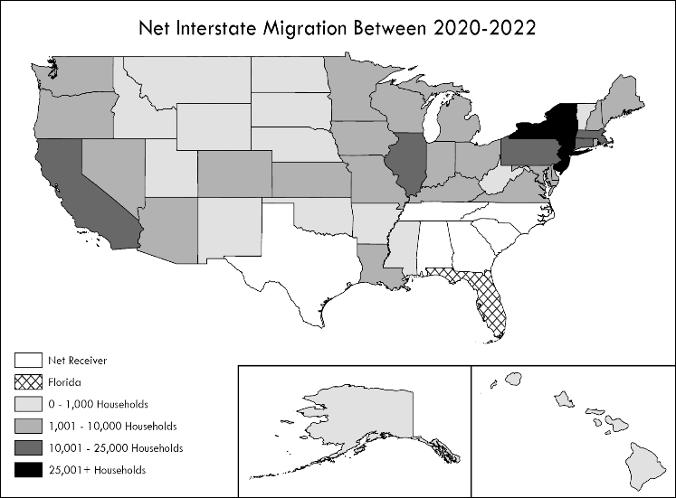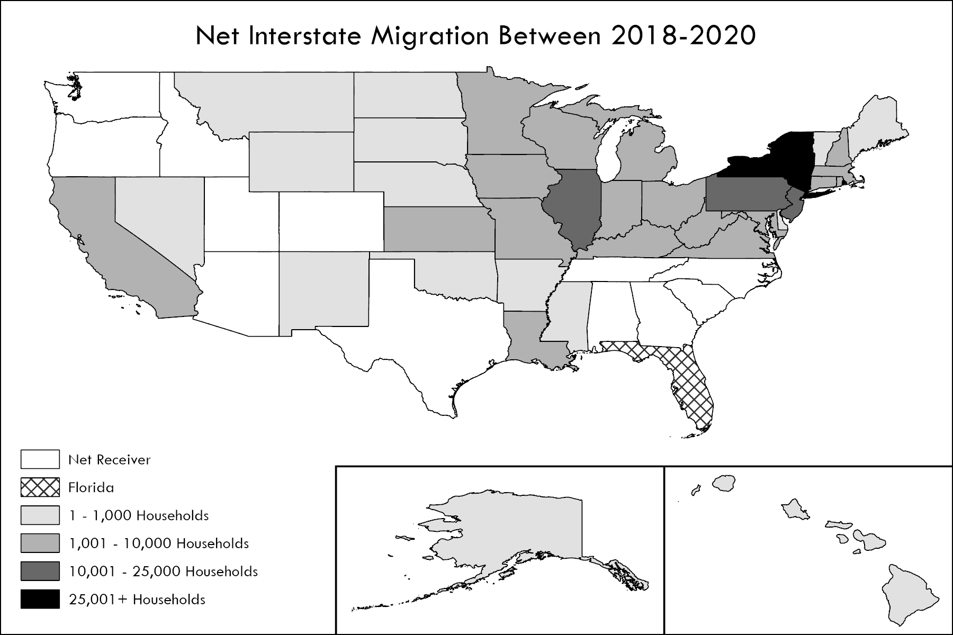Notes: Household counts by state refer to the net inflow of tax filers to Florida. “Net receivers” are states receiving more movers from Florida than they sent.
2018-2020
2020-2022
Source: Shimberg Center tabulation of U.S. Department of the Treasury, Statistics of Income, Individuals, State and County Migration Data

Mid-Florida counties were the top magnets for household migration.
Figure 2.4 shows the counties receiving the most households overall, the most out-of-state movers, and the most in-state movers. The last map shows the counties sending the most households to other Florida counties.
A group of counties stretching from St. Johns County in the northeast to Lee County in the southwest received the largest combined inflow of households from out-of-state and other parts of Florida. Most of these were medium-sized counties; fast-growing Polk and Lee Counties now have crossed the large county population threshold (825,000).
For out-of-state movers, the most popular destinations were counties in the southern half of the state, particularly along the Gulf Coast from Tampa Bay to Collier County. These included influxes into large counties (Lee, Hillsborough, Pinellas, Palm Beach, and Polk) and medium counties (Sarasota, Collier, Manatee, Pasco, and Brevard).
The largest magnets for in-state moves were counties located near more populous areas, including Polk (between the Orlando and Tampa Bay metropolitan areas), Pasco (part of the Tampa Bay metropolitan area), and St. Lucie (north of Palm Beach/Broward/Miami-Dade Counties).

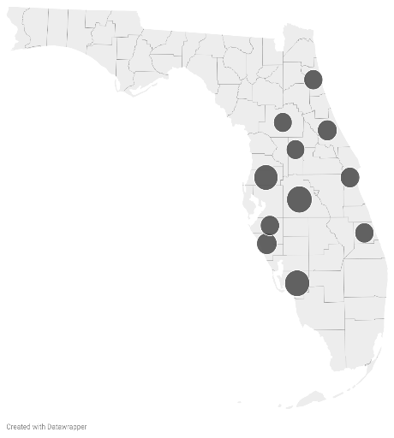
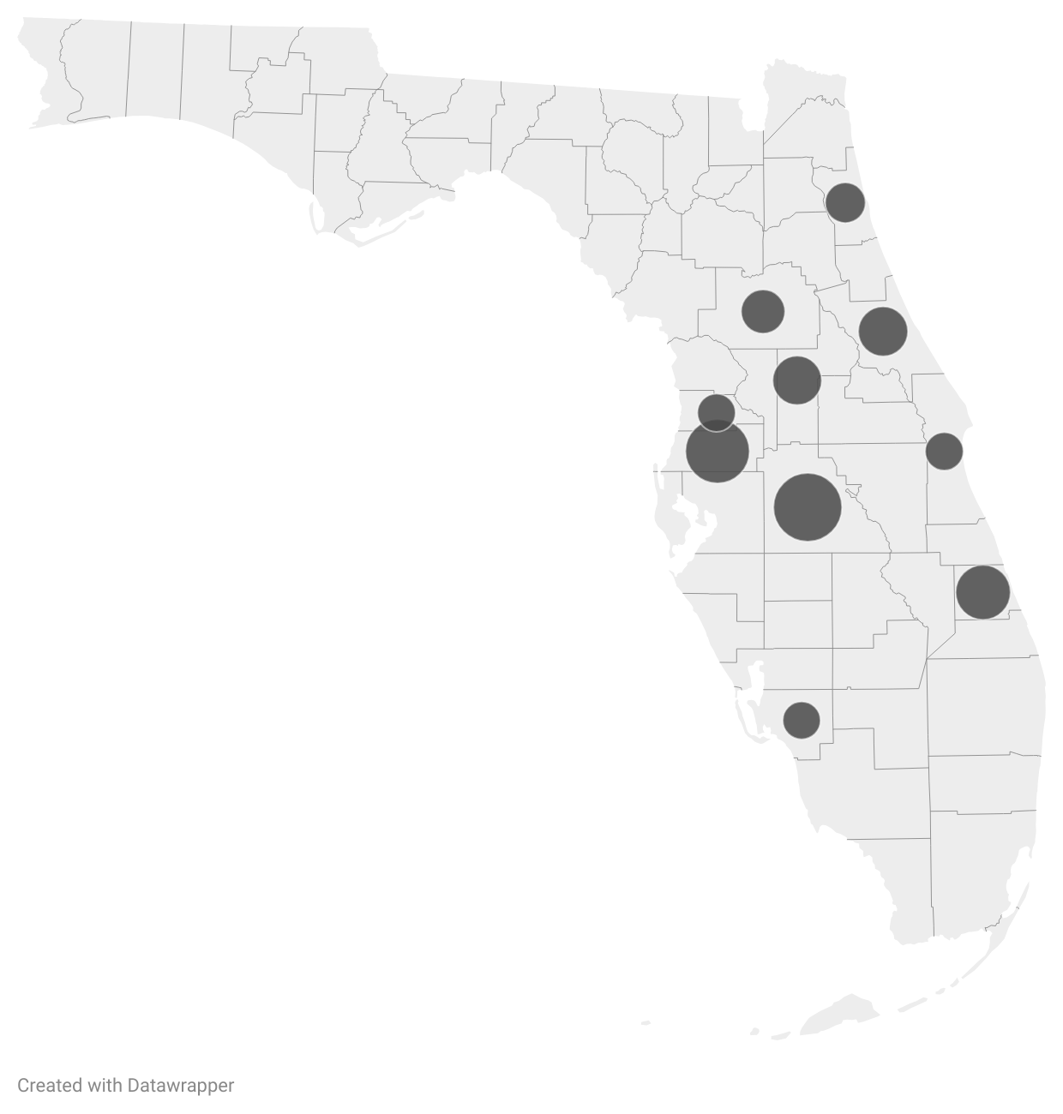
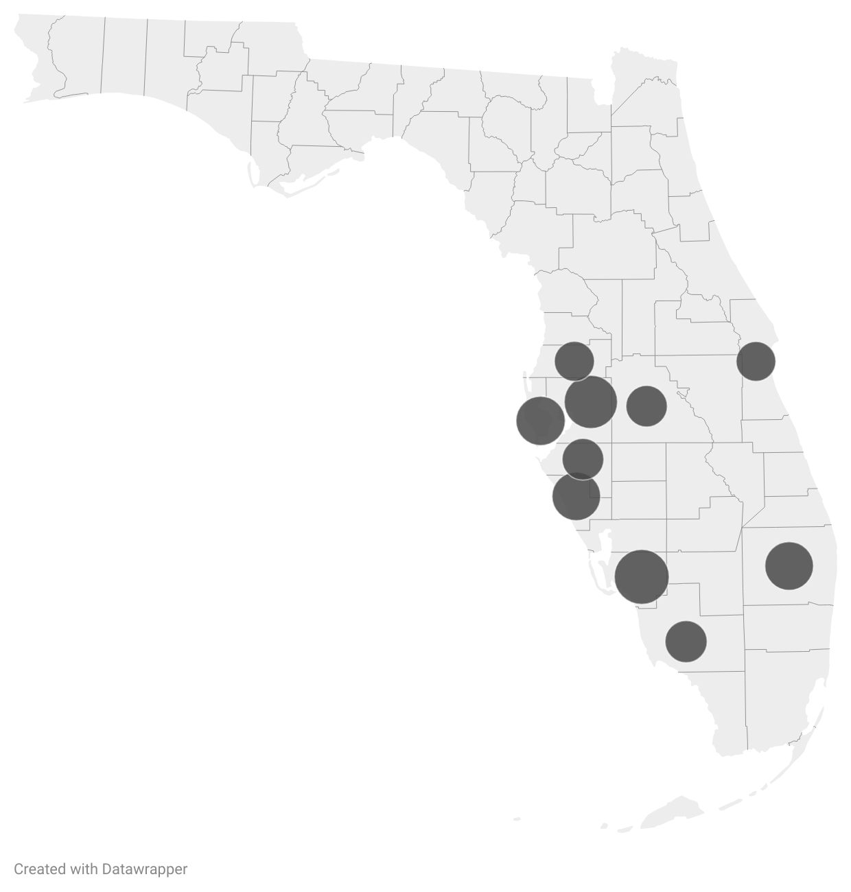
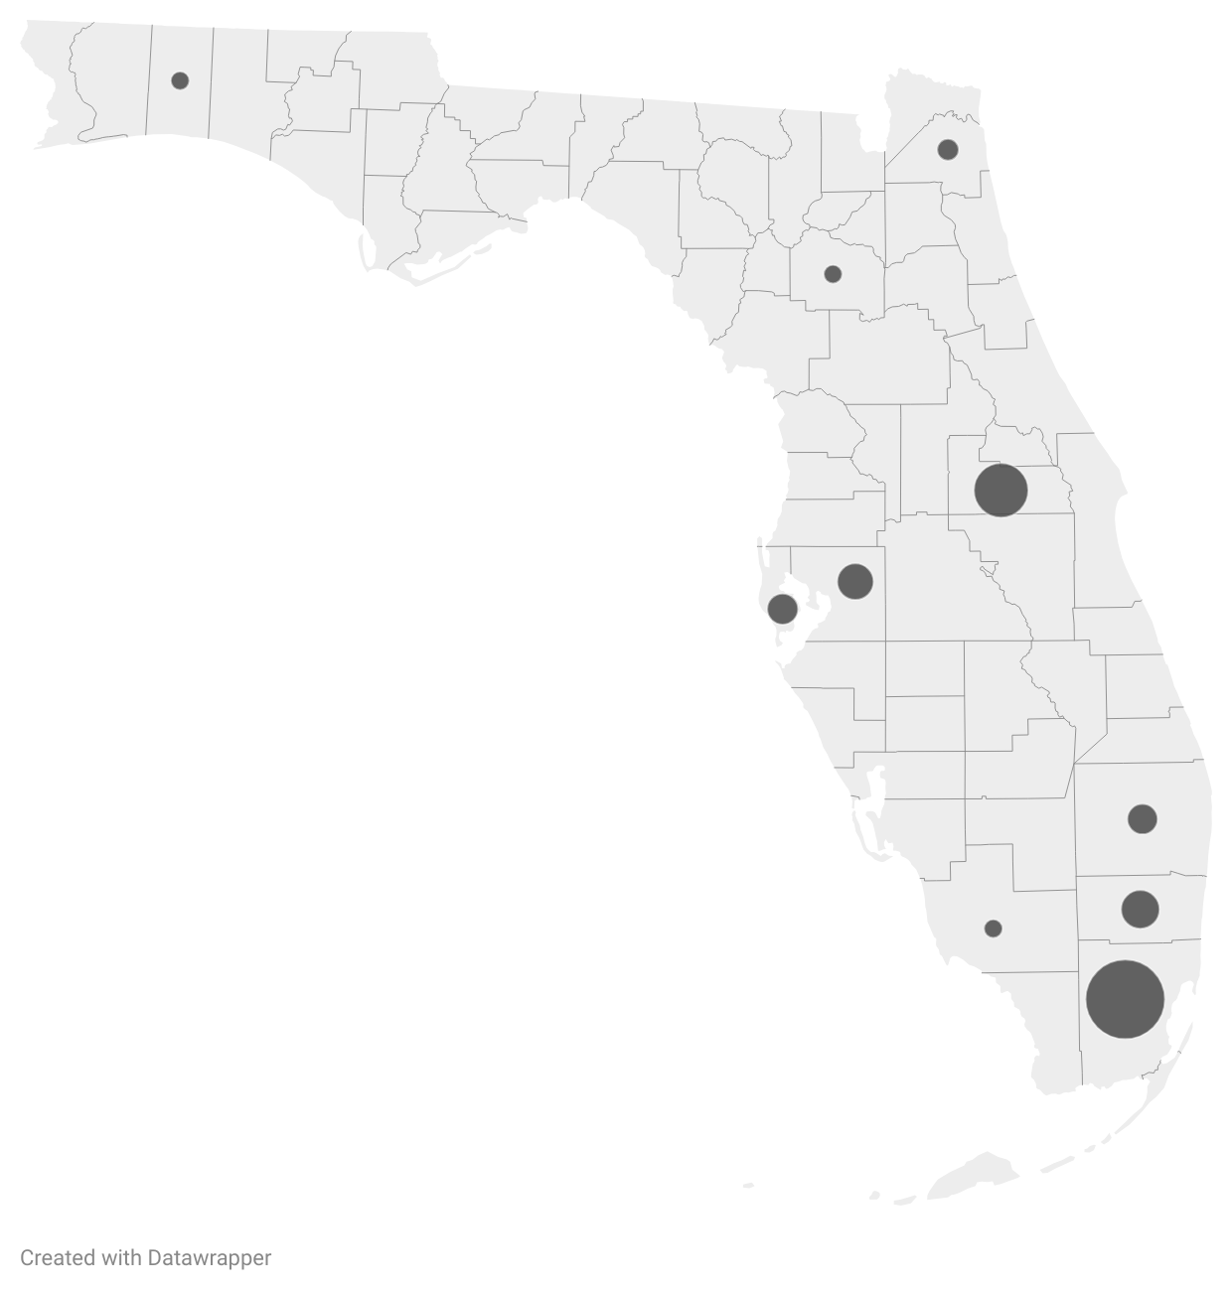
Figure 2.4. Top Counties for Net Inflow/Outflow, 2018-2022
Top Counties for Net Inflow, 2018-2022
Polk, 37,949 households
Lee, 36,553
Pasco, 34,054
Sarasota, 23,764
Volusia, 22,030
Brevard, 21,433
Manatee, 20,752
St. Lucie, 20,712
St. Johns, 20,337
Marion, 19,744
Lake, 19,523

Includes in-state and out-of-state movers

Top inflow, in-state & out-of-state
Top inflow, in-state only
Top inflow, out-of-state only
Top outflow to other FL counties

Source: Shimberg Center tabulation of U.S. Department of the Treasury, Statistics of Income, Individuals, State and County Migration Data
Florida’s most populous counties—Miami-Dade, Orange, Broward, Hillsborough, Pinellas, and Palm Beach—had the biggest outflow to other Florida counties, both before and after 2020. For Miami-Dade, Orange, and Broward, the loss of households to other Florida counties outweighed move-ins from other states. However, it appears that international migration into these counties made up for population losses to other parts of Florida and the U.S.

Rental Supply and Cost

Florida’s growth in renter households was absorbed by an increase in multifamily supply, especially in larger buildings.
Florida added over 240,000 renter-occupied multifamily units between 2019 and 2023. This included a 35 percent increase in apartments in 50+ unit buildings (Figure 2.5). The increase was partially offset by a 46,000 unit drop in single family and mobile home rentals.

Figure 2.5. Renter-Occupied Units by Units in Structure, Florida, 2019 & 2023

Notes: Single family includes detached and attached (townhome) units. Unit counts are building-level, not complex-level; for example, a 10-unit building in a 100-unit complex would be included in the multifamily 5-49 unit category.
Source: Shimberg Center tabulation of U.S. Census Bureau, 2019 and 2023 American Community Survey

Despite the increase in supply, median rent rose by 39 percent from 2019 to 2023.
Florida’s median gross rent increased from $1,238 in 2019 to $1,719 in 2023. The median rent increased 13 percent annually in the latter two years, and by 39 percent over the entire 4-year period.

Figure 2.6. Median Gross Rent, Florida, 2019-2023

Notes: Gross rent includes rent paid to landlord and tenant-paid utilities. 2020 value not included due to limitations in data collection for the 2020 American Community Survey.
Source: Shimberg Center tabulation of U.S. Census Bureau, 2019/2021/2022/2023 American Community Survey
Over the longer term, Florida’s increase in rental supply has been concentrated in units renting for more than $1,200 per month. Between 2013 and 2023, Florida added approximately 736,000 units with gross rent above $1,200 (in 2023 dollars) but lost 404,000 units at $1,200 or less.

Figure 2.7. Units by Gross Rent Above/Below $1,200 (2023 $), Florida, 2013-2023

Notes: 2013 values converted to 2023 dollars using the Consumer Price Index to correct for inflation.
Source: Shimberg Center tabulation of U.S. Census Bureau, 2013 & 2023 American Community Survey

With unsubsidized rentals becoming more expensive, assisted housing rents now fall well below market-rate levels.
In the early years of the Low-Income Housing Tax Credit (LIHTC, or Housing Credit) and other Florida Housing programs, middle market rents in Florida were similar to the maximum allowable rents for housing targeting 60 percent of AMI households. As private rental housing has become more expensive, market rents and 60 percent of AMI rents have diverged. Apartments restricted to 60 percent of AMI now offer housing that is substantially more affordable to tenants than the market-rate stock.
In the Orlando metropolitan area, for example, the rent limit for a two-bedroom apartment at 60 percent of AMI was nearly identical to the median gross rent for all rental units in the 1990s, with 50 percent of AMI rents slightly below and 30 percent of AMI rents about half of the median. Starting with the early 2000s housing boom, market rents and 60 percent of AMI limits began to diverge. By 2023, the median rent ($1,799 in the Orlando area) was nearly $500 higher than the 60 percent of AMI rent limit, over $700 higher than the 50 percent of AMI limit, and over $1,100 higher than the 30 percent of AMI limit.

Figure 2.8. Median Gross Rent vs. 2 Bedroom 30/50/60% AMI Rents, Orlando-Kissimmee-Sanford Metropolitan Statistical Area, 1990-2023

Notes: Early 1990s comparison uses median rent from 1990 Census versus 1993 rent limits, the earliest year available on Florida Housing’s website.
Source: Shimberg Center tabulation of U.S. Census Bureau, 1990 and 2000 Census and 2010/2015/2019/2023 American Community Survey; Florida Housing Finance Corporation Rent Limits

Renters in the Workforce

Nearly three-quarters of renter households include a working adult. Most non-working renter households are made up of older adults or persons with disabilities.
Because renter households tend to be younger, renters participate in the workforce at higher rates than homeowners. Seventy-nine percent of renter households include at least one working adult, compared to 67 percent of owner households.
Most renter households without employment are those in which all adults are elderly, disabled, or both. As Figure 2.9 shows, only six percent of renter households with working age, non-disabled adults are without employment.

Figure 2.9. Renter Households by Age/Disability and Work Status, Florida, 2023

Notes: “Working age” means that at least one person in the household is age 16-64 and not disabled. Student-headed, nonfamily households are excluded.
Source: Shimberg Center tabulation of U.S. Census Bureau, 2023 American Community Survey
This pattern holds for all but the lowest income renters. As Figure 2.10 shows, 75 percent of renter households at 30.01-60 percent of AMI and 89-95 percent of renter households above 60 percent of AMI include at least one working adult.
Among renters with incomes below 30 percent of AMI, 38 percent of households are employed. Most of the rest (41 percent) are non-working households where all adults are elderly, have disabilities, or both. Working age, non-disabled households without an employed adult make up the smallest group at 22 percent.

Figure 2.10. Renter Households by Age/Disability, Work Status, and Income (% AMI) Florida, 2023

Source: Shimberg Center tabulation of U.S. Census Bureau, 2023 American Community Survey
Table 2.1 shows the ten most common occupations of the head of household for low-income renters and for all renters. Renters fill many high-demand jobs. Starred jobs have been identified by the Florida Department of Commerce as top-growing occupations through 2032.

Table 2.1. Top Ten Occupations for 0-60 Percent of AMI Renters and All Renters, Florida
 | Median hourly wage | Top Ten Occupations
 | Median hourly wage | 0-60% AMI Renters | All Renters
Customer Service Representatives* | $18.70 | X | X
Janitors and Building Cleaners* | $15.16 | X | X
Cooks | $13.91-28.64 | X | X
Retail Salespersons* | $15.36 | X | X
Cashiers | $14.10 | X | X
Waiters and Waitresses* | $14.22 | X | X
Driver/Sales Workers and Truck Drivers | $19.31-24.04 | X | X
Landscaping And Groundskeeping Workers | $17.32 | X
Nursing Assistants | $17.72 | X
Construction Laborers | $19.63 | X
Managers* | $25.13-80.61 |  | X
Registered Nurses | $39.83 |  | X
First-Line Supervisors of Retail Sales Workers | $22.65 |  | X
Source: Shimberg Center tabulation of U.S. Census Bureau, 2023 American Community Survey; Florida Department of Commerce, 2024 Occupational Employment Statistics and Wages and 2024-2032 Fastest Growing Occupations

Elder Housing Needs

Nearly 40 percent of low-income, cost burdened renter households are headed by someone age 55 or older.
Florida’s older population grew more than twice as fast as the state’s overall population between 2010 and 2020. Nearly 7.6 million Floridians were age 55 or older in the 2020 Census, up from 5.6 million in 2010.
The share of older cost burdened renter households grew alongside the population increase. In the 2010 Rental Market Study, 29 percent of low-income, cost burdened households were headed by someone age 55 or older. By 2022, that share had grown to 39 percent.
This year, the share of age 55+ cost burdened renters has leveled off at the same 39 percent. An estimated 352,861 cost burdened renter households with incomes below 60 percent of AMI are headed by someone age 55 or older.
Just over half of the 55+ cost burdened households have incomes below 30 percent of AMI. These households tend to be small; two-thirds are single-person households, and most of the rest (23 percent) are two-person households. Forty-three percent are headed by someone with a disability, and 28 percent include at least one employed household member.
In addition to cost burdened renters, some elders are experiencing homelessness, as older households struggle to meet their housing costs and as people already experiencing homelessness have aged. In 2024, the Florida Council on Homelessness reported that 8,369 Florida residents aged 55 and older were homeless, including 2,707 aged 65 and older.

Florida’s elders are a core constituency for assisted rental housing, both in elder set-aside units and in family and special needs developments.
All major housing funders set aside units for older residents. Age limits start at 55 for Florida Housing’s set-aside units and at 62 in federally subsidized developments. Nearly a third of the state’s assisted housing developments (918 developments with 94,803 assisted units) set aside some or all of their units for elders.
In addition to the set-aside units, older households make up large shares of households in developments for families and other populations. In Florida Housing’s inventory, approximately 90,000 units are occupied by households where at least one person is age 55 or older. Almost half of these units are in family properties, and another 3,700 are in developments for homeless persons, persons with disabilities, and farmworker/fishing workers.
In all, between elder set-asides and the general assisted supply, nearly two-thirds of HUD and USDA multifamily units and over 40 percent of Florida Housing and public housing units serve elder households. The large share of 55+ households in family units suggests that many developments outside of the traditional elder housing inventory could benefit from additional accessibility features and services for older residents.

County and Regional Rental Housing Needs
This section of the Rental Market Study provides county-level estimates of renter households by income, cost burden and household size. It also includes regional estimates of cost burdened households by age. The estimates are based on extrapolations from the American Community Survey and population projections from the University of Florida Bureau of Economic and Business Research. See “Notes on Methodology” at the end of the chapter for additional details about the methodology for household estimates.
A household is classified as “low-income” if its income is at or below 60 percent of the area median income (AMI), adjusted for household size. A household is “cost burdened” if it pays more than 40 percent of income for gross rent, including utility costs. Student-headed, non-family households are excluded from the analysis.

Cost Burdened Households by County
Of Florida’s 3 million renter households, an estimated 904,635 households are low-income, cost burdened renters.
Table 3.1 and Figures 3.1 and 3.2 show the estimated distribution of cost burdened households by county and county size for 2025. Large counties have populations of 825,000 or more; medium counties have populations of 100,001-824,999; and small counties have populations of 100,000 or less. Lee and Polk Counties now have populations above the large county threshold.
Detailed tables at the end of the chapter track cost burdened households in more detail and for higher income levels. Those tables include counts of all renters and cost burden share for households at 0-30, 30.01-60, 60.01-80, 80.01-100, 100.01-120, and 120.01-140 percent of AMI.

Table 3.1. Low-Income (≤60% AMI), Cost Burdened (>40%) Renter Households by County in Florida, 2025
 | All Renter Households | Low-Income (<=60% AMI), Cost Burdened (>40%) Renters | Low-Income/ Cost Burdened Renters as % of All Renters in the County | Low-Income/ Cost Burdened Renters as % of State Total
Large
Broward | 299,663 | 95,683 | 32% | 10.58%
Duval | 181,436 | 55,420 | 31% | 6.13%
Hillsborough | 236,253 | 68,950 | 29% | 7.62%
Lee | 98,882 | 28,785 | 29% | 3.18%
Miami-Dade | 490,663 | 132,808 | 27% | 14.68%
Orange | 244,081 | 71,377 | 29% | 7.89%
Palm Beach | 205,153 | 64,209 | 31% | 7.10%
Pinellas | 151,725 | 43,663 | 29% | 4.83%
Polk | 93,134 | 22,452 | 24% | 2.48%
Large Total | 2,000,990 | 583,347 | 29% | 64.48%
Medium
Alachua | 43,684 | 16,778 | 38% | 1.85%
Bay | 24,477 | 6,240 | 25% | 0.69%
Brevard | 73,316 | 25,039 | 34% | 2.77%
Charlotte | 18,246 | 6,392 | 35% | 0.71%
Citrus | 13,483 | 3,946 | 29% | 0.44%
Clay | 23,008 | 6,160 | 27% | 0.68%
Collier | 44,239 | 14,394 | 33% | 1.59%
Escambia | 47,568 | 12,255 | 26% | 1.35%
Flagler | 12,080 | 4,478 | 37% | 0.50%
Hernando | 17,766 | 5,543 | 31% | 0.61%
Highlands | 11,031 | 2,805 | 25% | 0.31%
Indian River | 18,399 | 4,595 | 25% | 0.51%
Lake | 45,754 | 15,853 | 35% | 1.75%
Leon | 48,355 | 16,091 | 33% | 1.78%
Manatee | 54,836 | 15,287 | 28% | 1.69%
Marion | 41,958 | 12,061 | 29% | 1.33%
Martin | 16,640 | 5,746 | 35% | 0.64%
Nassau | 7,749 | 1,796 | 23% | 0.20%
Okaloosa | 31,098 | 7,306 | 23% | 0.81%
Osceola | 57,921 | 19,824 | 34% | 2.19%
Pasco | 67,322 | 17,267 | 26% | 1.91%
Santa Rosa | 16,832 | 3,618 | 21% | 0.40%
Sarasota | 51,443 | 14,197 | 28% | 1.57%
Seminole | 68,604 | 19,253 | 28% | 2.13%
St. Johns | 25,248 | 6,777 | 27% | 0.75%
St. Lucie | 37,352 | 11,699 | 31% | 1.29%
Sumter | 10,857 | 3,867 | 36% | 0.43%
Volusia | 68,813 | 18,372 | 27% | 2.03%
Medium Total | 998,079 | 297,639 | 30% | 32.90%
Small
Baker | 2,145 | 497 | 23% | 0.05%
Bradford | 2,479 | 625 | 25% | 0.07%
Calhoun | 1,043 | 251 | 24% | 0.03%
Columbia | 7,796 | 1,966 | 25% | 0.22%
DeSoto | 3,363 | 855 | 25% | 0.09%
Dixie | 1,316 | 332 | 25% | 0.04%
Franklin | 1,251 | 301 | 24% | 0.03%
Gadsden | 4,689 | 1,128 | 24% | 0.12%
Gilchrist | 1,123 | 283 | 25% | 0.03%
Glades | 864 | 265 | 31% | 0.03%
Gulf | 1,336 | 321 | 24% | 0.04%
Hamilton | 1,366 | 286 | 21% | 0.03%
Hardee | 2,498 | 635 | 25% | 0.07%
Hendry | 4,098 | 1,256 | 31% | 0.14%
Holmes | 1,775 | 305 | 17% | 0.03%
Jackson | 4,780 | 1,150 | 24% | 0.13%
Jefferson | 1,390 | 334 | 24% | 0.04%
Lafayette | 635 | 133 | 21% | 0.01%
Levy | 3,897 | 983 | 25% | 0.11%
Liberty | 611 | 147 | 24% | 0.02%
Madison | 1,862 | 389 | 21% | 0.04%
Monroe | 14,425 | 3,904 | 27% | 0.43%
Okeechobee | 3,981 | 1,220 | 31% | 0.13%
Putnam | 7,504 | 2,014 | 27% | 0.22%
Suwannee | 4,369 | 913 | 21% | 0.10%
Taylor | 2,015 | 421 | 21% | 0.05%
Union | 1,381 | 348 | 25% | 0.04%
Wakulla | 2,560 | 616 | 24% | 0.07%
Walton | 8,190 | 1,406 | 17% | 0.16%
Washington | 2,126 | 365 | 17% | 0.04%
Small Total | 96,868 | 23,649 | 24% | 2.61%
State Total | 3,095,937 | 904,635 | 29% | 100.00%
Source: Shimberg Center tabulation of U.S. Census Bureau, 2023 American Community Survey; University of Florida Bureau of Economic and Business Research, 2025 Population Projections

Figure 3.1. Number of Low-Income (≤60% AMI), Cost Burdened (>40%) Renter Households by County in Florida, 2025
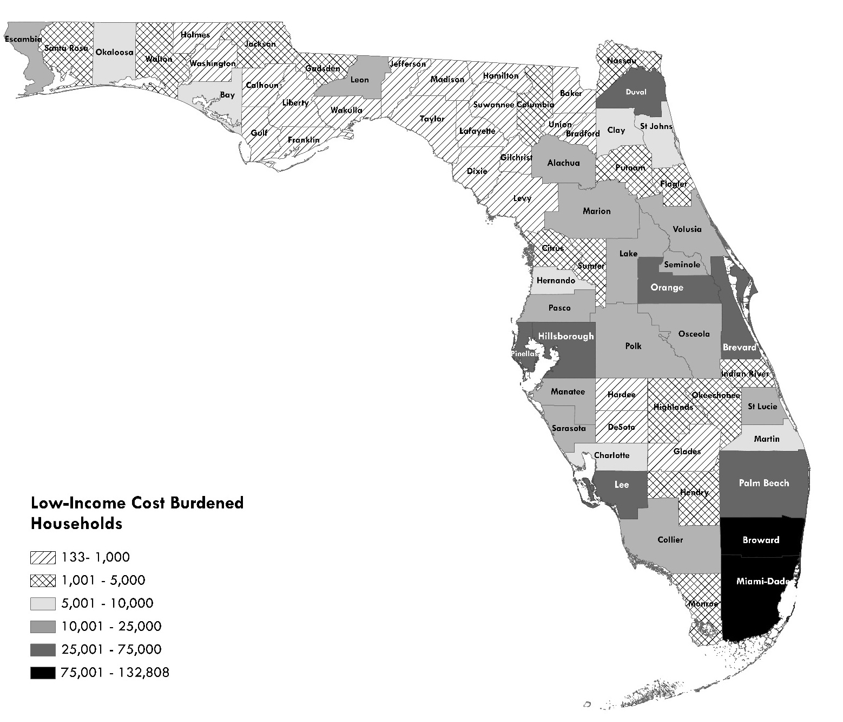

Source: Shimberg Center tabulation of U.S. Census Bureau, 2023 American Community Survey; University of Florida Bureau of Economic and Business Research, 2025 Population Projections

Figure 3.2. Low-Income (≤60% AMI), Cost Burdened (>40%) Renter Households by County Size in Florida, 2025

Source: Shimberg Center tabulation of U.S. Census Bureau, 2023 American Community Survey; University of Florida Bureau of Economic and Business Research, 2025 Population Projections
Sixty-four percent of low-income, cost burdened renter households are located in large counties: Broward, Duval, Hillsborough, Lee, Miami-Dade, Orange, Palm Beach, Pinellas, and Polk. Miami-Dade County has the largest share of the state’s low-income, cost burdened renters, at 15 percent.
The medium counties contain 33 percent of the low-income, cost burdened households, with 297,639 households. The medium size counties with the most low-income cost burdened renters are mostly located in Central Florida: Brevard (25,039), Osceola (19,824), Seminole (19,253), Pasco (17,267), and Alachua (16,778).
The remaining 23,649 low-income, cost burdened households (2.61 percent) are located in small counties. Monroe County has the largest share, with 3,904 households. Several other small counties also have more than 1,000 cost burdened households, including Putnam, Columbia, Walton, Hendry, Okeechobee, Jackson, and Gadsden.

Low-Income, Cost Burdened Renters by Household Size and Age
Household Size: Most low-income, cost burdened renter households are small. Statewide, 68 percent of low-income, cost burdened households consist of 1-2 household members, 24 percent have 3-4 members, and eight percent have five or more members. Table 3.2 shows the size of low-income, cost burdened households by county.

Table 3.2. Low-Income (≤60% AMI), Cost Burdened (>40%) Renter Households by Size, 2025
 | Low-Income, Cost Burdened Renter Households
 | 1-2  Person | % 1-2  Person | 3-4  Person | % 3-4  Person | 5 or  More  Person | % 5 or  More  Person
Large
Broward | 63,435 | 66.3% | 23,479 | 24.5% | 8,768 | 9.2%
Duval | 36,172 | 65.3% | 14,595 | 26.3% | 4,653 | 8.4%
Hillsborough | 45,337 | 65.8% | 18,399 | 26.7% | 5,214 | 7.6%
Lee | 20,248 | 70.3% | 5,644 | 19.6% | 2,893 | 10.1%
Miami-Dade | 83,728 | 63.0% | 37,165 | 28.0% | 11,915 | 9.0%
Orange | 45,562 | 63.8% | 22,029 | 30.9% | 3,786 | 5.3%
Palm Beach | 46,268 | 72.1% | 11,625 | 18.1% | 6,316 | 9.8%
Pinellas | 32,537 | 74.5% | 8,456 | 19.4% | 2,670 | 6.1%
Polk | 15,028 | 66.9% | 4,660 | 20.8% | 2,764 | 12.3%
Large Total | 388,315 | 66.6% | 146,052 | 25.0% | 48,979 | 8.4%
Medium
Alachua | 13,716 | 81.7% | 1,663 | 9.9% | 1,400 | 8.3%
Bay | 4,752 | 76.2% | 1,258 | 20.2% | (X) | (X)
Brevard | 17,138 | 68.4% | 6,055 | 24.2% | 1,846 | 7.4%
Charlotte | 4,255 | 66.6% | 2,137 | 33.4% | (X) | (X)
Citrus | 3,113 | 78.9% | 833 | 21.1% | (X) | (X)
Clay | 4,315 | 70.0% | 1,144 | 18.6% | 701 | 11.4%
Collier | 8,518 | 59.2% | 3,835 | 26.6% | 2,040 | 14.2%
Escambia | 8,960 | 73.1% | 2,279 | 18.6% | 1,016 | 8.3%
Flagler | 3,234 | 72.2% | (X) | (X) | (X) | (X)
Hernando | 3,603 | 65.0% | 1,940 | 35.0% | (X) | (X)
Highlands | 1,990 | 70.9% | 717 | 25.6% | (X) | (X)
Indian River | 2,896 | 63.0% | 1,699 | 37.0% | (X) | (X)
Lake | 12,156 | 76.7% | 3,457 | 21.8% | (X) | (X)
Leon | 13,070 | 81.2% | 1,676 | 10.4% | 1,345 | 8.4%
Manatee | 11,971 | 78.3% | 2,333 | 15.3% | 984 | 6.4%
Marion | 7,979 | 66.2% | 2,653 | 22.0% | 1,428 | 11.8%
Martin | 3,446 | 60.0% | 1,661 | 28.9% | (X) | (X)
Nassau | 1,265 | 70.4% | (X) | (X) | (X) | (X)
Okaloosa | 4,707 | 64.4% | 1,807 | 24.7% | 793 | 10.9%
Osceola | 11,536 | 58.2% | 5,681 | 28.7% | 2,607 | 13.2%
Pasco | 13,719 | 79.5% | 2,936 | 17.0% | (X) | (X)
Santa Rosa | 2,707 | 74.8% | (X) | (X) | (X) | (X)
Sarasota | 11,387 | 80.2% | 1,830 | 12.9% | 980 | 6.9%
Seminole | 11,774 | 61.2% | 6,031 | 31.3% | 1,448 | 7.5%
St. Johns | 5,345 | 78.9% | 936 | 13.8% | (X) | (X)
St. Lucie | 7,558 | 64.6% | 3,159 | 27.0% | 982 | 8.4%
Sumter | 2,806 | 72.5% | 1,062 | 27.5% | (X) | (X)
Volusia | 13,722 | 74.7% | 3,518 | 19.1% | 1,133 | 6.2%
Medium Total | 211,638 | 71.1% | 64,201 | 21.6% | 21,801 | 7.3%
Small
Baker | 350 | 70.4% | (X) | (X) | (X) | (X)
Bradford | 488 | 78.0% | (X) | (X) | (X) | (X)
Calhoun | 146 | 57.9% | 93 | 36.9% | (X) | (X)
Columbia | 1,533 | 78.0% | (X) | (X) | (X) | (X)
DeSoto | 607 | 71.0% | 218 | 25.5% | (X) | (X)
Dixie | 259 | 77.8% | (X) | (X) | (X) | (X)
Franklin | 175 | 58.1% | 111 | 36.9% | (X) | (X)
Gadsden | 655 | 58.1% | 416 | 36.9% | (X) | (X)
Gilchrist | 221 | 77.8% | (X) | (X) | (X) | (X)
Glades | 127 | 47.9% | 101 | 38.1% | (X) | (X)
Gulf | 187 | 58.1% | 119 | 37.0% | (X) | (X)
Hamilton | 196 | 68.5% | (X) | (X) | (X) | (X)
Hardee | 451 | 71.0% | 162 | 25.5% | (X) | (X)
Hendry | 600 | 47.8% | 479 | 38.1% | (X) | (X)
Holmes | 249 | 81.6% | (X) | (X) | (X) | (X)
Jackson | 668 | 58.1% | 424 | 36.9% | (X) | (X)
Jefferson | 194 | 58.1% | 123 | 36.8% | (X) | (X)
Lafayette | 91 | 68.9% | (X) | (X) | (X) | (X)
Levy | 766 | 78.0% | (X) | (X) | (X) | (X)
Liberty | 85 | 58.2% | 54 | 37.0% | (X) | (X)
Madison | 267 | 68.6% | (X) | (X) | (X) | (X)
Monroe | 2,461 | 63.0% | 1,093 | 28.0% | 350 | 9.0%
Okeechobee | 583 | 47.8% | 465 | 38.1% | (X) | (X)
Putnam | 1,589 | 78.9% | 278 | 13.8% | (X) | (X)
Suwannee | 626 | 68.6% | (X) | (X) | (X) | (X)
Taylor | 289 | 68.5% | (X) | (X) | (X) | (X)
Union | 272 | 77.9% | (X) | (X) | (X) | (X)
Wakulla | 358 | 58.1% | 227 | 36.9% | (X) | (X)
Walton | 1,150 | 81.8% | (X) | (X) | (X) | (X)
Washington | 299 | 81.7% | (X) | (X) | (X) | (X)
Small Total | 15,942 | 67.4% | 6,134 | 25.9% | 1,577 | 6.7%
State Total | 615,895 | 68.1% | 216,387 | 23.9% | 72,357 | 8.0%
Notes: County totals differ slightly from Table 3.1 because of rounding in household size categories. (X) indicates suppressed results where estimates are not statistically significantly different from zero. Where possible, missing values are included in data aggregated to a higher level, such as state totals. Therefore, totals for columns and rows with missing values may be higher than the sum of the preceding numeric values.
Source: Shimberg Center tabulation of U.S. Census Bureau, 2023 American Community Survey; University of Florida Bureau of Economic and Business Research, 2025 Population Projections
Age: To provide more detail about the ages of households eligible for age-restricted housing (55 and older), the analysis of cost burdened households by age of householder includes four age categories: 15-54, 55-74, 75-84, and 85 and older. The sample size of the ACS limits the statistical significance of a county-by-county breakdown of cost burdened households by age. Instead, we provide households by age for the small, medium and large county groups and for the Planning and Service Areas (PSAs) defined by Florida’s Department of Elder Affairs.

Table 3.3. Low-Income (≤60% AMI), Cost Burdened (>40%) Renter Households by Age and County Size, 2025
County  Size | Age of Low-Income, Cost Burdened Householder |  |  |  |  |  |  |  | Total
County  Size | 15-54 | % 15-54 | 55-74 | % 55-74 | 75-84 | % 75-84 | 85 and  Older | % 85  and Older | Total
Large | 360,295 | 61.8% | 158,738 | 27.2% | 43,887 | 7.5% | 20,427 | 3.5% | 583,347
Medium | 178,666 | 60.0% | 79,658 | 26.8% | 24,840 | 8.3% | 14,475 | 4.9% | 297,639
Small | 12,783 | 54.1% | 8,439 | 35.7% | 2,063 | 8.7% | (X) | (X) | 23,649
State Total | 551,773 | 61.0% | 246,793 | 27.3% | 70,787 | 7.8% | 35,281 | 3.9% | 904,635
Notes: County size totals differ slightly from Table 3.1 because of rounding in household size categories. (X) indicates suppressed results where estimates are not statistically significantly different from zero. Where possible, missing values are included in data aggregated to a higher level, such as state totals. Therefore, totals for columns and rows with missing values may be higher than the sum of the preceding numeric values.
Source: Shimberg Center tabulation of U.S. Census Bureau, 2023 American Community Survey; University of Florida Bureau of Economic and Business Research, 2025 Population Projections

After many years of growth, the share of age 55+ households as a proportion of all low-income, cost burdened renters households is stabilizing. Statewide, 39 percent of the households are headed by persons age 55 and older, the same share as in the 2022 Rental Market Study. Twelve percent of all householders are age 75 and older, including four percent who are age 85 and older.
As Table 3.4 shows, concentrations of older low-income, cost burdened renters vary regionally. At the highest, 44-50 percent of low-income, cost burdened households are headed by persons age 55 and older in the southwest region stretching from Sarasota to Collier Counties and adjacent inland counties, the Pasco/Pinellas region, and the southeast coast from Indian River to Palm Beach County. At the lowest, 29-30 percent of low-income, cost burdened households are headed by persons age 55 and over in Central Florida and in the Panhandle region stretching from Jefferson to Walton County.

Table 3.4. Low-Income (≤60% AMI), Cost Burdened (>40%) Renter Households by Age of Households and Region in Florida, 2025
Planning and Service Area | Age of Householder
Planning and Service Area | 15-54 | %  15-54 | 55-74 | %  55-74 | 75-84 | % 75-  84 | 85 or  Older | % 85  or  Older | Total
1) Escambia, Okaloosa, Santa Rosa | 15,665 | 67% | 4,914 | 21% | 1,579 | 7% | 1,193 | 5% | 23,351
2) Bay, Calhoun, Franklin, Gadsden, Gulf, Jackson, Jefferson, Holmes, Leon, Liberty, Wakulla, Walton, Washington | 20,109 | 70% | 6,713 | 23% | 1,452 | 5% | (X) | (X) | 28,731
3) Alachua, Bradford, Citrus, Columbia, Dixie, Gilchrist, Hamilton, Hernando, Lafayette, Lake, Levy, Madison, Marion, Sumter, Suwannee, Taylor, Union | 37,916 | 59% | 19,181 | 30% | 4,939 | 8% | 2,609 | 4% | 64,645
4) Baker, Clay, Duval, Flagler, Nassau, Putnam, St. Johns, Volusia | 58,962 | 62% | 25,873 | 27% | 6,959 | 7% | 3,788 | 4% | 95,582
5) Pasco, Pinellas | 32,732 | 54% | 18,687 | 31% | 7,044 | 12% | 2,617 | 4% | 61,079
6) Desoto, Hardee, Hillsborough, Highlands (part), Manatee, Polk | 67,778 | 63% | 30,388 | 28% | 6,776 | 6% | 3,131 | 3% | 108,072
7) Brevard, Orange, Osceola, Seminole | 96,022 | 71% | 28,656 | 21% | 6,440 | 5% | 3,556 | 3% | 134,675
8) Charlotte, Collier, Glades, Hendry, Highlands (part), Lee, Okeechobee, Sarasota | 34,814 | 50% | 21,231 | 30% | 8,915 | 13% | 4,688 | 7% | 69,649
9) Indian River, Martin, Palm Beach, St. Lucie | 48,701 | 56% | 25,025 | 29% | 6,486 | 8% | 6,154 | 7% | 86,366
10) Broward | 58,288 | 61% | 25,311 | 26% | 9,144 | 10% | 2,977 | 3% | 95,720
11) Miami, Monroe | 79,125 | 58% | 41,430 | 30% | 11,626 | 9% | 4,584 | 3% | 136,765
State Total | 551,773 | 61% | 246,793 | 27% | 70,787 | 8% | 35,281 | 4% | 904,635
Notes: (X) indicates suppressed results where estimates are not statistically significantly different from zero. Where possible, missing values are included in data aggregated to a higher level, such as state totals. Therefore, totals for columns and rows with missing values may be higher than the sum of the preceding numeric values. Percentages may not add up to 100 percent due to rounding.
Source: Shimberg Center tabulation of U.S. Census Bureau, 2023 American Community Survey; University of Florida Bureau of Economic and Business Research, 2025 Population Projections.

Cost Burden Among Households at 60-140 Percent of AMI
Most cost burdened renters in Florida have incomes below 60 percent of AMI, but many renters with incomes above 60 percent of AMI also experience cost burden. Statewide, 45 percent of renters at 60.01-80 percent of AMI and 21 percent at 80.01-100 percent of AMI are cost burdened, compared to 73 percent of renters with incomes below 60 percent of AMI. Cost burden is less common among households above 100 percent of AMI. Eleven percent of renters at 100.01-120 percent of AMI and six percent of renters at 120.01-140 of percent of AMI are cost burdened.
Tables 3.5 and 3.6 show cost burdened renters by detailed income categories at the county level. Because cost burden is less common among households above 60 percent of AMI, household counts are suppressed for most small counties and several medium counties. These estimates are not statistically significantly different from zero. The maps in Figures 3.3 through 3.5 show cost burdened households for the middle categories (60.01-80, 80.01-100, and 100.01-120 percent of AMI).

Detailed Data Tables

Table 3.5 Renter Households by Detailed Income and Cost Burden by County, Florida, 2025, Part I (0-30% AMI, 30.01-60% AMI, 60.01-80% AMI)
 | 0-30% AMI |  |  | 30-60% AMI |  |  | 60-80% AMI
 | All Renters in Income Category | Cost Burdened (>40%) Renters in Category | % Cost Burdened | All Renters in Income Category | Cost Burdened (>40%) Renters in Category | % Cost Burdened | All Renters in Income Category | Cost Burdened (>40%) Renters in Category | % Cost Burdened
Large
Broward | 54,205 | 40,802 | 75% | 64,119 | 54,881 | 86% | 38,228 | 20,497 | 54%
Duval | 39,511 | 27,968 | 71% | 41,235 | 27,451 | 67% | 20,946 | 5,578 | 27%
Hillsborough | 46,793 | 33,955 | 73% | 45,978 | 34,994 | 76% | 29,395 | 12,169 | 41%
Lee | 16,825 | 12,439 | 74% | 19,455 | 16,346 | 84% | 13,730 | 8,569 | 62%
Miami-Dade | 88,912 | 56,368 | 63% | 94,532 | 76,440 | 81% | 63,640 | 42,627 | 67%
Orange | 35,765 | 26,428 | 74% | 57,445 | 44,949 | 78% | 27,838 | 15,256 | 55%
Palm Beach | 37,036 | 29,987 | 81% | 48,755 | 34,221 | 70% | 25,988 | 12,149 | 47%
Pinellas | 22,404 | 17,424 | 78% | 32,631 | 26,239 | 80% | 19,315 | 9,927 | 51%
Polk | 14,421 | 9,166 | 64% | 20,886 | 13,287 | 64% | 14,312 | 4,237 | 30%
Large Total | 355,872 | 254,537 | 72% | 425,036 | 328,808 | 77% | 253,392 | 131,009 | 52%
Medium
Alachua | 11,082 | 9,036 | 82% | 11,673 | 7,742 | 66% | 6,528 | 1,065 | 16%
Bay | 4,369 | 2,970 | 68% | 4,771 | 3,270 | 69% | 3,481 | 1,085 | 31%
Brevard | 13,197 | 10,202 | 77% | 20,781 | 14,838 | 71% | 9,363 | 3,838 | 41%
Charlotte | 3,194 | 2,387 | 75% | 4,269 | 4,005 | 94% | 2,737 | (X) | (X)
Citrus | 2,686 | 2,163 | 81% | 3,415 | 1,783 | 52% | 2,036 | 690 | 34%
Clay | 2,451 | 1,942 | 79% | 6,938 | 4,218 | 61% | 3,293 | 1,044 | 32%
Collier | 8,799 | 6,309 | 72% | 12,049 | 8,084 | 67% | 5,208 | 1,415 | 27%
Escambia | 8,458 | 6,488 | 77% | 10,796 | 5,766 | 53% | 5,886 | 860 | 15%
Flagler | 2,256 | 1,335 | 59% | 3,449 | 3,143 | 91% | 1,336 | (X) | (X)
Hernando | 3,875 | 3,081 | 80% | 5,433 | 2,462 | 45% | 2,290 | (X) | (X)
Highlands | 1,852 | 1,109 | 60% | 2,763 | 1,695 | 61% | 1,523 | 622 | 41%
Indian River | 3,721 | 2,211 | 59% | 3,279 | 2,384 | 73% | 2,385 | (X) | (X)
Lake | 9,819 | 7,774 | 79% | 11,501 | 8,079 | 70% | 6,819 | 3,683 | 54%
Leon | 9,649 | 7,855 | 81% | 13,480 | 8,236 | 61% | 8,269 | 2,567 | 31%
Manatee | 9,953 | 6,732 | 68% | 11,215 | 8,555 | 76% | 7,851 | 2,443 | 31%
Marion | 6,840 | 5,908 | 86% | 7,727 | 6,152 | 80% | 6,202 | 2,300 | 37%
Martin | 3,016 | 1,812 | 60% | 5,384 | 3,934 | 73% | 1,509 | 1,123 | 74%
Nassau | 1,636 | 1,211 | 74% | 1,906 | 585 | 31% | 734 | (X) | (X)
Okaloosa | 6,872 | 4,538 | 66% | 4,716 | 2,767 | 59% | 3,957 | 1,367 | 35%
Osceola | 9,798 | 8,743 | 89% | 14,478 | 11,080 | 77% | 5,908 | 3,498 | 59%
Pasco | 11,267 | 7,963 | 71% | 13,985 | 9,304 | 67% | 10,124 | 2,714 | 27%
Santa Rosa | 3,232 | 2,573 | 80% | 3,323 | 1,045 | 31% | 2,007 | (X) | (X)
Sarasota | 6,771 | 4,778 | 71% | 12,289 | 9,419 | 77% | 8,265 | 4,254 | 51%
Seminole | 7,926 | 6,569 | 83% | 16,155 | 12,684 | 79% | 8,776 | 5,005 | 57%
St. Johns | 5,116 | 3,026 | 59% | 5,721 | 3,751 | 66% | 5,048 | 1,556 | 31%
St. Lucie | 5,855 | 4,496 | 77% | 8,915 | 7,203 | 81% | 4,996 | 2,266 | 45%
Sumter | 2,469 | 1,506 | 61% | 3,854 | 2,361 | 61% | 1,215 | (X) | (X)
Volusia | 13,230 | 7,803 | 59% | 14,331 | 10,569 | 74% | 9,572 | 3,169 | 33%
Medium Total | 179,389 | 132,520 | 74% | 238,596 | 165,114 | 69% | 137,318 | 49,418 | 36%
Small
Baker | 453 | 335 | 74% | 528 | 162 | 31% | 203 | (X) | (X)
Bradford | 426 | 230 | 54% | 749 | 395 | 53% | 171 | (X) | (X)
Calhoun | 316 | 174 | 55% | 204 | 77 | 38% | 144 | (X) | (X)
Columbia | 1,339 | 722 | 54% | 2,359 | 1,244 | 53% | 538 | (X) | (X)
DeSoto | 565 | 338 | 60% | 843 | 517 | 61% | 465 | 190 | 41%
Dixie | 226 | 122 | 54% | 398 | 210 | 53% | 91 | (X) | (X)
Franklin | 378 | 208 | 55% | 245 | 93 | 38% | 173 | (X) | (X)
Gadsden | 1,418 | 780 | 55% | 920 | 348 | 38% | 649 | (X) | (X)
Gilchrist | 193 | 104 | 54% | 340 | 179 | 53% | 78 | (X) | (X)
Glades | 158 | 117 | 74% | 197 | 147 | 75% | 176 | (X) | (X)
Gulf | 404 | 222 | 55% | 262 | 99 | 38% | 185 | (X) | (X)
Hamilton | 231 | 166 | 72% | 408 | 120 | 29% | 110 | (X) | (X)
Hardee | 419 | 251 | 60% | 626 | 384 | 61% | 345 | 141 | 41%
Hendry | 751 | 557 | 74% | 938 | 699 | 75% | 835 | (X) | (X)
Holmes | 251 | 153 | 61% | 423 | 151 | 36% | 309 | (X) | (X)
Jackson | 1,445 | 795 | 55% | 937 | 354 | 38% | 661 | (X) | (X)
Jefferson | 420 | 231 | 55% | 272 | 103 | 38% | 192 | (X) | (X)
Lafayette | 107 | 77 | 72% | 190 | 56 | 29% | 51 | (X) | (X)
Levy | 669 | 361 | 54% | 1,179 | 622 | 53% | 269 | (X) | (X)
Liberty | 185 | 102 | 55% | 119 | 45 | 38% | 85 | (X) | (X)
Madison | 314 | 226 | 72% | 557 | 164 | 29% | 150 | (X) | (X)
Monroe | 2,614 | 1,657 | 63% | 2,779 | 2,247 | 81% | 1,871 | 1,253 | 67%
Okeechobee | 729 | 541 | 74% | 911 | 679 | 75% | 812 | (X) | (X)
Putnam | 1,520 | 899 | 59% | 1,701 | 1,115 | 66% | 1,500 | 462 | 31%
Suwannee | 736 | 529 | 72% | 1,305 | 384 | 29% | 352 | (X) | (X)
Taylor | 340 | 244 | 72% | 602 | 177 | 29% | 162 | (X) | (X)
Union | 237 | 128 | 54% | 418 | 220 | 53% | 95 | (X) | (X)
Wakulla | 774 | 426 | 55% | 502 | 190 | 38% | 354 | (X) | (X)
Walton | 1,162 | 708 | 61% | 1,953 | 699 | 36% | 1,426 | (X) | (X)
Washington | 302 | 184 | 61% | 506 | 181 | 36% | 371 | (X) | (X)
Small Total | 19,082 | 11,587 | 61% | 23,371 | 12,061 | 52% | 12,823 | 3,085 | 24%
State Total | 554,343 | 398,644 | 72% | 687,003 | 505,983 | 74% | 403,533 | 183,512 | 45%
Notes: (X) indicates suppressed results where estimates are not statistically significantly different from zero. Where possible, missing values are included in data aggregated to a higher level, such as state totals of data from county-size categories. Therefore, totals for columns and rows with missing values may be higher than the sum of the preceding numeric values.
Source: Shimberg Center tabulation of U.S. Census Bureau, 2023 American Community Survey; University of Florida Bureau of Economic and Business Research, 2025 Population Projections

Table 3.6. Renter Households by Detailed Income and Cost Burden by County, Florida, 2025, Part II (80.01-100% AMI, 100.01-120% AMI, 120.01-140% AMI)
 | 80-100% AMI |  |  | 100-120% AMI |  |  | 120-140% AMI
 | All Renters in Income Category | Cost Burdened (>40%) Renters in Category | % Cost Burdened | All Renters in Income Category | Cost Burdened (>40%) Renters in Category | % Cost Burdened | All Renters in Income Category | Cost Burdened (>40%) Renters in Category | % Cost Burdened
Large
Broward | 34,360 | 10,732 | 31% | 29,058 | 5,747 | 20% | 18,095 | 2,616 | 14%
Duval | 21,330 | 2,532 | 12% | 16,350 | (X) | (X) | 9,992 | (X) | (X)
Hillsborough | 30,763 | 5,552 | 18% | 20,856 | 1,133 | 5% | 18,418 | (X) | (X)
Lee | 12,973 | 3,034 | 23% | 11,843 | 1,256 | 11% | 7,571 | (X) | (X)
Miami-Dade | 51,345 | 17,296 | 34% | 41,866 | 9,247 | 22% | 30,200 | 4,453 | 15%
Orange | 32,378 | 6,953 | 21% | 20,562 | 1,672 | 8% | 18,419 | (X) | (X)
Palm Beach | 23,521 | 4,895 | 21% | 17,463 | 928 | 5% | 14,338 | (X) | (X)
Pinellas | 22,979 | 4,840 | 21% | 12,069 | 1,181 | 10% | 9,856 | (X) | (X)
Polk | 9,791 | 3,236 | 33% | 11,159 | 1,862 | 17% | 6,331 | (X) | (X)
Large Total | 239,440 | 59,070 | 25% | 181,226 | 23,200 | 13% | 133,220 | 9,271 | 7%
Medium
Alachua | 5,188 | (X) | (X) | 2,535 | (X) | (X) | 1,970 | (X) | (X)
Bay | 2,810 | (X) | (X) | 2,592 | (X) | (X) | 2,497 | (X) | (X)
Brevard | 6,267 | (X) | (X) | 6,513 | (X) | (X) | 4,738 | (X) | (X)
Charlotte | 1,481 | (X) | (X) | 1,560 | (X) | (X) | 1,728 | (X) | (X)
Citrus | 1,540 | (X) | (X) | 926 | (X) | (X) | 160 | (X) | (X)
Clay | 2,280 | (X) | (X) | 1,990 | (X) | (X) | 2,702 | (X) | (X)
Collier | 5,826 | 1,558 | 27% | 2,708 | (X) | (X) | 2,390 | (X) | (X)
Escambia | 5,401 | (X) | (X) | 6,249 | (X) | (X) | 3,851 | (X) | (X)
Flagler | 814 | (X) | (X) | 1,555 | (X) | (X) | 948 | (X) | (X)
Hernando | 1,796 | (X) | (X) | 868 | (X) | (X) | 1,557 | (X) | (X)
Highlands | 1,184 | (X) | (X) | 1,613 | (X) | (X) | 556 | (X) | (X)
Indian River | 2,283 | (X) | (X) | 2,563 | (X) | (X) | 1,192 | (X) | (X)
Lake | 4,014 | 726 | 18% | 3,254 | 750 | 23% | 3,099 | (X) | (X)
Leon | 5,983 | (X) | (X) | 3,900 | (X) | (X) | 1,573 | (X) | (X)
Manatee | 7,708 | 1,415 | 18% | 6,259 | (X) | (X) | 3,321 | (X) | (X)
Marion | 4,886 | (X) | (X) | 4,718 | (X) | (X) | 3,442 | (X) | (X)
Martin | 1,545 | (X) | (X) | 818 | (X) | (X) | 1,228 | (X) | (X)
Nassau | 754 | (X) | (X) | 779 | (X) | (X) | 229 | (X) | (X)
Okaloosa | 4,543 | 801 | 18% | 3,881 | (X) | (X) | 2,773 | (X) | (X)
Osceola | 7,436 | 1,065 | 14% | 5,780 | (X) | (X) | 3,286 | (X) | (X)
Pasco | 7,571 | (X) | (X) | 6,999 | (X) | (X) | 2,915 | (X) | (X)
Santa Rosa | 2,007 | (X) | (X) | 1,303 | (X) | (X) | 1,499 | (X) | (X)
Sarasota | 5,301 | 1,017 | 19% | 5,251 | 810 | 15% | 3,600 | (X) | (X)
Seminole | 9,924 | 2,671 | 27% | 5,362 | (X) | (X) | 6,265 | (X) | (X)
St. Johns | 2,879 | 1,033 | 36% | 2,333 | 547 | 23% | 973 | (X) | (X)
St. Lucie | 7,003 | 1,545 | 22% | 3,100 | (X) | (X) | 1,870 | (X) | (X)
Sumter | 1,439 | (X) | (X) | 170 | (X) | (X) | 794 | (X) | (X)
Volusia | 8,624 | 1,514 | 18% | 5,472 | (X) | (X) | 5,804 | 937 | 16%
Medium Total | 118,487 | 17,634 | 15% | 91,051 | 6,018 | 7% | 66,960 | 2,725 | 4%
Small
Baker | 209 | (X) | (X) | 216 | (X) | (X) | 63 | (X) | (X)
Bradford | 248 | (X) | (X) | 303 | (X) | (X) | 70 | (X) | (X)
Calhoun | 102 | (X) | (X) | 107 | (X) | (X) | 20 | (X) | (X)
Columbia | 781 | (X) | (X) | 953 | (X) | (X) | 220 | (X) | (X)
DeSoto | 361 | (X) | (X) | 491 | (X) | (X) | 169 | (X) | (X)
Dixie | 132 | (X) | (X) | 161 | (X) | (X) | 37 | (X) | (X)
Franklin | 123 | (X) | (X) | 128 | (X) | (X) | 24 | (X) | (X)
Gadsden | 460 | (X) | (X) | 480 | (X) | (X) | 91 | (X) | (X)
Gilchrist | 113 | (X) | (X) | 137 | (X) | (X) | 32 | (X) | (X)
Glades | 134 | (X) | (X) | 82 | (X) | (X) | 52 | (X) | (X)
Gulf | 131 | (X) | (X) | 137 | (X) | (X) | 26 | (X) | (X)
Hamilton | 46 | (X) | (X) | 183 | (X) | (X) | 120 | (X) | (X)
Hardee | 269 | (X) | (X) | 365 | (X) | (X) | 126 | (X) | (X)
Hendry | 634 | (X) | (X) | 387 | (X) | (X) | 246 | (X) | (X)
Holmes | 54 | (X) | (X) | 100 | (X) | (X) | 189 | (X) | (X)
Jackson | 469 | (X) | (X) | 489 | (X) | (X) | 93 | (X) | (X)
Jefferson | 136 | (X) | (X) | 142 | (X) | (X) | 27 | (X) | (X)
Lafayette | 22 | (X) | (X) | 85 | (X) | (X) | 56 | (X) | (X)
Levy | 390 | (X) | (X) | 476 | (X) | (X) | 110 | (X) | (X)
Liberty | 60 | (X) | (X) | 63 | (X) | (X) | 12 | (X) | (X)
Madison | 63 | (X) | (X) | 249 | (X) | (X) | 164 | (X) | (X)
Monroe | 1,509 | 508 | 34% | 1,231 | 272 | 22% | 888 | 131 | 15%
Okeechobee | 616 | (X) | (X) | 376 | (X) | (X) | 239 | (X) | (X)
Putnam | 856 | 307 | 36% | 694 | 163 | 23% | 289 | (X) | (X)
Suwannee | 146 | (X) | (X) | 584 | (X) | (X) | 384 | (X) | (X)
Taylor | 68 | (X) | (X) | 269 | (X) | (X) | 177 | (X) | (X)
Union | 138 | (X) | (X) | 169 | (X) | (X) | 39 | (X) | (X)
Wakulla | 251 | (X) | (X) | 262 | (X) | (X) | 50 | (X) | (X)
Walton | 253 | (X) | (X) | 459 | (X) | (X) | 871 | (X) | (X)
Washington | 65 | (X) | (X) | 119 | (X) | (X) | 226 | (X) | (X)
Small Total | 8,839 | 1,550 | 18% | 9,897 | 918 | 9% | 5,110 | 168 | 3%
State Total | 366,766 | 78,254 | 21% | 282,174 | 30,136 | 11% | 205,290 | 12,164 | 6%
Notes: (X) indicates suppressed results where estimates are not statistically significantly different from zero. Where possible, missing values are included in data aggregated to a higher level, such as state totals of data from county-size categories. Therefore, totals for columns and rows with missing values may be higher than the sum of the preceding numeric values.
Source: Shimberg Center tabulation of U.S. Census Bureau, 2023 American Community Survey; University of Florida Bureau of Economic and Business Research, 2025 Population Projections
.

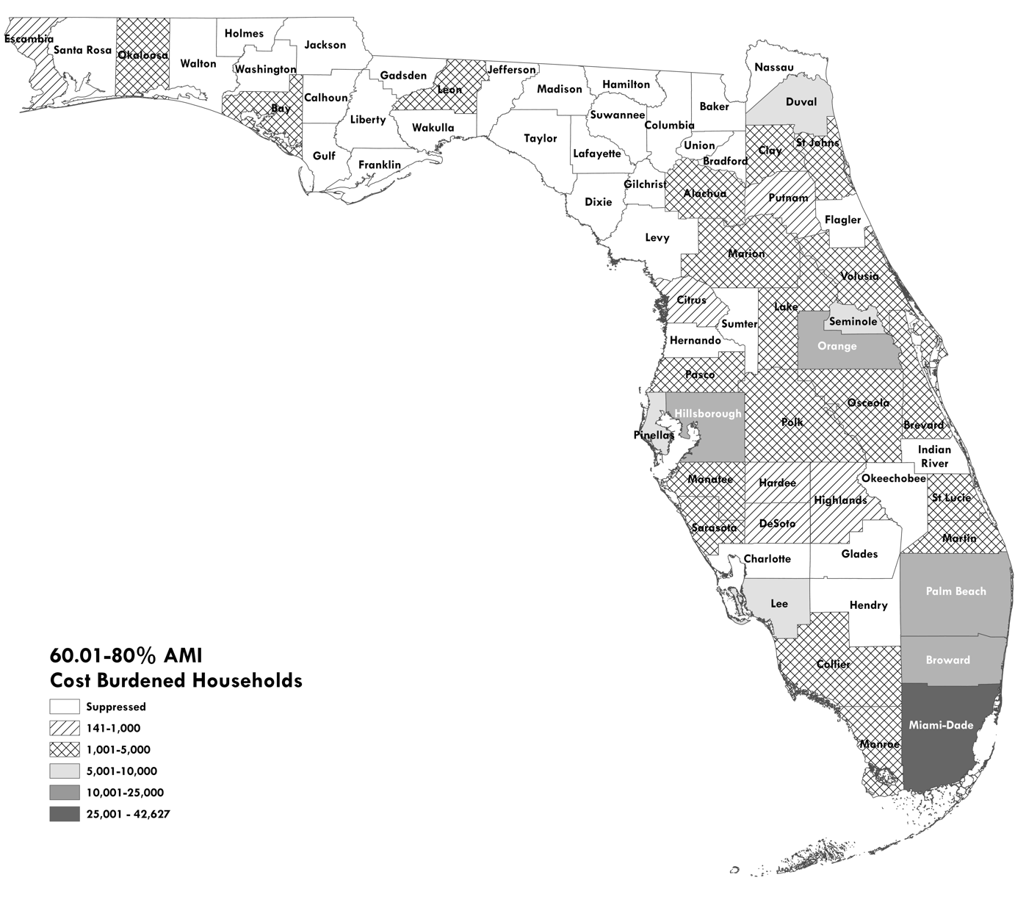
Figure 3.3. 60.01-80% AMI, Cost Burdened (>40%) Renter Households by County in Florida, 2025
Notes: Counties with “suppressed” counts have estimated household counts that are not statistically significantly different from zero.
Source: Shimberg Center tabulation of U.S. Census Bureau, 2023 American Community Survey; University of Florida Bureau of Economic and Business Research, 2025 Population Projections

Figure 3.4. 80.01-100% AMI, Cost Burdened (>40%) Renter Households by County in Florida, 2025
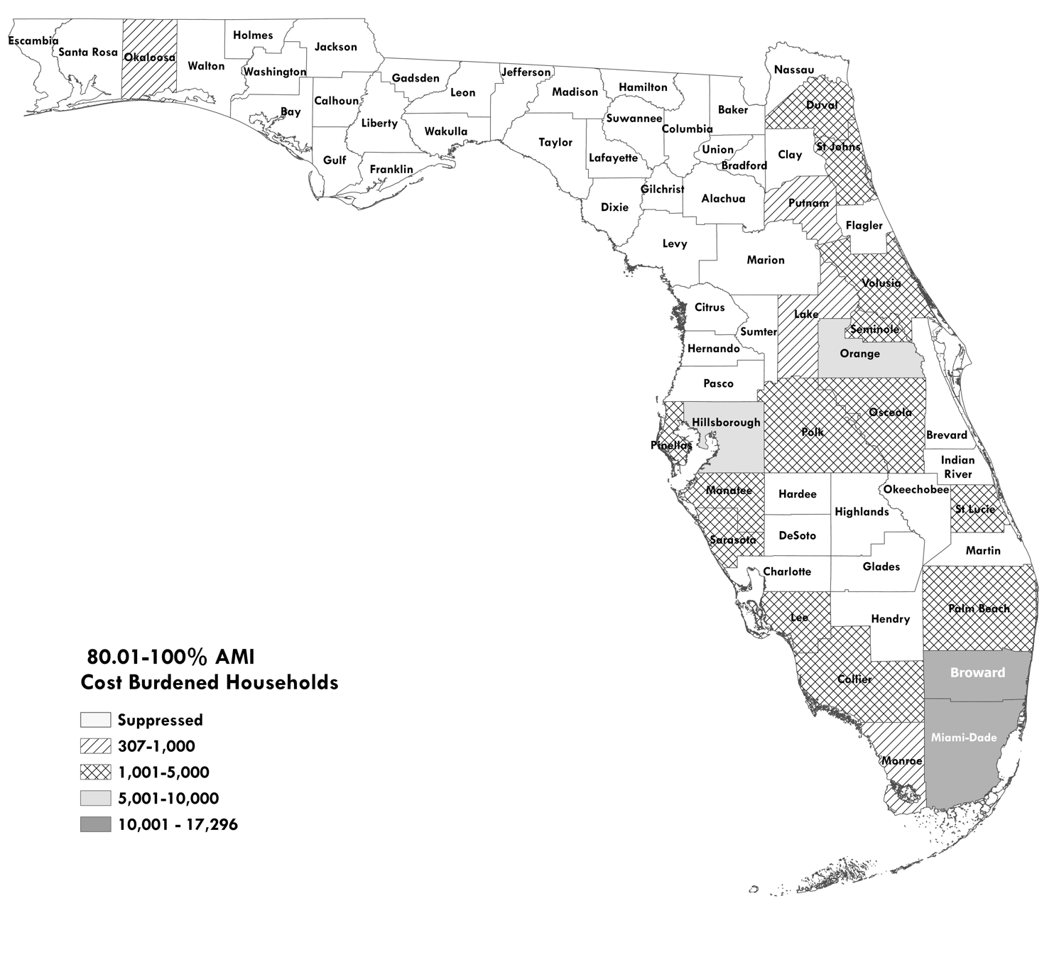 Notes: Counties with “suppressed” counts have estimated household counts that are not statistically significantly different from zero.
Source: Shimberg Center tabulation of U.S. Census Bureau, 2023 American Community Survey; University of Florida Bureau of Economic and Business Research, 2025 Population Projections

Figure 3.5. 100.01-120% AMI, Cost Burdened (>40%) Renter Households by County in Florida, 2025
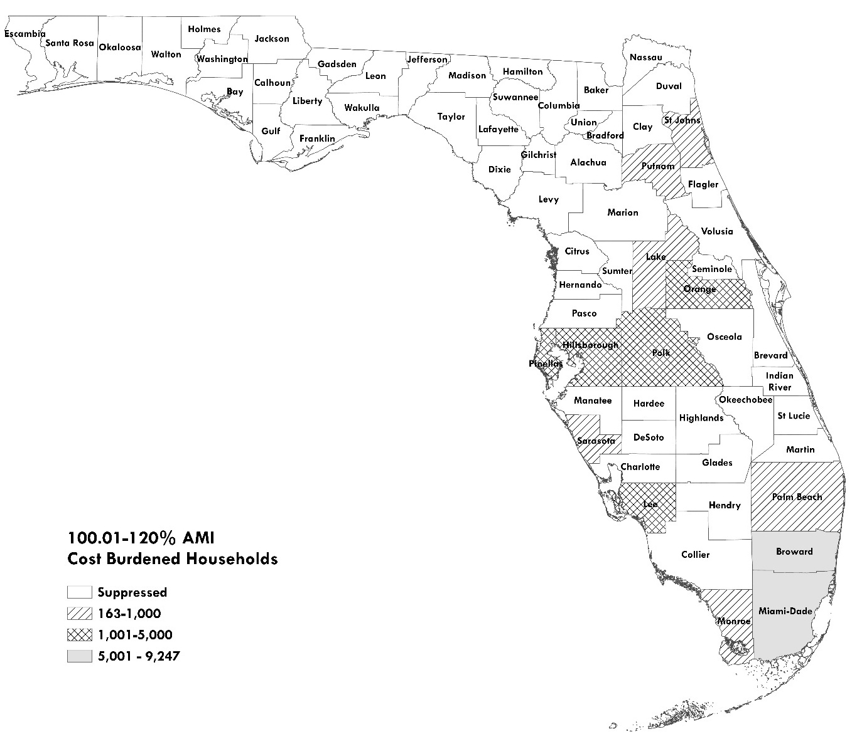 Notes: Counties with “suppressed” counts have estimated household counts that are not statistically significantly different from zero.
Source: Shimberg Center tabulation of U.S. Census Bureau, 2023 American Community Survey; University of Florida Bureau of Economic and Business Research, 2025 Population Projections

Notes on Methodology: 2025 Household Estimates
All household estimates in Chapter 3 are based on 2023 American Community Survey (ACS) data. Three steps are required to create the county-level household estimates for cost burden, income and size and the regional estimates for households by age:
- Produce a 2025 estimate of households by tenure using 2025 county population by age estimates and 2023 place-level population estimates from University of Florida Bureau of Economic and Business Research and methods from the Shimberg Center’s Affordable Housing Needs Assessment.
- Construct complex cross-tabulations of household characteristics at appropriate levels of geography from the 2023 ACS. These include households by tenure, cost burden, income, household size, and student-headed status at the county level, and households by these variables plus age of householder for the Small/Medium/Large county size categories and modified versions of the Department of Elder Affairs’ multi-county Planning and Service Areas.
- Combine the 2025 estimate of households by tenure from step (1) with the 2023 ACS cross-tabulations.
A limitation of the PUMS dataset is its geographic coding scheme, which is based on Census-defined Public Use Microdata Areas (PUMAs) with population of 100,000 or more. Some PUMAs contain several less populous counties, while more populous counties contain numerous PUMAs. To create county-level estimates for the more populous counties, we aggregated PUMAs contained in a single county together. To create county-level estimates for the smaller counties that are grouped together in a single PUMA, we used basic household by tenure estimates that are available at the county level and extrapolated detailed household characteristics from the PUMA-level analysis.

Affordable and Available Rental Units
This analysis compares the number of renter households at various income levels to the supply of units that are affordable and available to them. An affordable and available unit at a particular income threshold is: 1) affordable at that income threshold and 2) either vacant or occupied by a household with an income at or below the threshold.
For the affordable/available analysis, a unit is defined as “affordable” if it costs no more than 30 percent of income at the top of the income threshold, adjusted for unit size. This is a different affordability threshold than is used to define a “cost burdened” household in the geographic and demographic needs analyses elsewhere in the report. For those sections, a cost burdened household is one that pays more than 40 percent of income for housing. See “Why Use a 30 Percent Affordability Threshold?” below for the rationale for using different thresholds.
Data come from the 2023 American Community Survey (ACS) Public Use Microdata Sample (PUMS). Information is provided at the state and regional level. For metropolitan counties, regions are made up of single or multiple counties and are drawn to match Metropolitan Statistical Areas (MSAs) and HUD Metro Fair Market Rent Areas (HMFAs) as closely as ACS microdata areas allow. Nonmetropolitan counties are grouped into Northwest, Northeast, and South Florida areas.
Student-headed, nonfamily households and units are removed from the data. A small number of substandard units are also removed from the unit counts.

Affordable/Available Definition
An “affordable” unit is any market rate, subsidized, or public housing unit for which a household at a given income limit, expressed as a percentage of AMI, would pay no more than 30 percent of income for gross rent. Units include apartments, condominiums for rent, and single family homes for rent. Gross rent includes rent to the landlord plus utility costs.
However, many “affordable” units are effectively unavailable to low-income households because they are already occupied by higher income households. The affordable/available analysis accounts for this difference by removing units that are occupied by higher income households from unit counts. In the analysis that follows, we compare affordable/available housing supply to renter households for eight income groups: 0-30, 0-40, 0-50, 0-60, 0-80, 0-100, 0-120, and 0-140 percent of AMI. Each category is inclusive of those that come before it. For example, all households and units in the 0-30 percent of AMI group also appear in all of the other groups.

Why Use a 30 Percent Affordability Threshold?
The reasoning behind the different affordability thresholds for affordable/available (30 percent of income) and cost burden (40 percent) is as follows:
Affordable housing programs set maximum gross rents at 30 percent of the top income limit. For example, for Florida Housing-financed units with 60 percent of AMI affordability restrictions, maximum gross rents are set at 30 percent of the monthly income of a household at the 60 percent of AMI level in that region. The rent limits are adjusted by the number of bedrooms.
In the affordable/available analysis, we define an “affordable” unit the same way: a unit costing no more than 30 percent of income at the top of the allowable income range. For most regions, these limits are similar to the rent limits for Florida Housing’s multifamily programs. The limits are slightly different because of differences in data sources and methods.
If we continued to use the 40 percent affordability threshold, then hundreds of thousands of units in the state would be counted as “affordable” that in fact have rents above Florida Housing’s rent limits. For example, using the 30 percent affordability threshold and 2023 American Community Survey data, we set the two-bedroom/60 percent of AMI affordable rent in the Orlando metropolitan area at $1,225 per month. This is similar to Florida Housing’s 2023 two-bedroom/60 percent of AMI rent limit of $1,186 per month. If we had used the 40 percent affordability threshold, two-bedroom units with rents up to $1,633 would have been considered affordable at 60 percent of AMI, well above allowable rent limits for LIHTC and other Florida Housing programs.
For identifying cost burdened households, the rationale is different. Most households living in Florida Housing’s affordable housing units have incomes below the top income limits for their units. If the tenants do not also receive rental assistance through a voucher or project-based rental assistance, they may pay more than 30 percent of income for rent. For example, a household with income at 50 percent of AMI may live in a unit restricted to 60 percent of AMI or less. That household would pay more than 30 percent of income for rent if the development charged the maximum allowable rent. Forty percent of income is a more realistic threshold for cost burden for most low income households living in affordable housing units.

Statewide Affordable/Available Units
Figure 4.1 below shows the distinction between affordable units and affordable/available units. All units in each column have rents that do not exceed 30 percent of income for a household at the top of the income group. However, the units in the darker shaded areas are occupied by households with incomes above the top threshold and therefore are not available to the households in that income category.

Figure 4.1. Number of Affordable Units, Affordable/Available Units, and Renter Households by Income, Florida, 2023

Source: Shimberg Center tabulation of U.S. Census Bureau, 2023 American Community Survey
Figure 4.1 shows that for the 0-30 through 0-80 percent of AMI levels, there are more renter households than affordable units, whether available or not. At 100 percent of AMI, there are more affordable units than renter households, but still a shortage of affordable and available units, since over 470,000 affordable units are rented by households with incomes above 100 percent of AMI. The gap narrows significantly at the 0-120 percent of AMI level. Finally, at 0-140 percent of AMI, the number of affordable and available units slightly exceeds the number of renter households.

Measures of Affordable and Available Units
Once we have calculated the supply of affordable/available units and the demand from renter households for each income category, we compare supply and demand using two measurements:
- Absolute difference between affordable and available units and renter households. This equals the number of units that are affordable and available at a particular income level minus the number of households at or below that income level. A negative number indicates a shortfall of affordable/available units at the income level; a positive number indicates that the supply exceeds the number of renter households.
- Affordable and available units per 100 renter households at a particular income threshold. This relative measure allows us to assess affordable housing needs in less populated areas where the absolute need for units may be small because the number of low-income renter households is smaller. A value of 100 means that the region has one affordable and available housing unit for every household at or below the given income threshold. A value below 100 means that the number of renter households exceeds the number of affordable/available units, while a value above 100 indicates that supply exceeds the number of households.

Results of Affordable and Available Housing Analysis by Region
Tables 4.1 and 4.2 on the following pages show regional results for the two measures of affordable/available units for each income band. See also Tables 4.3-4.10 at the end of this chapter, which show more detailed data for each income range on the numbers of renter households, total affordable units, affordable/available units, and affordable units occupied by higher income households.
Figures 4.2-4.9 are regional maps of affordable and available units per 100 households for income thresholds up to 140 percent of AMI. The darker areas on the maps indicate places where there are fewer than 100 affordable and available units per 100 households. The cross-hatched areas have at least 100 affordable and available units per 100 households in the given income category.

Table 4.1. Difference Between Affordable and Available Rental Housing Units and Renter Households by Income, Florida Regions, 2023
Modified Metropolitan Statistical Area (MSA)/HUD Metro Fair Market Rent Area (HMFA) | Counties | Affordable/Available Units Minus Renter Households
 | Counties | 0-30% AMI | 0-40% AMI | 0-50% AMI | 0-60% AMI | 0-80% AMI | 0-100% AMI | 0-120% AMI | 0-140% AMI
Cape Coral-Fort Myers, FL MSA | Lee | -10,362 | -13,886 | -18,311 | -20,335 | -17,333 | -8,689 | -352 | 2,497
Deltona-Daytona Beach-Ormond Beach, FL HMFA | Volusia | -8,523 | -10,609 | -12,009 | -13,251 | -10,566 | -2,255 | 1,917 | 2,462
Crestview-Fort Walton Beach-Destin, FL HMFA | Okaloosa | -4,513 | -4,421 | -5,019 | -5,559 | -4,176 | -1,612 | 590 | 1,182
Fort Lauderdale, FL HMFA | Broward | -40,187 | -50,266 | -68,112 | -82,200 | -84,345 | -64,306 | -37,884 | -14,228
Gainesville, FL HMFA (minus Gilchrist) | Alachua | -7,896 | -7,791 | -10,683 | -5,440 | -471 | 2,099 | 2,576 | 2,550
Homosassa Springs, FL MSA | Citrus | -1,975 | -2,714 | -3,578 | -3,715 | -2,425 | -1,147 | -284 | 47
Jacksonville, FL HMFA/Baker County, FL HMFA (plus Putnam) | Baker, Clay, Duval, Nassau, Putnam, St. Johns | -33,555 | -42,526 | -48,760 | -47,290 | -22,307 | 146 | 8,210 | 8,978
Lakeland-Winter Haven, FL MSA | Polk | -10,600 | -11,227 | -14,412 | -12,526 | -11,681 | -7,726 | -2,636 | 442
Miami-Miami Beach-Kendall, FL HMFA (plus Monroe) | Miami-Dade, Monroe | -58,509 | -79,672 | -100,810 | -119,801 | -143,805 | -116,979 | -78,510 | -44,378
Naples-Immokalee-Marco Island, FL MSA | Collier | -5,489 | -6,634 | -8,554 | -8,566 | -7,432 | -3,715 | -1,183 | -263
Northeast Nonmetropolitan Area (plus Gilchrist and Levy) | Bradford, Columbia, Dixie, Gilchrist, Hamilton, Lafayette, Levy, Madison, Suwannee, Taylor, Union | -2,637 | -3,212 | -2,653 | -2,483 | -1,065 | 217 | 307 | 495
Northwest Nonmetropolitan Area (plus Gadsden, Jefferson, Wakulla, and Walton) | Calhoun, Franklin, Gadsden, Gulf, Holmes, Jackson, Jefferson, Liberty, Wakulla, Walton, Washington | -4,103 | -3,595 | -3,143 | -2,949 | -1,493 | -1,284 | -678 | 745
Ocala, FL MSA | Marion | -5,773 | -6,917 | -5,826 | -7,590 | -6,929 | -2,912 | -221 | 697
Orlando-Kissimmee-Sanford, FL MSA | Lake, Orange, Osceola, Seminole | -50,796 | -70,248 | -91,670 | -97,707 | -85,074 | -44,606 | 5,274 | 17,264
Palm Bay-Melbourne-Titusville, FL MSA | Brevard | -8,232 | -11,716 | -14,116 | -13,643 | -3,756 | 4,095 | 6,913 | 7,085
Palm Coast, FL HMFA | Flagler | -1,127 | -1,619 | -2,638 | -3,038 | -2,133 | -685 | -761 | 148
Panama City-Lynn Haven, FL MSA | Bay | -3,344 | -4,370 | -4,445 | -2,381 | -1,574 | 1,037 | 2,428 | 2,802
Pensacola-Ferry Pass-Brent, FL MSA | Escambia, Santa Rosa | -5,947 | -6,918 | -7,556 | -5,957 | -1,928 | 1,685 | 1,914 | 2,078
Port St. Lucie, FL MSA | Martin, St. Lucie | -5,581 | -9,172 | -11,708 | -12,491 | -10,136 | -7,257 | -3,440 | -623
Punta Gorda, FL MSA | Charlotte | -1,951 | -3,192 | -3,481 | -3,340 | -1,997 | -824 | -239 | 865
North Port-Sarasota-Bradenton, FL MSA | Manatee, Sarasota | -11,302 | -14,560 | -19,907 | -20,916 | -19,776 | -9,084 | -2,801 | 223
Sebastian-Vero Beach, FL MSA | Indian River | -2,128 | -2,846 | -2,562 | -2,523 | -1,109 | -443 | -66 | -315
South Nonmetropolitan Area (minus Monroe, plus Highlands) | DeSoto, Glades, Hardee, Hendry, Highlands, Okeechobee | -3,002 | -4,161 | -4,935 | -3,848 | -1,582 | -1,409 | -677 | 682
Tallahassee, FL HMFA (minus Gadsden and Jefferson) | Leon | -6,761 | -9,591 | -10,489 | -6,065 | -584 | 1,773 | 2,738 | 3,259
Tampa-St. Petersburg-Clearwater, FL MSA | Hernando, Hillsborough, Pasco, Pinellas | -56,633 | -71,137 | -89,352 | -91,197 | -70,247 | -33,592 | 4,873 | 15,556
The Villages, FL MSA | Sumter | -1,497 | -1,076 | -1,920 | -2,660 | -1,056 | 229 | 537 | 438
West Palm Beach-Boca Raton, FL HMFA | Palm Beach | -25,598 | -35,101 | -43,487 | -43,270 | -37,699 | -20,512 | -6,864 | 2,814
State of Florida Total |  | -378,021 | -489,177 | -610,136 | -640,741 | -552,679 | -317,756 | -98,319 | 13,502
Source: Shimberg Center tabulation of U.S. Census Bureau, 2023 American Community Survey

Table 4.2. Affordable and Available Rental Units per 100 Renters, Florida Regions, 2023
Modified Metropolitan Statistical Area (MSA)/HUD Metro Fair Market Rent Area (HMFA) | Counties | Affordable & Available Units per 100 Renter Households
 | Counties | 0-30% AMI | 0-40% AMI | 0-50% AMI | 0-60% AMI | 0-80% AMI | 0-100% AMI | 0-120% AMI | 0-140% AMI
Cape Coral-Fort Myers, FL MSA | Lee | 24 | 25 | 24 | 31 | 57 | 83 | 99 | 104
Deltona-Daytona Beach-Ormond Beach, FL HMFA | Volusia | 27 | 33 | 37 | 46 | 68 | 94 | 104 | 105
Crestview-Fort Walton Beach-Destin, FL HMFA | Okaloosa | 22 | 33 | 38 | 43 | 68 | 90 | 103 | 105
Fort Lauderdale, FL HMFA | Broward | 17 | 21 | 20 | 22 | 40 | 62 | 81 | 93
Gainesville, FL HMFA (minus Gilchrist) | Alachua | 22 | 40 | 43 | 74 | 98 | 107 | 108 | 107
Homosassa Springs, FL MSA | Citrus | 26 | 27 | 27 | 39 | 70 | 88 | 97 | 100
Jacksonville, FL HMFA/Baker County, FL HMFA (plus Putnam) | Baker, Clay, Duval, Nassau, Putnam, St. Johns | 29 | 35 | 41 | 54 | 83 | 100 | 105 | 105
Lakeland-Winter Haven, FL MSA | Polk | 20 | 38 | 44 | 61 | 74 | 86 | 96 | 101
Miami-Miami Beach-Kendall, FL HMFA (plus Monroe) | Miami-Dade, Monroe | 29 | 29 | 29 | 30 | 37 | 58 | 75 | 87
Naples-Immokalee-Marco Island, FL MSA | Collier | 26 | 39 | 40 | 51 | 66 | 86 | 96 | 99
Northeast Nonmetropolitan Area (plus Gilchrist and Levy) | Bradford, Columbia, Dixie, Gilchrist, Hamilton, Lafayette, Levy, Madison, Suwannee, Taylor, Union | 36 | 52 | 68 | 78 | 92 | 101 | 102 | 103
Northwest Nonmetropolitan Area (plus Gadsden, Jefferson, Wakulla, and Walton) | Calhoun, Franklin, Gadsden, Gulf, Holmes, Jackson, Jefferson, Liberty, Wakulla, Walton, Washington | 45 | 61 | 71 | 79 | 92 | 94 | 97 | 103
Ocala, FL MSA | Marion | 7 | 14 | 42 | 42 | 63 | 87 | 99 | 102
Orlando-Kissimmee-Sanford, FL MSA | Lake, Orange, Osceola, Seminole | 13 | 20 | 24 | 35 | 57 | 82 | 102 | 106
Palm Bay-Melbourne-Titusville, FL MSA | Brevard | 22 | 28 | 36 | 50 | 89 | 110 | 115 | 115
Palm Coast, FL HMFA | Flagler | 33 | 39 | 29 | 28 | 59 | 88 | 89 | 102
Panama City-Lynn Haven, FL MSA | Bay | 25 | 26 | 43 | 75 | 88 | 107 | 113 | 113
Pensacola-Ferry Pass-Brent, FL MSA | Escambia, Santa Rosa | 40 | 47 | 59 | 73 | 93 | 105 | 105 | 105
Port St. Lucie, FL MSA | Martin, St. Lucie | 26 | 27 | 26 | 37 | 60 | 78 | 90 | 98
Punta Gorda, FL MSA | Charlotte | 24 | 18 | 31 | 44 | 76 | 91 | 98 | 107
North Port-Sarasota-Bradenton, FL MSA | Manatee, Sarasota | 27 | 32 | 34 | 44 | 62 | 86 | 96 | 100
Sebastian-Vero Beach, FL MSA | Indian River | 29 | 28 | 44 | 55 | 85 | 95 | 99 | 97
South Nonmetropolitan Area (minus Monroe, plus Highlands) | DeSoto, Glades, Hardee, Hendry, Highlands, Okeechobee | 26 | 36 | 42 | 60 | 88 | 91 | 97 | 103
Tallahassee, FL HMFA (minus Gadsden and Jefferson) | Leon | 28 | 31 | 47 | 73 | 98 | 105 | 107 | 108
Tampa-St. Petersburg-Clearwater, FL MSA | Hernando, Hillsborough, Pasco, Pinellas | 25 | 29 | 33 | 44 | 68 | 88 | 102 | 105
The Villages, FL MSA | Sumter | 26 | 62 | 56 | 49 | 83 | 103 | 107 | 105
West Palm Beach-Boca Raton, FL HMFA | Palm Beach | 16 | 20 | 26 | 39 | 59 | 82 | 95 | 102
State of Florida Total |  | 24 | 29 | 33 | 42 | 62 | 82 | 95 | 101
Source: Shimberg Center tabulation of U.S. Census Bureau, 2023 American Community Survey

Figure 4.2. Affordable and Available Housing Units per 100 Renter Households at 0-30% AMI, Modified MSA/HMFA and Non-Metropolitan Areas, 2023
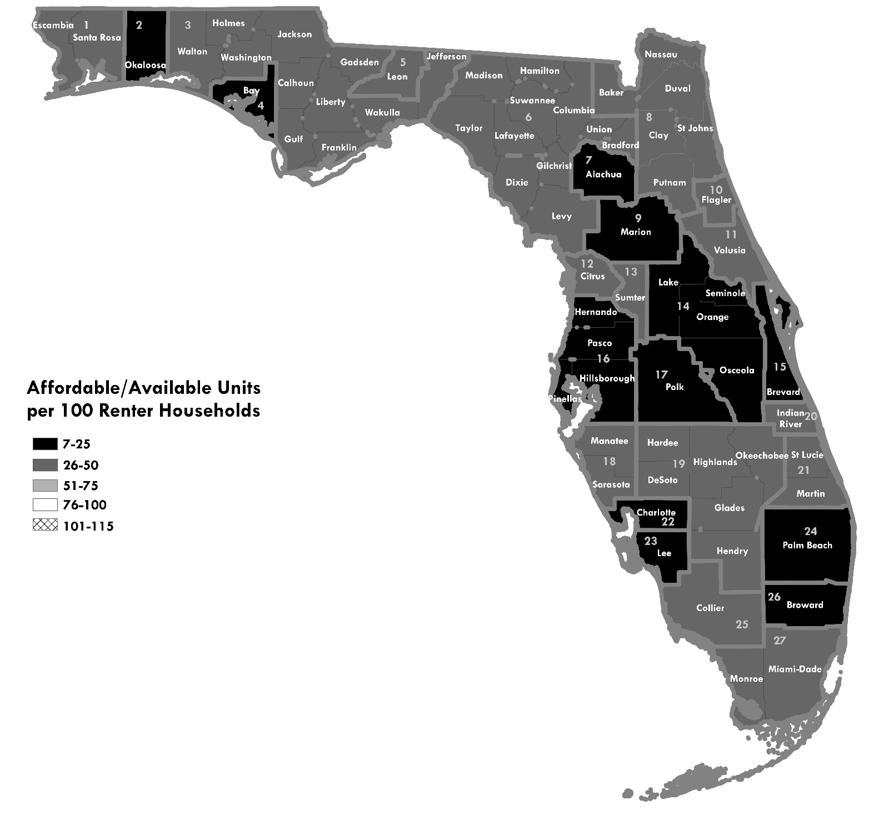
Notes: The map shades show the number of available and affordable units in the income category divided by the number of households in the same category, times 100. A value below 100 indicates a shortage of housing units (shaded areas); a value above 100 indicates that units exceed households (striped and cross-hatched areas). The areas on the map are groups of counties that belong either to modified metropolitan statistical areas (MSAs) or non-metropolitan areas.
Source: Shimberg Center tabulation of U.S. Census Bureau, 2023 American Community Survey
Region Modified MSA/HMFA
1 Pensacola-Ferry Pass-Brent, FL MSA
2 Crestview-Fort Walton Beach-Destin, FL HMFA
3 Northwest Nonmetropolitan Area (plus Gadsden, Jefferson, Wakulla, and Walton)
4 Panama City-Lynn Haven, FL MSA
5 Tallahassee, FL HMFA (minus Gadsden and Jefferson)
6 Northeast Nonmetropolitan Area (plus Gilchrist and Levy)
7 Gainesville, FL HMFA (minus Gilchrist)
8 Jacksonville, FL HMFA/Baker County, FL HMFA (plus Putnam)
9 Ocala, FL MSA
10 Palm Coast, FL HMFA
11 Deltona-Daytona Beach-Ormond Beach, FL HMFA
12 Homosassa Springs, FL MSA
13 The Villages, FL MSA
14 Orlando-Kissimmee-Sanford, FL MSA
15 Palm Bay-Melbourne-Titusville, FL MSA
16 Tampa-St. Petersburg-Clearwater, FL MSA
17 Lakeland-Winter Haven, FL MSA
18 North Port-Sarasota-Bradenton, FL MSA
19 South Nonmetropolitan Area (minus Monroe, plus Highlands)
20 Sebastian-Vero Beach, FL MSA
21 Port St. Lucie, FL MSA
22 Punta Gorda, FL MSA
23 Cape Coral-Fort Myers, FL MSA
24 West Palm Beach-Boca Raton, FL HMFA
25 Naples-Immokalee-Marco Island, FL MSA
26 Fort Lauderdale, FL HMFA
27 Miami-Miami Beach-Kendall, FL HMFA (plus Monroe)

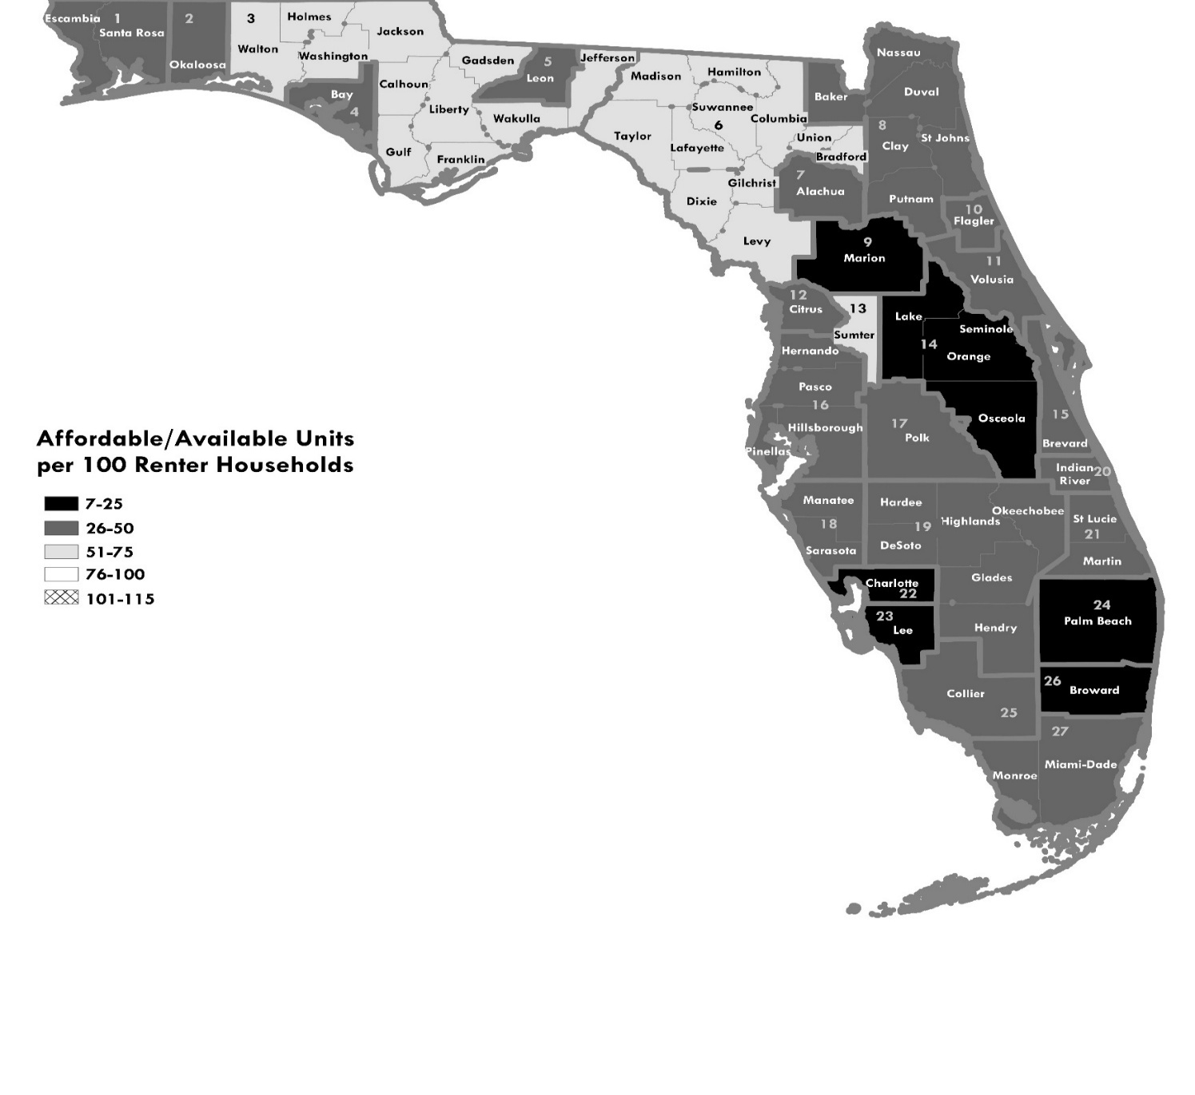
Figure 4.3. Affordable and Available Housing Units per 100 Renter Households at 0-40% AMI, Modified MSA/HMFA and Non-Metropolitan Areas, 2023
Region Modified MSA/HMFA
1 Pensacola-Ferry Pass-Brent, FL MSA
2 Crestview-Fort Walton Beach-Destin, FL HMFA
3 Northwest Nonmetropolitan Area (plus Gadsden, Jefferson, Wakulla, and Walton)
4 Panama City-Lynn Haven, FL MSA
5 Tallahassee, FL HMFA (minus Gadsden and Jefferson)
6 Northeast Nonmetropolitan Area (plus Gilchrist and Levy)
7 Gainesville, FL HMFA (minus Gilchrist)
8 Jacksonville, FL HMFA/Baker County, FL HMFA (plus Putnam)
9 Ocala, FL MSA
10 Palm Coast, FL HMFA
11 Deltona-Daytona Beach-Ormond Beach, FL HMFA
12 Homosassa Springs, FL MSA
13 The Villages, FL MSA
14 Orlando-Kissimmee-Sanford, FL MSA
15 Palm Bay-Melbourne-Titusville, FL MSA
16 Tampa-St. Petersburg-Clearwater, FL MSA
17 Lakeland-Winter Haven, FL MSA
18 North Port-Sarasota-Bradenton, FL MSA
19 South Nonmetropolitan Area (minus Monroe, plus Highlands)
20 Sebastian-Vero Beach, FL MSA
21 Port St. Lucie, FL MSA
22 Punta Gorda, FL MSA
23 Cape Coral-Fort Myers, FL MSA
24 West Palm Beach-Boca Raton, FL HMFA
25 Naples-Immokalee-Marco Island, FL MSA
26 Fort Lauderdale, FL HMFA
27 Miami-Miami Beach-Kendall, FL HMFA (plus Monroe)

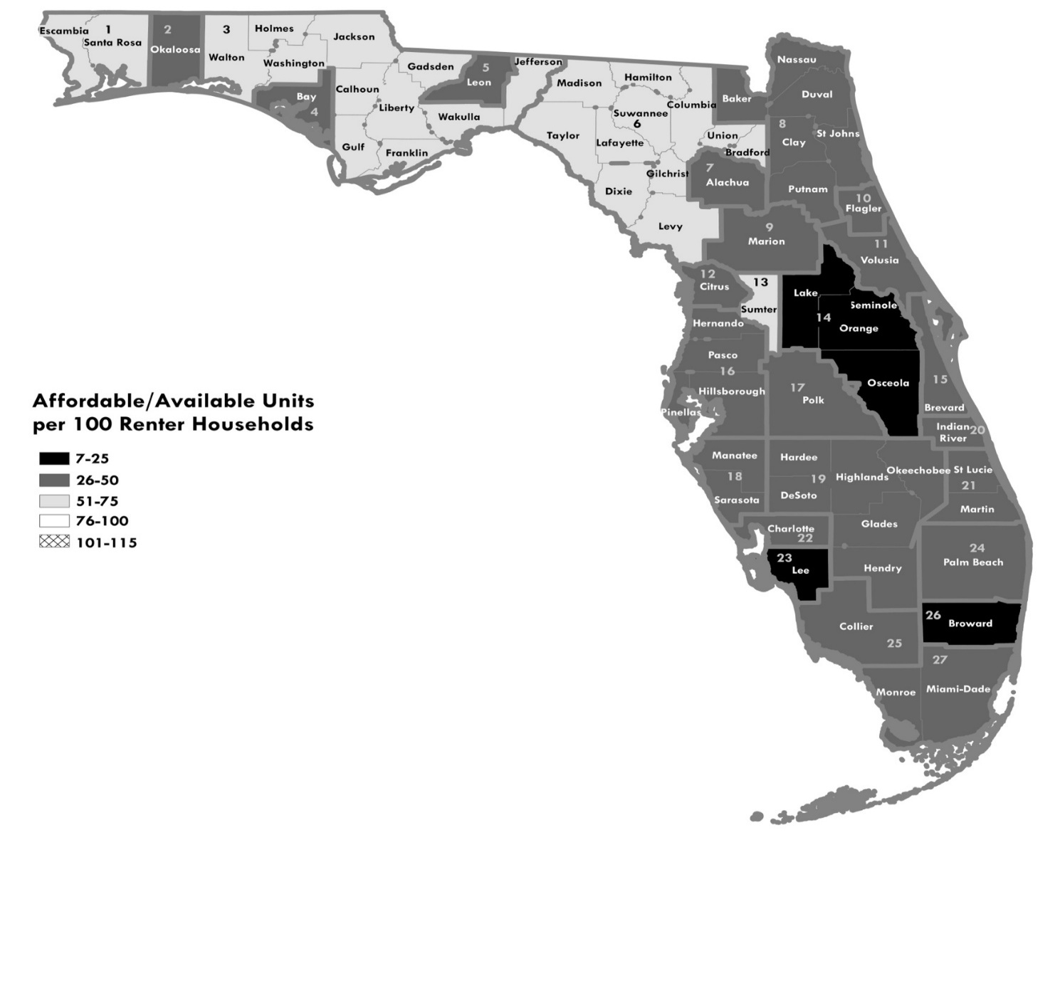
Figure 4.4. Affordable and Available Housing Units per 100 Renter Households at 0-50% AMI, Modified MSA/HMFA and Non-Metropolitan Areas, 2023 Estimate
Region Modified MSA/HMFA
1 Pensacola-Ferry Pass-Brent, FL MSA
2 Crestview-Fort Walton Beach-Destin, FL HMFA
3 Northwest Nonmetropolitan Area (plus Gadsden, Jefferson, Wakulla, and Walton)
4 Panama City-Lynn Haven, FL MSA
5 Tallahassee, FL HMFA (minus Gadsden and Jefferson)
6 Northeast Nonmetropolitan Area (plus Gilchrist and Levy)
7 Gainesville, FL HMFA (minus Gilchrist)
8 Jacksonville, FL HMFA/Baker County, FL HMFA (plus Putnam)
9 Ocala, FL MSA
10 Palm Coast, FL HMFA
11 Deltona-Daytona Beach-Ormond Beach, FL HMFA
12 Homosassa Springs, FL MSA
13 The Villages, FL MSA
14 Orlando-Kissimmee-Sanford, FL MSA
15 Palm Bay-Melbourne-Titusville, FL MSA
16 Tampa-St. Petersburg-Clearwater, FL MSA
17 Lakeland-Winter Haven, FL MSA
18 North Port-Sarasota-Bradenton, FL MSA
19 South Nonmetropolitan Area (minus Monroe, plus Highlands)
20 Sebastian-Vero Beach, FL MSA
21 Port St. Lucie, FL MSA
22 Punta Gorda, FL MSA
23 Cape Coral-Fort Myers, FL MSA
24 West Palm Beach-Boca Raton, FL HMFA
25 Naples-Immokalee-Marco Island, FL MSA
26 Fort Lauderdale, FL HMFA
27 Miami-Miami Beach-Kendall, FL HMFA (plus Monroe)

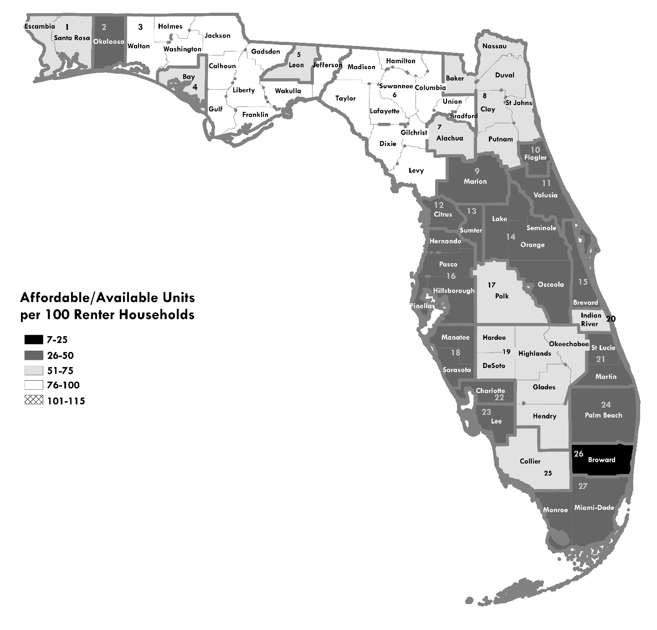
Figure 4.5. Affordable and Available Housing Units per 100 Renter Households at 0-60% AMI, Modified MSA/HMFA and Non-Metropolitan Areas, 2023 Estimate
Region Modified MSA/HMFA
1 Pensacola-Ferry Pass-Brent, FL MSA
2 Crestview-Fort Walton Beach-Destin, FL HMFA
3 Northwest Nonmetropolitan Area (plus Gadsden, Jefferson, Wakulla, and Walton)
4 Panama City-Lynn Haven, FL MSA
5 Tallahassee, FL HMFA (minus Gadsden and Jefferson)
6 Northeast Nonmetropolitan Area (plus Gilchrist and Levy)
7 Gainesville, FL HMFA (minus Gilchrist)
8 Jacksonville, FL HMFA/Baker County, FL HMFA (plus Putnam)
9 Ocala, FL MSA
10 Palm Coast, FL HMFA
11 Deltona-Daytona Beach-Ormond Beach, FL HMFA
12 Homosassa Springs, FL MSA
13 The Villages, FL MSA
14 Orlando-Kissimmee-Sanford, FL MSA
15 Palm Bay-Melbourne-Titusville, FL MSA
16 Tampa-St. Petersburg-Clearwater, FL MSA
17 Lakeland-Winter Haven, FL MSA
18 North Port-Sarasota-Bradenton, FL MSA
19 South Nonmetropolitan Area (minus Monroe, plus Highlands)
20 Sebastian-Vero Beach, FL MSA
21 Port St. Lucie, FL MSA
22 Punta Gorda, FL MSA
23 Cape Coral-Fort Myers, FL MSA
24 West Palm Beach-Boca Raton, FL HMFA
25 Naples-Immokalee-Marco Island, FL MSA
26 Fort Lauderdale, FL HMFA
27 Miami-Miami Beach-Kendall, FL HMFA (plus Monroe)

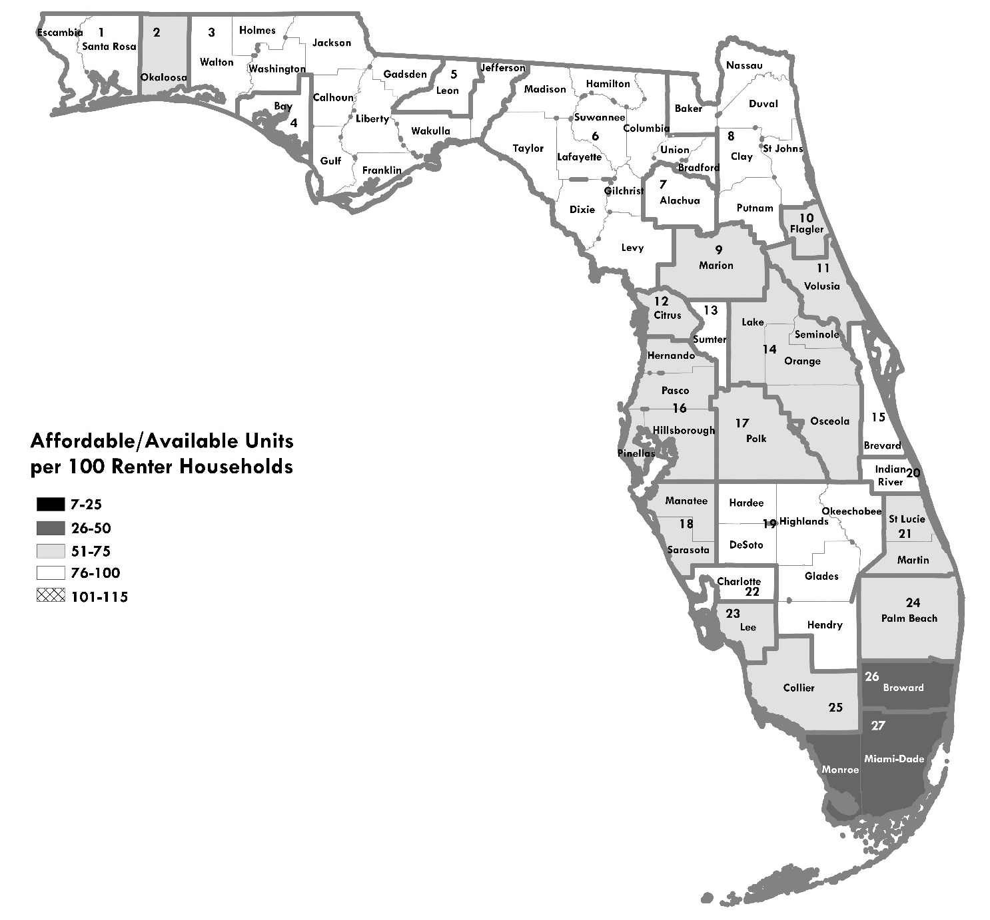
Figure 4.6. Affordable and Available Housing Units per 100 Renter Households at 0-80% AMI, Modified MSA/HMFA and Non-Metropolitan Areas, 2023 Estimate
Region Modified MSA/HMFA
1 Pensacola-Ferry Pass-Brent, FL MSA
2 Crestview-Fort Walton Beach-Destin, FL HMFA
3 Northwest Nonmetropolitan Area (plus Gadsden, Jefferson, Wakulla, and Walton)
4 Panama City-Lynn Haven, FL MSA
5 Tallahassee, FL HMFA (minus Gadsden and Jefferson)
6 Northeast Nonmetropolitan Area (plus Gilchrist and Levy)
7 Gainesville, FL HMFA (minus Gilchrist)
8 Jacksonville, FL HMFA/Baker County, FL HMFA (plus Putnam)
9 Ocala, FL MSA
10 Palm Coast, FL HMFA
11 Deltona-Daytona Beach-Ormond Beach, FL HMFA
12 Homosassa Springs, FL MSA
13 The Villages, FL MSA
14 Orlando-Kissimmee-Sanford, FL MSA
15 Palm Bay-Melbourne-Titusville, FL MSA
16 Tampa-St. Petersburg-Clearwater, FL MSA
17 Lakeland-Winter Haven, FL MSA
18 North Port-Sarasota-Bradenton, FL MSA
19 South Nonmetropolitan Area (minus Monroe, plus Highlands)
20 Sebastian-Vero Beach, FL MSA
21 Port St. Lucie, FL MSA
22 Punta Gorda, FL MSA
23 Cape Coral-Fort Myers, FL MSA
24 West Palm Beach-Boca Raton, FL HMFA
25 Naples-Immokalee-Marco Island, FL MSA
26 Fort Lauderdale, FL HMFA
27 Miami-Miami Beach-Kendall, FL HMFA (plus Monroe)c

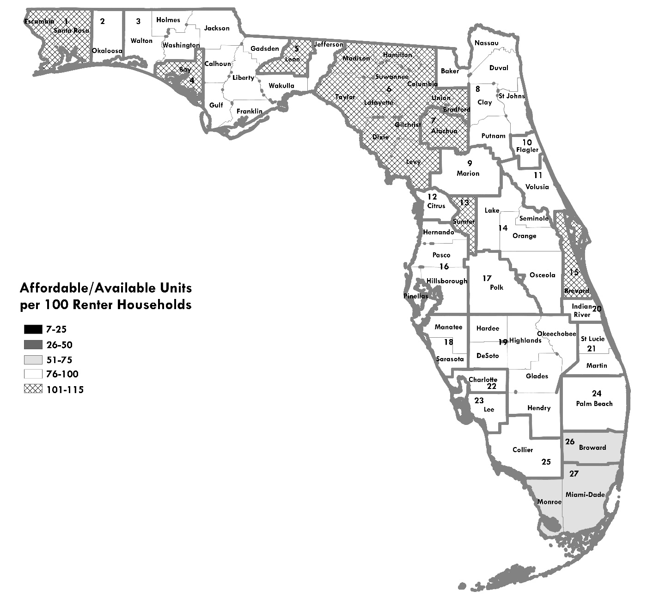
Figure 4.7. Affordable and Available Housing Units per 100 Renter Households at 0-100% AMI, Modified MSA/HMFA and Non-Metropolitan Areas, 2023 Estimate
Region Modified MSA/HMFA
1 Pensacola-Ferry Pass-Brent, FL MSA
2 Crestview-Fort Walton Beach-Destin, FL HMFA
3 Northwest Nonmetropolitan Area (plus Gadsden, Jefferson, Wakulla, and Walton)
4 Panama City-Lynn Haven, FL MSA
5 Tallahassee, FL HMFA (minus Gadsden and Jefferson)
6 Northeast Nonmetropolitan Area (plus Gilchrist and Levy)
7 Gainesville, FL HMFA (minus Gilchrist)
8 Jacksonville, FL HMFA/Baker County, FL HMFA (plus Putnam)
9 Ocala, FL MSA
10 Palm Coast, FL HMFA
11 Deltona-Daytona Beach-Ormond Beach, FL HMFA
12 Homosassa Springs, FL MSA
13 The Villages, FL MSA
14 Orlando-Kissimmee-Sanford, FL MSA
15 Palm Bay-Melbourne-Titusville, FL MSA
16 Tampa-St. Petersburg-Clearwater, FL MSA
17 Lakeland-Winter Haven, FL MSA
18 North Port-Sarasota-Bradenton, FL MSA
19 South Nonmetropolitan Area (minus Monroe, plus Highlands)
20 Sebastian-Vero Beach, FL MSA
21 Port St. Lucie, FL MSA
22 Punta Gorda, FL MSA
23 Cape Coral-Fort Myers, FL MSA
24 West Palm Beach-Boca Raton, FL HMFA
25 Naples-Immokalee-Marco Island, FL MSA
26 Fort Lauderdale, FL HMFA
27 Miami-Miami Beach-Kendall, FL HMFA (plus Monroe)

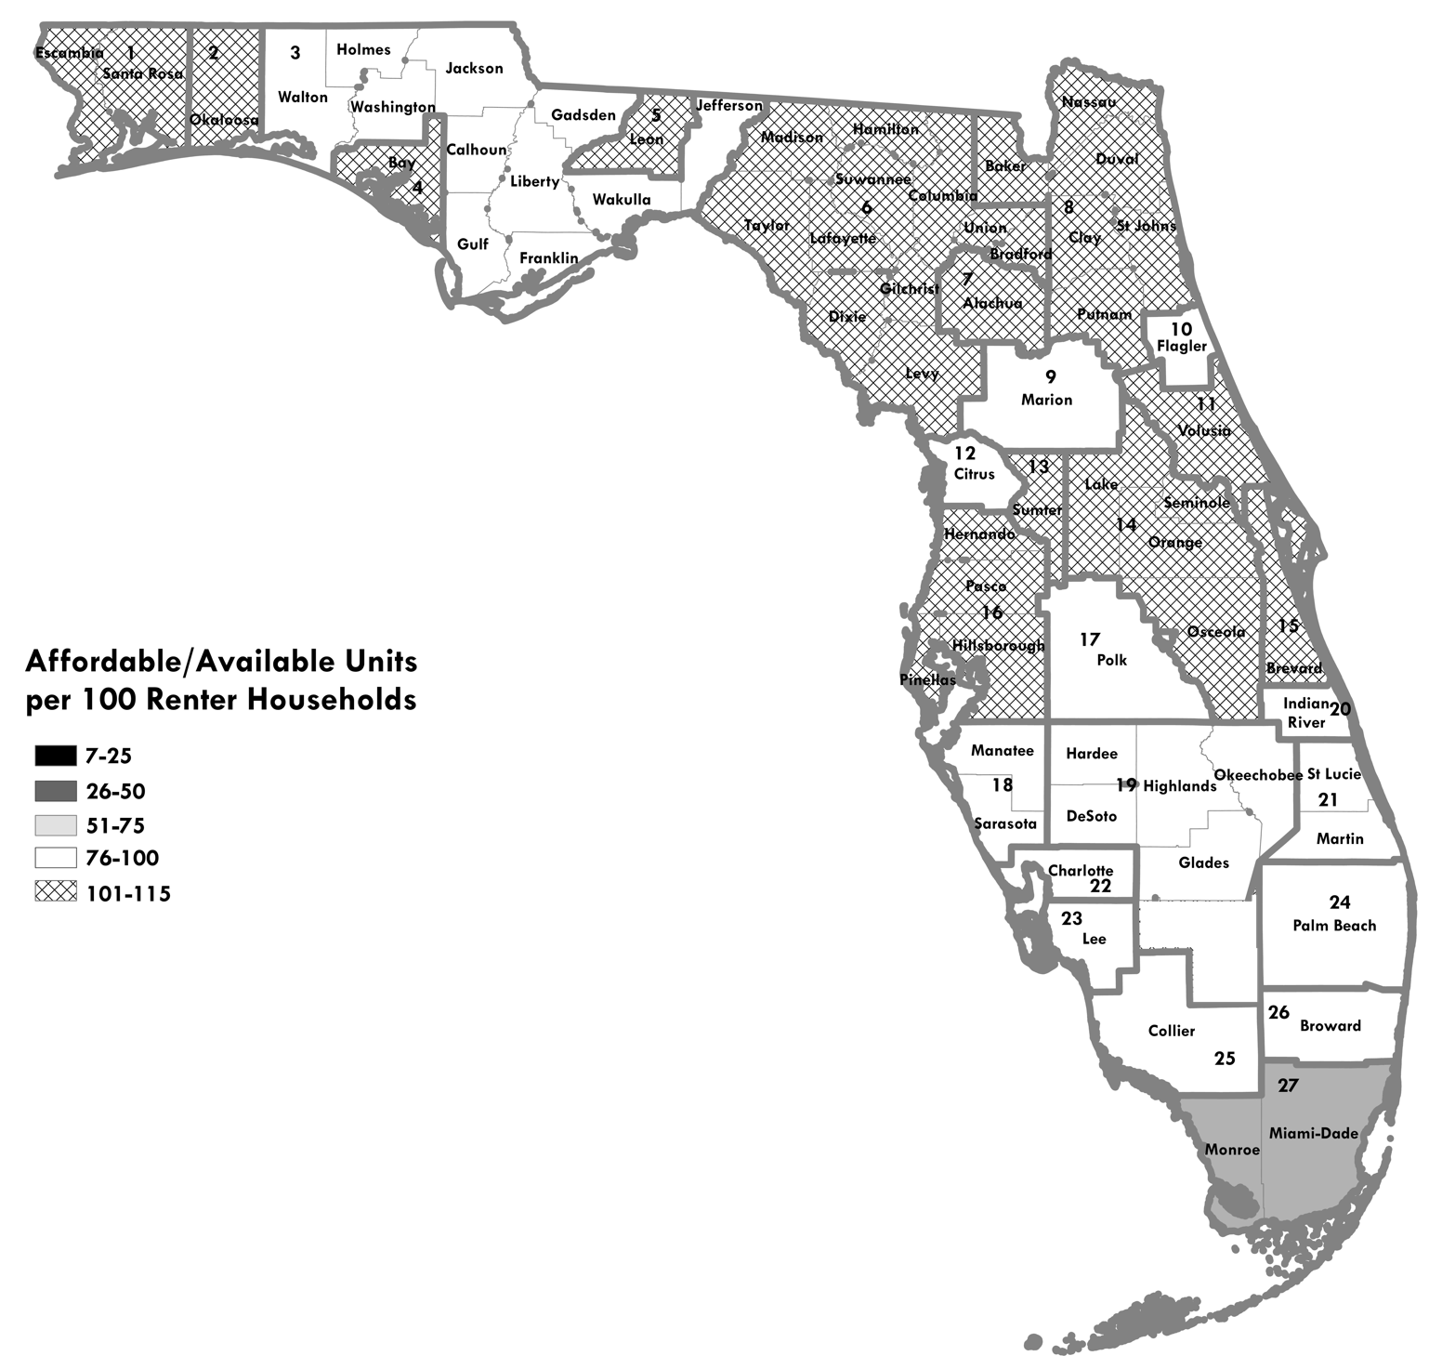
Figure 4.8. Affordable and Available Housing Units per 100 Renter Households at 0-120% AMI, Modified MSA/HMFA and Non-Metropolitan Areas, 2023 Estimate
Region Modified MSA/HMFA
1 Pensacola-Ferry Pass-Brent, FL MSA
2 Crestview-Fort Walton Beach-Destin, FL HMFA
3 Northwest Nonmetropolitan Area (plus Gadsden, Jefferson, Wakulla, and Walton)
4 Panama City-Lynn Haven, FL MSA
5 Tallahassee, FL HMFA (minus Gadsden and Jefferson)
6 Northeast Nonmetropolitan Area (plus Gilchrist and Levy)
7 Gainesville, FL HMFA (minus Gilchrist)
8 Jacksonville, FL HMFA/Baker County, FL HMFA (plus Putnam)
9 Ocala, FL MSA
10 Palm Coast, FL HMFA
11 Deltona-Daytona Beach-Ormond Beach, FL HMFA
12 Homosassa Springs, FL MSA
13 The Villages, FL MSA
14 Orlando-Kissimmee-Sanford, FL MSA
15 Palm Bay-Melbourne-Titusville, FL MSA
16 Tampa-St. Petersburg-Clearwater, FL MSA
17 Lakeland-Winter Haven, FL MSA
18 North Port-Sarasota-Bradenton, FL MSA
19 South Nonmetropolitan Area (minus Monroe, plus Highlands)
20 Sebastian-Vero Beach, FL MSA
21 Port St. Lucie, FL MSA
22 Punta Gorda, FL MSA
23 Cape Coral-Fort Myers, FL MSA
24 West Palm Beach-Boca Raton, FL HMFA
25 Naples-Immokalee-Marco Island, FL MSA
26 Fort Lauderdale, FL HMFA
27 Miami-Miami Beach-Kendall, FL HMFA (plus Monroe)

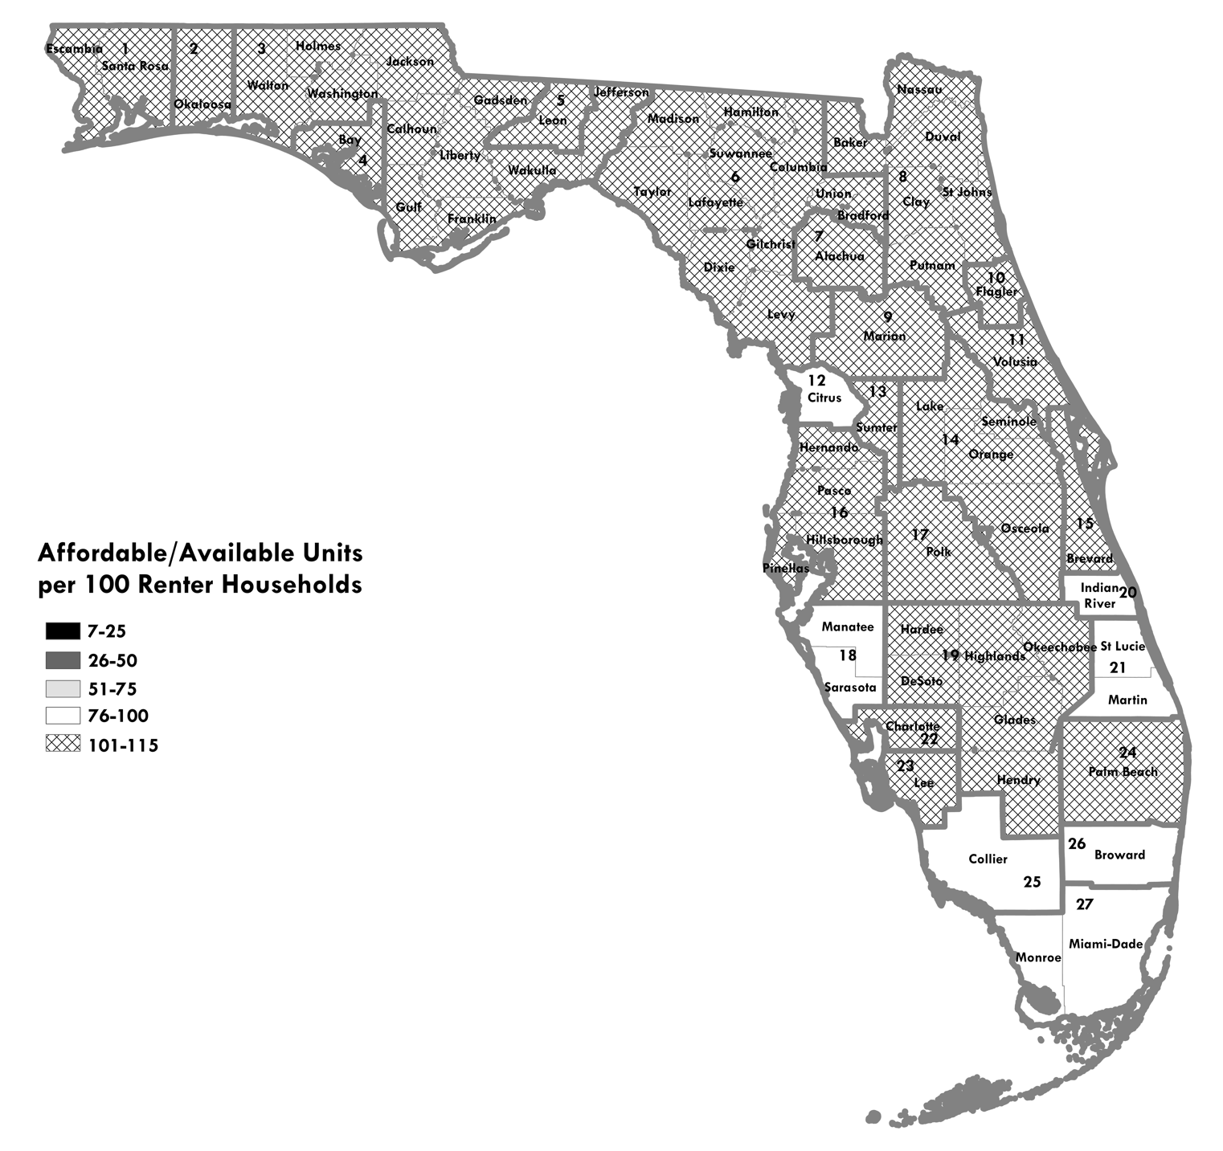
Figure 4.9. Affordable and Available Housing Units per 100 Renter Households at 0-140% AMI, Modified MSA/HMFA and Non-Metropolitan Areas, 2023 Estimate
Region Modified MSA/HMFA
1 Pensacola-Ferry Pass-Brent, FL MSA
2 Crestview-Fort Walton Beach-Destin, FL HMFA
3 Northwest Nonmetropolitan Area (plus Gadsden, Jefferson, Wakulla, and Walton)
4 Panama City-Lynn Haven, FL MSA
5 Tallahassee, FL HMFA (minus Gadsden and Jefferson)
6 Northeast Nonmetropolitan Area (plus Gilchrist and Levy)
7 Gainesville, FL HMFA (minus Gilchrist)
8 Jacksonville, FL HMFA/Baker County, FL HMFA (plus Putnam)
9 Ocala, FL MSA
10 Palm Coast, FL HMFA
11 Deltona-Daytona Beach-Ormond Beach, FL HMFA
12 Homosassa Springs, FL MSA
13 The Villages, FL MSA
14 Orlando-Kissimmee-Sanford, FL MSA
15 Palm Bay-Melbourne-Titusville, FL MSA
16 Tampa-St. Petersburg-Clearwater, FL MSA
17 Lakeland-Winter Haven, FL MSA
18 North Port-Sarasota-Bradenton, FL MSA
19 South Nonmetropolitan Area (minus Monroe, plus Highlands)
20 Sebastian-Vero Beach, FL MSA
21 Port St. Lucie, FL MSA
22 Punta Gorda, FL MSA
23 Cape Coral-Fort Myers, FL MSA
24 West Palm Beach-Boca Raton, FL HMFA
25 Naples-Immokalee-Marco Island, FL MSA
26 Fort Lauderdale, FL HMFA
27 Miami-Miami Beach-Kendall, FL HMFA (plus Monroe)

As the table and maps show, renter households exceed affordable and available units in nearly all regions up to 80 percent of AMI. In most regions, there are 60 or fewer affordable and available units per 100 renter households at 0-60 percent of AMI. The imbalance is most stark in Broward County, which has only 22 affordable and available units per 100 renter households at 60 percent of AMI.
At 0-100 and 0-120 percent of AMI, more regions reach parity between affordable/available units and renters. At the highest income band (0-140 percent of AMI), most regions have more affordable and available units than renter households, with some deficits in Southeast Florida and Collier County.
In absolute terms, Florida’s most populous metropolitan areas show the largest shortfalls of affordable and available units. At the 0-60 percent of AMI level, there are deficits of 119,801 units in Miami-Dade/Monroe; 82,000-98,000 units each in the Orlando, Tampa/St. Petersburg, and Fort Lauderdale metropolitan areas; and 43,000-47,000 units in the Jacksonville and West Palm Beach areas.

Limitations of the Affordable/Available Analysis
This method has several limitations that cause it to overstate the availability of affordable rental units. Most importantly, a unit may be considered affordable if its rent falls anywhere below the top of the income threshold, and available if the household occupying it also falls anywhere within that range. For example, a unit may be considered affordable and available in the 0-60 percent income group if its rent is affordable at 55 percent of AMI, even if the household occupying it has an income of just 35 percent of AMI. The rent for this “affordable” unit would still be well over 30 percent of income this household. The broader the income category, the more households that fall into this situation. It is a far larger drawback in the 0-80 percent of AMI and above analyses than in the 0-30 percent of AMI analysis.
Several other limitations also may cause the method to overstate the housing supply:
- Aggregating data to the MSA level may mask housing shortages in specific counties, cities or neighborhoods because they are counterbalanced by large affordable/available housing supplies in another part of the MSA.
- The formula for rental affordability takes the number of bedrooms in the unit into account, but households are not matched with units by size. For example, we do not assume that a 2-person household would only live in a one- or two-bedroom unit. Therefore, in areas where there are numerous small households but the housing supply is dominated by larger units, the method would overestimate the supply of affordable and available units.
- Some units that are affordable and available may be in poor condition. This affordable/available supply analysis does exclude some substandard units: those lacking complete kitchen, plumbing, or heating. These are the only indicators of housing condition available in the American Community Survey. However, other units that are included may have maintenance, electrical, or structural problems that are not be covered by this limited definition of substandard housing.
- The method does not determine whether affordable and available units provide the appropriate services and physical design for special needs populations, such as elders or persons with disabilities.

Affordable/Available Detail Tables

Table 4.3. Affordable/Available Detail Table for 0-30% AMI, Florida Regions, 2023 Estimate
 |  | Renters 0-30% AMI | Affordable @ 30% AMI |  |  | Affordable/Available @ 30% AMI |  |  | Affordable, Not Available @ 30% AMI
A |  | B | C | D | E | F | G | H | I
Modified Metropolitan Statistical Area (MSA)/HUD Metro Fair Market Rent Area (HMFA) | Counties | Renter Households | Affordable Units | Difference Between Renters and Affordable Units (C-B) | Affordable Units per 100 Renter Households (C/(B/100)) | Affordable & Available Units | Difference Between Renters and Affordable & Available Units (F-B) | Affordable & Available Units per 100 Renter Households (F/(B/100)) | Affordable Units Occupied by Households Above Income Ceiling (C-F)
Cape Coral-Fort Myers, FL MSA | Lee | 13,579 | 6,156 | -7,423 | 45 | 3,217 | -10,362 | 24 | 2,939
Crestview-Fort Walton Beach-Destin, FL HMFA | Okaloosa | 5,801 | 2,340 | -3,461 | 40 | 1,288 | -4,513 | 22 | 1,052
Deltona-Daytona Beach-Ormond Beach, FL HMFA | Volusia | 11,716 | 6,439 | -5,277 | 55 | 3,193 | -8,523 | 27 | 3,246
Fort Lauderdale, FL HMFA | Broward | 48,442 | 15,243 | -33,199 | 31 | 8,255 | -40,187 | 17 | 6,988
Gainesville, FL HMFA (minus Gilchrist) | Alachua | 10,117 | 3,991 | -6,126 | 39 | 2,221 | -7,896 | 22 | 1,770
Homosassa Springs, FL MSA | Citrus | 2,680 | 1,292 | -1,388 | 48 | 705 | -1,975 | 26 | 587
Jacksonville, FL HMFA/Baker County, FL HMFA (plus Putnam) | Baker, Clay, Duval, Nassau, Putnam, St. Johns | 47,409 | 29,656 | -17,753 | 63 | 13,854 | -33,555 | 29 | 15,802
Lakeland-Winter Haven, FL MSA | Polk | 13,284 | 7,086 | -6,198 | 53 | 2,684 | -10,600 | 20 | 4,402
Miami-Miami Beach-Kendall, FL HMFA (plus Monroe) | Miami-Dade, Monroe | 82,439 | 39,276 | -43,163 | 48 | 23,930 | -58,509 | 29 | 15,346
Naples-Immokalee-Marco Island, FL MSA | Collier | 7,376 | 3,396 | -3,980 | 46 | 1,887 | -5,489 | 26 | 1,509
North Port-Sarasota-Bradenton, FL MSA | Manatee, Sarasota | 15,386 | 7,829 | -7,557 | 51 | 4,084 | -11,302 | 27 | 3,745
Northeast Nonmetropolitan Area (plus Gilchrist and Levy) | Bradford, Columbia, Dixie, Gilchrist, Hamilton, Lafayette, Levy, Madison, Suwannee, Taylor, Union | 4,122 | 4,435 | 313 | 108 | 1,485 | -2,637 | 36 | 2,950
Northwest Nonmetropolitan Area (plus Gadsden, Jefferson, Wakulla, and Walton) | Calhoun, Franklin, Gadsden, Gulf, Holmes, Jackson, Jefferson, Liberty, Wakulla, Walton, Washington | 7,419 | 7,565 | 146 | 102 | 3,316 | -4,103 | 45 | 4,249
Ocala, FL MSA | Marion | 6,196 | 4,208 | -1,988 | 68 | 423 | -5,773 | 7 | 3,785
Orlando-Kissimmee-Sanford, FL MSA | Lake, Orange, Osceola, Seminole | 58,647 | 17,418 | -41,229 | 30 | 7,851 | -50,796 | 13 | 9,567
Palm Bay-Melbourne-Titusville, FL MSA | Brevard | 10,566 | 6,478 | -4,088 | 61 | 2,334 | -8,232 | 22 | 4,144
Palm Coast, FL HMFA | Flagler | 1,680 | 1,249 | -431 | 74 | 553 | -1,127 | 33 | 696
Panama City-Lynn Haven, FL MSA | Bay | 4,465 | 1,848 | -2,617 | 41 | 1,121 | -3,344 | 25 | 727
Pensacola-Ferry Pass-Brent, FL MSA | Escambia, Santa Rosa | 9,916 | 7,528 | -2,388 | 76 | 3,969 | -5,947 | 40 | 3,559
Port St. Lucie, FL MSA | Martin, St. Lucie | 7,548 | 4,207 | -3,341 | 56 | 1,967 | -5,581 | 26 | 2,240
Punta Gorda, FL MSA | Charlotte | 2,569 | 1,747 | -822 | 68 | 618 | -1,951 | 24 | 1,129
Sebastian-Vero Beach, FL MSA | Indian River | 2,986 | 1,675 | -1,311 | 56 | 858 | -2,128 | 29 | 817
South Nonmetropolitan Area (minus Monroe, plus Highlands) | DeSoto, Glades, Hardee, Hendry, Highlands, Okeechobee | 4,073 | 3,517 | -556 | 86 | 1,071 | -3,002 | 26 | 2,446
Tallahassee, FL HMFA (minus Gadsden and Jefferson) | Leon | 9,451 | 4,200 | -5,251 | 44 | 2,690 | -6,761 | 28 | 1,510
Tampa-St. Petersburg-Clearwater, FL MSA | Hernando, Hillsborough, Pasco, Pinellas | 75,264 | 31,377 | -43,887 | 42 | 18,631 | -56,633 | 25 | 12,746
The Villages, FL MSA | Sumter | 2,028 | 2,143 | 115 | 106 | 531 | -1,497 | 26 | 1,612
West Palm Beach-Boca Raton, FL HMFA | Palm Beach | 30,423 | 9,106 | -21,317 | 30 | 4,825 | -25,598 | 16 | 4,281
State of Florida Total |  | 495,582 | 231,405 | -264,177 | 47 | 117,561 | -378,021 | 24 | 113,844
Source: Shimberg Center tabulation of U.S. Census Bureau, 2023 American Community Survey

Table 4.4. Affordable/Available Detail Table for 0-40% AMI, Florida Regions, 2023 Estimate
 |  | Renters 0-40% AMI | Affordable @ 40% AMI |  |  | Affordable/Available @ 40% AMI |  |  | Affordable, Not Available @ 40% AMI
A |  | B | C | D | E | F | G | H | I
Modified Metropolitan Statistical Area (MSA)/HUD Metro Fair Market Rent Area (HMFA) | Counties | Renter Households | Affordable Units | Difference Between Renters and Affordable Units (C-B) | Affordable Units per 100 Renter Households (C/(B/100)) | Affordable & Available Units | Difference Between Renters and Affordable & Available Units (F-B) | Affordable & Available Units per 100 Renter Households (F/(B/100)) | Affordable Units Occupied by Households Above Income Ceiling (C-F)
Cape Coral-Fort Myers, FL MSA | Lee | 18,416 | 7,365 | -11,051 | 40 | 4,530 | -13,886 | 25 | 2,835
Crestview-Fort Walton Beach-Destin, FL HMFA | Okaloosa | 6,602 | 3,062 | -3,540 | 46 | 2,181 | -4,421 | 33 | 881
Deltona-Daytona Beach-Ormond Beach, FL HMFA | Volusia | 15,866 | 9,180 | -6,686 | 58 | 5,257 | -10,609 | 33 | 3,923
Fort Lauderdale, FL HMFA | Broward | 63,383 | 19,314 | -44,069 | 30 | 13,117 | -50,266 | 21 | 6,197
Gainesville, FL HMFA (minus Gilchrist) | Alachua | 13,046 | 7,264 | -5,782 | 56 | 5,255 | -7,791 | 40 | 2,009
Homosassa Springs, FL MSA | Citrus | 3,726 | 1,567 | -2,159 | 42 | 1,012 | -2,714 | 27 | 555
Jacksonville, FL HMFA/Baker County, FL HMFA (plus Putnam) | Baker, Clay, Duval, Nassau, Putnam, St. Johns | 64,988 | 39,325 | -25,663 | 61 | 22,462 | -42,526 | 35 | 16,863
Lakeland-Winter Haven, FL MSA | Polk | 17,995 | 12,921 | -5,074 | 72 | 6,768 | -11,227 | 38 | 6,153
Miami-Miami Beach-Kendall, FL HMFA (plus Monroe) | Miami-Dade, Monroe | 111,821 | 47,407 | -64,414 | 42 | 32,149 | -79,672 | 29 | 15,258
Naples-Immokalee-Marco Island, FL MSA | Collier | 10,904 | 6,477 | -4,427 | 59 | 4,270 | -6,634 | 39 | 2,207
North Port-Sarasota-Bradenton, FL MSA | Manatee, Sarasota | 21,359 | 11,098 | -10,261 | 52 | 6,799 | -14,560 | 32 | 4,299
Northeast Nonmetropolitan Area (plus Gilchrist and Levy) | Bradford, Columbia, Dixie, Gilchrist, Hamilton, Lafayette, Levy, Madison, Suwannee, Taylor, Union | 6,665 | 6,547 | -118 | 98 | 3,453 | -3,212 | 52 | 3,094
Northwest Nonmetropolitan Area (plus Gadsden, Jefferson, Wakulla, and Walton) | Calhoun, Franklin, Gadsden, Gulf, Holmes, Jackson, Jefferson, Liberty, Wakulla, Walton, Washington | 9,103 | 10,745 | 1,642 | 118 | 5,508 | -3,595 | 61 | 5,237
Ocala, FL MSA | Marion | 8,034 | 5,056 | -2,978 | 63 | 1,117 | -6,917 | 14 | 3,939
Orlando-Kissimmee-Sanford, FL MSA | Lake, Orange, Osceola, Seminole | 87,352 | 27,619 | -59,733 | 32 | 17,104 | -70,248 | 20 | 10,515
Palm Bay-Melbourne-Titusville, FL MSA | Brevard | 16,364 | 8,134 | -8,230 | 50 | 4,648 | -11,716 | 28 | 3,486
Palm Coast, FL HMFA | Flagler | 2,675 | 1,679 | -996 | 63 | 1,056 | -1,619 | 39 | 623
Panama City-Lynn Haven, FL MSA | Bay | 5,910 | 2,281 | -3,629 | 39 | 1,540 | -4,370 | 26 | 741
Pensacola-Ferry Pass-Brent, FL MSA | Escambia, Santa Rosa | 13,176 | 13,004 | -172 | 99 | 6,258 | -6,918 | 47 | 6,746
Port St. Lucie, FL MSA | Martin, St. Lucie | 12,538 | 5,247 | -7,291 | 42 | 3,366 | -9,172 | 27 | 1,881
Punta Gorda, FL MSA | Charlotte | 3,888 | 2,145 | -1,743 | 55 | 696 | -3,192 | 18 | 1,449
Sebastian-Vero Beach, FL MSA | Indian River | 3,945 | 1,836 | -2,109 | 47 | 1,099 | -2,846 | 28 | 737
South Nonmetropolitan Area (minus Monroe, plus Highlands) | DeSoto, Glades, Hardee, Hendry, Highlands, Okeechobee | 6,500 | 5,423 | -1,077 | 83 | 2,339 | -4,161 | 36 | 3,084
Tallahassee, FL HMFA (minus Gadsden and Jefferson) | Leon | 13,854 | 6,866 | -6,988 | 50 | 4,263 | -9,591 | 31 | 2,603
Tampa-St. Petersburg-Clearwater, FL MSA | Hernando, Hillsborough, Pasco, Pinellas | 100,736 | 45,791 | -54,945 | 45 | 29,599 | -71,137 | 29 | 16,192
The Villages, FL MSA | Sumter | 2,832 | 3,182 | 350 | 112 | 1,756 | -1,076 | 62 | 1,426
West Palm Beach-Boca Raton, FL HMFA | Palm Beach | 43,990 | 15,373 | -28,617 | 35 | 8,889 | -35,101 | 20 | 6,484
State of Florida Total |  | 685,668 | 325,908 | -359,760 | 48 | 196,491 | -489,177 | 29 | 129,417
Source: Shimberg Center tabulation of U.S. Census Bureau, 2023 American Community Survey

Table 4.5. Affordable/Available Detail Table for 0-50% AMI, Florida Regions, 2023 Estimate
 |  | Renters 0-50% AMI | Affordable @ 50% AMI |  |  | Affordable/Available @ 50% AMI |  |  | Affordable, Not Available @ 50% AMI
A |  | B | C | D | E | F | G | H | I
Modified Metropolitan Statistical Area (MSA)/HUD Metro Fair Market Rent Area (HMFA) | Counties | Renter Households | Affordable Units | Difference Between Renters and Affordable Units (C-B) | Affordable Units per 100 Renter Households (C/(B/100)) | Affordable & Available Units | Difference Between Renters and Affordable & Available Units (F-B) | Affordable & Available Units per 100 Renter Households (F/(B/100)) | Affordable Units Occupied by Households Above Income Ceiling (C-F)
Cape Coral-Fort Myers, FL MSA | Lee | 24,057 | 9,158 | 38 | -14,899 | 5,746 | -18,311 | 24 | 3,412
Crestview-Fort Walton Beach-Destin, FL HMFA | Okaloosa | 8,117 | 4,228 | 52 | -3,889 | 3,098 | -5,019 | 38 | 1,130
Deltona-Daytona Beach-Ormond Beach, FL HMFA | Volusia | 19,166 | 12,021 | 63 | -7,145 | 7,157 | -12,009 | 37 | 4,864
Fort Lauderdale, FL HMFA | Broward | 84,620 | 23,188 | 27 | -61,432 | 16,508 | -68,112 | 20 | 6,680
Gainesville, FL HMFA (minus Gilchrist) | Alachua | 18,779 | 11,932 | 64 | -6,847 | 8,096 | -10,683 | 43 | 3,836
Homosassa Springs, FL MSA | Citrus | 4,910 | 2,042 | 42 | -2,868 | 1,332 | -3,578 | 27 | 710
Jacksonville, FL HMFA/Baker County, FL HMFA (plus Putnam) | Baker, Clay, Duval, Nassau, Putnam, St. Johns | 82,731 | 58,427 | 71 | -24,304 | 33,971 | -48,760 | 41 | 24,456
Lakeland-Winter Haven, FL MSA | Polk | 25,961 | 21,001 | 81 | -4,960 | 11,549 | -14,412 | 44 | 9,452
Miami-Miami Beach-Kendall, FL HMFA (plus Monroe) | Miami-Dade, Monroe | 141,682 | 55,729 | 39 | -85,953 | 40,872 | -100,810 | 29 | 14,857
Naples-Immokalee-Marco Island, FL MSA | Collier | 14,290 | 7,937 | 56 | -6,353 | 5,736 | -8,554 | 40 | 2,201
North Port-Sarasota-Bradenton, FL MSA | Manatee, Sarasota | 30,288 | 16,948 | 56 | -13,340 | 10,381 | -19,907 | 34 | 6,567
Northeast Nonmetropolitan Area (plus Gilchrist and Levy) | Bradford, Columbia, Dixie, Gilchrist, Hamilton, Lafayette, Levy, Madison, Suwannee, Taylor, Union | 8,357 | 10,708 | 128 | 2,351 | 5,704 | -2,653 | 68 | 5,004
Northwest Nonmetropolitan Area (plus Gadsden, Jefferson, Wakulla, and Walton) | Calhoun, Franklin, Gadsden, Gulf, Holmes, Jackson, Jefferson, Liberty, Wakulla, Walton, Washington | 10,826 | 15,079 | 139 | 4,253 | 7,683 | -3,143 | 71 | 7,396
Ocala, FL MSA | Marion | 10,034 | 8,708 | 87 | -1,326 | 4,208 | -5,826 | 42 | 4,500
Orlando-Kissimmee-Sanford, FL MSA | Lake, Orange, Osceola, Seminole | 120,556 | 42,606 | 35 | -77,950 | 28,886 | -91,670 | 24 | 13,720
Palm Bay-Melbourne-Titusville, FL MSA | Brevard | 22,210 | 12,380 | 56 | -9,830 | 8,094 | -14,116 | 36 | 4,286
Palm Coast, FL HMFA | Flagler | 3,705 | 1,766 | 48 | -1,939 | 1,067 | -2,638 | 29 | 699
Panama City-Lynn Haven, FL MSA | Bay | 7,767 | 4,458 | 57 | -3,309 | 3,322 | -4,445 | 43 | 1,136
Pensacola-Ferry Pass-Brent, FL MSA | Escambia, Santa Rosa | 18,236 | 20,361 | 112 | 2,125 | 10,680 | -7,556 | 59 | 9,681
Port St. Lucie, FL MSA | Martin, St. Lucie | 15,913 | 6,559 | 41 | -9,354 | 4,205 | -11,708 | 26 | 2,354
Punta Gorda, FL MSA | Charlotte | 5,026 | 3,328 | 66 | -1,698 | 1,545 | -3,481 | 31 | 1,783
Sebastian-Vero Beach, FL MSA | Indian River | 4,606 | 3,717 | 81 | -889 | 2,044 | -2,562 | 44 | 1,673
South Nonmetropolitan Area (minus Monroe, plus Highlands) | DeSoto, Glades, Hardee, Hendry, Highlands, Okeechobee | 8,513 | 7,154 | 84 | -1,359 | 3,578 | -4,935 | 42 | 3,576
Tallahassee, FL HMFA (minus Gadsden and Jefferson) | Leon | 19,609 | 14,397 | 73 | -5,212 | 9,120 | -10,489 | 47 | 5,277
Tampa-St. Petersburg-Clearwater, FL MSA | Hernando, Hillsborough, Pasco, Pinellas | 134,219 | 66,471 | 50 | -67,748 | 44,867 | -89,352 | 33 | 21,604
The Villages, FL MSA | Sumter | 4,373 | 3,525 | 81 | -848 | 2,453 | -1,920 | 56 | 1,072
West Palm Beach-Boca Raton, FL HMFA | Palm Beach | 58,516 | 23,743 | 41 | -34,773 | 15,029 | -43,487 | 26 | 8,714
State of Florida Total |  | 907,067 | 467,571 | 52 | -439,496 | 296,931 | -610,136 | 33 | 170,640
Source: Shimberg Center tabulation of U.S. Census Bureau, 2023 American Community Survey

Table 4.6. Affordable/Available Detail Table for 0-60% AMI, Florida Regions, 2023 Estimate
 |  | Renters 0-60% AMI | Affordable @ 60% AMI |  |  | Affordable/Available @ 60% AMI |  |  | Affordable, Not Available @ 60% AMI
A |  | B | C | D | E | F | G | H | I
Modified Metropolitan Statistical Area (MSA)/HUD Metro Fair Market Rent Area (HMFA) | Counties | Renter Households | Affordable Units | Difference Between Renters and Affordable Units (C-B) | Affordable Units per 100 Renter Households (C/(B/100)) | Affordable & Available Units | Difference Between Renters and Affordable & Available Units (F-B) | Affordable & Available Units per 100 Renter Households (F/(B/100)) | Affordable Units Occupied by Households Above Income Ceiling (C-F)
Cape Coral-Fort Myers, FL MSA | Lee | 29,280 | 14,243 | -15,037 | 49 | 8,945 | -20,335 | 31 | 5,298
Crestview-Fort Walton Beach-Destin, FL HMFA | Okaloosa | 9,782 | 6,688 | -3,094 | 68 | 4,223 | -5,559 | 43 | 2,465
Deltona-Daytona Beach-Ormond Beach, FL HMFA | Volusia | 24,406 | 16,958 | -7,448 | 69 | 11,155 | -13,251 | 46 | 5,803
Fort Lauderdale, FL HMFA | Broward | 105,744 | 34,411 | -71,333 | 33 | 23,544 | -82,200 | 22 | 10,867
Gainesville, FL HMFA (minus Gilchrist) | Alachua | 20,774 | 21,284 | 510 | 102 | 15,334 | -5,440 | 74 | 5,950
Homosassa Springs, FL MSA | Citrus | 6,087 | 4,302 | -1,785 | 71 | 2,372 | -3,715 | 39 | 1,930
Jacksonville, FL HMFA/Baker County, FL HMFA (plus Putnam) | Baker, Clay, Duval, Nassau, Putnam, St. Johns | 101,802 | 85,467 | -16,335 | 84 | 54,512 | -47,290 | 54 | 30,955
Lakeland-Winter Haven, FL MSA | Polk | 32,523 | 31,135 | -1,388 | 96 | 19,997 | -12,526 | 61 | 11,138
Miami-Miami Beach-Kendall, FL HMFA (plus Monroe) | Miami-Dade, Monroe | 170,089 | 68,248 | -101,841 | 40 | 50,288 | -119,801 | 30 | 17,960
Naples-Immokalee-Marco Island, FL MSA | Collier | 17,477 | 12,519 | -4,958 | 72 | 8,911 | -8,566 | 51 | 3,608
North Port-Sarasota-Bradenton, FL MSA | Manatee, Sarasota | 37,308 | 25,018 | -12,290 | 67 | 16,392 | -20,916 | 44 | 8,626
Northeast Nonmetropolitan Area (plus Gilchrist and Levy) | Bradford, Columbia, Dixie, Gilchrist, Hamilton, Lafayette, Levy, Madison, Suwannee, Taylor, Union | 11,398 | 15,025 | 3,627 | 132 | 8,915 | -2,483 | 78 | 6,110
Northwest Nonmetropolitan Area (plus Gadsden, Jefferson, Wakulla, and Walton) | Calhoun, Franklin, Gadsden, Gulf, Holmes, Jackson, Jefferson, Liberty, Wakulla, Walton, Washington | 13,826 | 19,207 | 5,381 | 139 | 10,877 | -2,949 | 79 | 8,330
Ocala, FL MSA | Marion | 13,196 | 11,285 | -1,911 | 86 | 5,606 | -7,590 | 42 | 5,679
Orlando-Kissimmee-Sanford, FL MSA | Lake, Orange, Osceola, Seminole | 151,395 | 74,812 | -76,583 | 49 | 53,688 | -97,707 | 35 | 21,124
Palm Bay-Melbourne-Titusville, FL MSA | Brevard | 27,204 | 19,654 | -7,550 | 72 | 13,561 | -13,643 | 50 | 6,093
Palm Coast, FL HMFA | Flagler | 4,248 | 2,035 | -2,213 | 48 | 1,210 | -3,038 | 28 | 825
Panama City-Lynn Haven, FL MSA | Bay | 9,340 | 9,987 | 647 | 107 | 6,959 | -2,381 | 75 | 3,028
Pensacola-Ferry Pass-Brent, FL MSA | Escambia, Santa Rosa | 22,010 | 28,909 | 6,899 | 131 | 16,053 | -5,957 | 73 | 12,856
Port St. Lucie, FL MSA | Martin, St. Lucie | 19,753 | 9,882 | -9,871 | 50 | 7,262 | -12,491 | 37 | 2,620
Punta Gorda, FL MSA | Charlotte | 6,002 | 5,431 | -571 | 90 | 2,662 | -3,340 | 44 | 2,769
Sebastian-Vero Beach, FL MSA | Indian River | 5,617 | 5,698 | 81 | 101 | 3,094 | -2,523 | 55 | 2,604
South Nonmetropolitan Area (minus Monroe, plus Highlands) | DeSoto, Glades, Hardee, Hendry, Highlands, Okeechobee | 9,714 | 11,739 | 2,025 | 121 | 5,866 | -3,848 | 60 | 5,873
Tallahassee, FL HMFA (minus Gadsden and Jefferson) | Leon | 22,654 | 24,795 | 2,141 | 109 | 16,589 | -6,065 | 73 | 8,206
Tampa-St. Petersburg-Clearwater, FL MSA | Hernando, Hillsborough, Pasco, Pinellas | 162,121 | 101,747 | -60,374 | 63 | 70,924 | -91,197 | 44 | 30,823
The Villages, FL MSA | Sumter | 5,193 | 4,044 | -1,149 | 78 | 2,533 | -2,660 | 49 | 1,511
West Palm Beach-Boca Raton, FL HMFA | Palm Beach | 70,473 | 37,529 | -32,944 | 53 | 27,203 | -43,270 | 39 | 10,326
State of Florida Total |  | 1,109,416 | 702,052 | -407,364 | 63 | 468,675 | -640,741 | 42 | 233,377
Source: Shimberg Center tabulation of U.S. Census Bureau, 2023 American Community Survey

Table 4.7. Affordable/Available Detail Table for 0-80% AMI, Florida Regions, 2023 Estimate
 |  | Renters 0-80% AMI | Affordable @ 80% AMI |  |  | Affordable/Available @ 80% AMI |  |  | Affordable, Not Available @ 80% AMI
A |  | B | C | D | E | F | G | H | I
Modified Metropolitan Statistical Area (MSA)/HUD Metro Fair Market Rent Area (HMFA) | Counties | Renter Households | Affordable Units | Difference Between Renters and Affordable Units (C-B) | Affordable Units per 100 Renter Households (C/(B/100)) | Affordable & Available Units | Difference Between Renters and Affordable & Available Units (F-B) | Affordable & Available Units per 100 Renter Households (F/(B/100)) | Affordable Units Occupied by Households Above Income Ceiling (C-F)
Cape Coral-Fort Myers, FL MSA | Lee | 40,361 | 32,239 | -8,122 | 80 | 23,028 | -17,333 | 57 | 9,211
Crestview-Fort Walton Beach-Destin, FL HMFA | Okaloosa | 13,122 | 13,660 | 538 | 104 | 8,946 | -4,176 | 68 | 4,714
Deltona-Daytona Beach-Ormond Beach, FL HMFA | Volusia | 32,882 | 31,073 | -1,809 | 94 | 22,316 | -10,566 | 68 | 8,757
Fort Lauderdale, FL HMFA | Broward | 139,908 | 73,686 | -66,222 | 53 | 55,563 | -84,345 | 40 | 18,123
Gainesville, FL HMFA (minus Gilchrist) | Alachua | 26,733 | 35,902 | 9,169 | 134 | 26,262 | -471 | 98 | 9,640
Homosassa Springs, FL MSA | Citrus | 8,118 | 8,002 | -116 | 99 | 5,693 | -2,425 | 70 | 2,309
Jacksonville, FL HMFA/Baker County, FL HMFA (plus Putnam) | Baker, Clay, Duval, Nassau, Putnam, St. Johns | 131,396 | 156,711 | 25,315 | 119 | 109,089 | -22,307 | 83 | 47,622
Lakeland-Winter Haven, FL MSA | Polk | 45,707 | 46,192 | 485 | 101 | 34,026 | -11,681 | 74 | 12,166
Miami-Miami Beach-Kendall, FL HMFA (plus Monroe) | Miami-Dade, Monroe | 229,096 | 120,369 | -108,727 | 53 | 85,291 | -143,805 | 37 | 35,078
Naples-Immokalee-Marco Island, FL MSA | Collier | 21,843 | 18,509 | -3,334 | 85 | 14,411 | -7,432 | 66 | 4,098
North Port-Sarasota-Bradenton, FL MSA | Manatee, Sarasota | 52,323 | 47,034 | -5,289 | 90 | 32,547 | -19,776 | 62 | 14,487
Northeast Nonmetropolitan Area (plus Gilchrist and Levy) | Bradford, Columbia, Dixie, Gilchrist, Hamilton, Lafayette, Levy, Madison, Suwannee, Taylor, Union | 13,176 | 20,163 | 6,987 | 153 | 12,111 | -1,065 | 92 | 8,052
Northwest Nonmetropolitan Area (plus Gadsden, Jefferson, Wakulla, and Walton) | Calhoun, Franklin, Gadsden, Gulf, Holmes, Jackson, Jefferson, Liberty, Wakulla, Walton, Washington | 18,411 | 25,167 | 6,756 | 137 | 16,918 | -1,493 | 92 | 8,249
Ocala, FL MSA | Marion | 18,814 | 18,924 | 110 | 101 | 11,885 | -6,929 | 63 | 7,039
Orlando-Kissimmee-Sanford, FL MSA | Lake, Orange, Osceola, Seminole | 197,419 | 160,848 | -36,571 | 81 | 112,345 | -85,074 | 57 | 48,503
Palm Bay-Melbourne-Titusville, FL MSA | Brevard | 34,701 | 41,971 | 7,270 | 121 | 30,945 | -3,756 | 89 | 11,026
Palm Coast, FL HMFA | Flagler | 5,243 | 4,483 | -760 | 86 | 3,110 | -2,133 | 59 | 1,373
Panama City-Lynn Haven, FL MSA | Bay | 12,897 | 16,042 | 3,145 | 124 | 11,323 | -1,574 | 88 | 4,719
Pensacola-Ferry Pass-Brent, FL MSA | Escambia, Santa Rosa | 28,740 | 42,979 | 14,239 | 150 | 26,812 | -1,928 | 93 | 16,167
Port St. Lucie, FL MSA | Martin, St. Lucie | 25,235 | 21,194 | -4,041 | 84 | 15,099 | -10,136 | 60 | 6,095
Punta Gorda, FL MSA | Charlotte | 8,203 | 9,172 | 969 | 112 | 6,206 | -1,997 | 76 | 2,966
Sebastian-Vero Beach, FL MSA | Indian River | 7,531 | 10,461 | 2,930 | 139 | 6,422 | -1,109 | 85 | 4,039
South Nonmetropolitan Area (minus Monroe, plus Highlands) | DeSoto, Glades, Hardee, Hendry, Highlands, Okeechobee | 13,583 | 18,678 | 5,095 | 138 | 12,001 | -1,582 | 88 | 6,677
Tallahassee, FL HMFA (minus Gadsden and Jefferson) | Leon | 30,753 | 42,046 | 11,293 | 137 | 30,169 | -584 | 98 | 11,877
Tampa-St. Petersburg-Clearwater, FL MSA | Hernando, Hillsborough, Pasco, Pinellas | 216,328 | 197,732 | -18,596 | 91 | 146,081 | -70,247 | 68 | 51,651
The Villages, FL MSA | Sumter | 6,191 | 7,003 | 812 | 113 | 5,135 | -1,056 | 83 | 1,868
West Palm Beach-Boca Raton, FL HMFA | Palm Beach | 91,821 | 75,505 | -16,316 | 82 | 54,122 | -37,699 | 59 | 21,383
State of Florida Total |  | 1,470,535 | 1,295,745 | -174,790 | 88 | 917,856 | -552,679 | 62 | 377,889
Source: Shimberg Center tabulation of U.S. Census Bureau, 2023 American Community Survey

Table 4.8. Affordable/Available Detail Table for 0-100% AMI, Florida Regions, 2023 Estimate
 |  | Renters 0-100% AMI | Affordable @ 100% AMI |  |  | Affordable/Available @ 100% AMI |  |  | Affordable, Not Available @ 100% AMI
A |  | B | C | D | E | F | G | H | I
Modified Metropolitan Statistical Area (MSA)/HUD Metro Fair Market Rent Area (HMFA) | Counties | Renter Households | Affordable Units | Difference Between Renters and Affordable Units (C-B) | Affordable Units per 100 Renter Households (C/(B/100)) | Affordable & Available Units | Difference Between Renters and Affordable & Available Units (F-B) | Affordable & Available Units per 100 Renter Households (F/(B/100)) | Affordable Units Occupied by Households Above Income Ceiling (C-F)
Cape Coral-Fort Myers, FL MSA | Lee | 50,831 | 54,093 | 3,262 | 106 | 42,142 | -8,689 | 83 | 11,951
Crestview-Fort Walton Beach-Destin, FL HMFA | Okaloosa | 16,957 | 21,810 | 4,853 | 129 | 15,345 | -1,612 | 90 | 6,465
Deltona-Daytona Beach-Ormond Beach, FL HMFA | Volusia | 40,519 | 49,123 | 8,604 | 121 | 38,264 | -2,255 | 94 | 10,859
Fort Lauderdale, FL HMFA | Broward | 170,615 | 132,406 | -38,209 | 78 | 106,309 | -64,306 | 62 | 26,097
Gainesville, FL HMFA (minus Gilchrist) | Alachua | 31,470 | 41,209 | 9,739 | 131 | 33,569 | 2,099 | 107 | 7,640
Homosassa Springs, FL MSA | Citrus | 9,654 | 10,505 | 851 | 109 | 8,507 | -1,147 | 88 | 1,998
Jacksonville, FL HMFA/Baker County, FL HMFA (plus Putnam) | Baker, Clay, Duval, Nassau, Putnam, St. Johns | 157,912 | 212,936 | 55,024 | 135 | 158,058 | 146 | 100 | 54,878
Lakeland-Winter Haven, FL MSA | Polk | 54,726 | 63,496 | 8,770 | 116 | 47,000 | -7,726 | 86 | 16,496
Miami-Miami Beach-Kendall, FL HMFA (plus Monroe) | Miami-Dade, Monroe | 276,703 | 207,139 | -69,564 | 75 | 159,724 | -116,979 | 58 | 47,415
Naples-Immokalee-Marco Island, FL MSA | Collier | 26,727 | 26,571 | -156 | 99 | 23,012 | -3,715 | 86 | 3,559
North Port-Sarasota-Bradenton, FL MSA | Manatee, Sarasota | 64,294 | 75,086 | 10,792 | 117 | 55,210 | -9,084 | 86 | 19,876
Northeast Nonmetropolitan Area (plus Gilchrist and Levy) | Bradford, Columbia, Dixie, Gilchrist, Hamilton, Lafayette, Levy, Madison, Suwannee, Taylor, Union | 14,961 | 22,951 | 7,990 | 153 | 15,178 | 217 | 101 | 7,773
Northwest Nonmetropolitan Area (plus Gadsden, Jefferson, Wakulla, and Walton) | Calhoun, Franklin, Gadsden, Gulf, Holmes, Jackson, Jefferson, Liberty, Wakulla, Walton, Washington | 20,650 | 26,804 | 6,154 | 130 | 19,366 | -1,284 | 94 | 7,438
Ocala, FL MSA | Marion | 23,240 | 27,223 | 3,983 | 117 | 20,328 | -2,912 | 87 | 6,895
Orlando-Kissimmee-Sanford, FL MSA | Lake, Orange, Osceola, Seminole | 247,715 | 274,023 | 26,308 | 111 | 203,109 | -44,606 | 82 | 70,914
Palm Bay-Melbourne-Titusville, FL MSA | Brevard | 39,719 | 58,257 | 18,538 | 147 | 43,814 | 4,095 | 110 | 14,443
Palm Coast, FL HMFA | Flagler | 5,849 | 7,189 | 1,340 | 123 | 5,164 | -685 | 88 | 2,025
Panama City-Lynn Haven, FL MSA | Bay | 15,768 | 23,487 | 7,719 | 149 | 16,805 | 1,037 | 107 | 6,682
Pensacola-Ferry Pass-Brent, FL MSA | Escambia, Santa Rosa | 35,032 | 54,071 | 19,039 | 154 | 36,717 | 1,685 | 105 | 17,354
Port St. Lucie, FL MSA | Martin, St. Lucie | 32,408 | 31,358 | -1,050 | 97 | 25,151 | -7,257 | 78 | 6,207
Punta Gorda, FL MSA | Charlotte | 9,394 | 11,918 | 2,524 | 127 | 8,570 | -824 | 91 | 3,348
Sebastian-Vero Beach, FL MSA | Indian River | 9,363 | 12,101 | 2,738 | 129 | 8,920 | -443 | 95 | 3,181
South Nonmetropolitan Area (minus Monroe, plus Highlands) | DeSoto, Glades, Hardee, Hendry, Highlands, Okeechobee | 16,553 | 20,604 | 4,051 | 124 | 15,144 | -1,409 | 91 | 5,460
Tallahassee, FL HMFA (minus Gadsden and Jefferson) | Leon | 36,613 | 48,161 | 11,548 | 132 | 38,386 | 1,773 | 105 | 9,775
Tampa-St. Petersburg-Clearwater, FL MSA | Hernando, Hillsborough, Pasco, Pinellas | 272,603 | 313,659 | 41,056 | 115 | 239,011 | -33,592 | 88 | 74,648
The Villages, FL MSA | Sumter | 7,373 | 8,582 | 1,209 | 116 | 7,602 | 229 | 103 | 980
West Palm Beach-Boca Raton, FL HMFA | Palm Beach | 111,142 | 116,480 | 5,338 | 105 | 90,630 | -20,512 | 82 | 25,850
State of Florida Total |  | 1,798,791 | 1,951,242 | 152,451 | 108 | 1,481,035 | -317,756 | 82 | 470,207
Source: Shimberg Center tabulation of U.S. Census Bureau, 2023 American Community Survey

Table 4.9. Affordable/Available Detail Table for 0-120% AMI, Florida Regions, 2023 Estimate
 |  | Renters 0-120% AMI | Affordable @ 120% AMI |  |  | Affordable/Available @ 120% AMI |  |  | Affordable, Not Available @ 120% AMI
A |  | B | C | D | E | F | G | H | I
Modified Metropolitan Statistical Area (MSA)/HUD Metro Fair Market Rent Area (HMFA) | Counties | Renter Households | Affordable Units | Difference Between Renters and Affordable Units (C-B) | Affordable Units per 100 Renter Households (C/(B/100)) | Affordable & Available Units | Difference Between Renters and Affordable & Available Units (F-B) | Affordable & Available Units per 100 Renter Households (F/(B/100)) | Affordable Units Occupied by Households Above Income Ceiling (C-F)
Cape Coral-Fort Myers, FL MSA | Lee | 60,389 | 71,883 | 11,494 | 119 | 60,037 | -352 | 99 | 11,846
Crestview-Fort Walton Beach-Destin, FL HMFA | Okaloosa | 20,233 | 24,538 | 4,305 | 121 | 20,823 | 590 | 103 | 3,715
Deltona-Daytona Beach-Ormond Beach, FL HMFA | Volusia | 45,365 | 58,260 | 12,895 | 128 | 47,282 | 1,917 | 104 | 10,978
Fort Lauderdale, FL HMFA | Broward | 196,584 | 187,813 | -8,771 | 96 | 158,700 | -37,884 | 81 | 29,113
Gainesville, FL HMFA (minus Gilchrist) | Alachua | 33,784 | 42,074 | 8,290 | 125 | 36,360 | 2,576 | 108 | 5,714
Homosassa Springs, FL MSA | Citrus | 10,578 | 12,389 | 1,811 | 117 | 10,294 | -284 | 97 | 2,095
Jacksonville, FL HMFA/Baker County, FL HMFA (plus Putnam) | Baker, Clay, Duval, Nassau, Putnam, St. Johns | 178,839 | 233,831 | 54,992 | 131 | 187,049 | 8,210 | 105 | 46,782
Lakeland-Winter Haven, FL MSA | Polk | 65,005 | 76,887 | 11,882 | 118 | 62,369 | -2,636 | 96 | 14,518
Miami-Miami Beach-Kendall, FL HMFA (plus Monroe) | Miami-Dade, Monroe | 315,521 | 290,526 | -24,995 | 92 | 237,011 | -78,510 | 75 | 53,515
Naples-Immokalee-Marco Island, FL MSA | Collier | 28,997 | 32,374 | 3,377 | 112 | 27,814 | -1,183 | 96 | 4,560
North Port-Sarasota-Bradenton, FL MSA | Manatee, Sarasota | 74,946 | 90,233 | 15,287 | 120 | 72,145 | -2,801 | 96 | 18,088
Northeast Nonmetropolitan Area (plus Gilchrist and Levy) | Bradford, Columbia, Dixie, Gilchrist, Hamilton, Lafayette, Levy, Madison, Suwannee, Taylor, Union | 18,025 | 23,531 | 5,506 | 131 | 18,332 | 307 | 102 | 5,199
Northwest Nonmetropolitan Area (plus Gadsden, Jefferson, Wakulla, and Walton) | Calhoun, Franklin, Gadsden, Gulf, Holmes, Jackson, Jefferson, Liberty, Wakulla, Walton, Washington | 23,248 | 28,193 | 4,945 | 121 | 22,570 | -678 | 97 | 5,623
Ocala, FL MSA | Marion | 27,513 | 34,887 | 7,374 | 127 | 27,292 | -221 | 99 | 7,595
Orlando-Kissimmee-Sanford, FL MSA | Lake, Orange, Osceola, Seminole | 280,253 | 365,787 | 85,534 | 131 | 285,527 | 5,274 | 102 | 80,260
Palm Bay-Melbourne-Titusville, FL MSA | Brevard | 44,934 | 64,288 | 19,354 | 143 | 51,847 | 6,913 | 115 | 12,441
Palm Coast, FL HMFA | Flagler | 7,007 | 8,152 | 1,145 | 116 | 6,246 | -761 | 89 | 1,906
Panama City-Lynn Haven, FL MSA | Bay | 18,417 | 26,398 | 7,981 | 143 | 20,845 | 2,428 | 113 | 5,553
Pensacola-Ferry Pass-Brent, FL MSA | Escambia, Santa Rosa | 41,597 | 55,885 | 14,288 | 134 | 43,511 | 1,914 | 105 | 12,374
Port St. Lucie, FL MSA | Martin, St. Lucie | 35,704 | 39,219 | 3,515 | 110 | 32,264 | -3,440 | 90 | 6,955
Punta Gorda, FL MSA | Charlotte | 10,649 | 13,543 | 2,894 | 127 | 10,410 | -239 | 98 | 3,133
Sebastian-Vero Beach, FL MSA | Indian River | 11,420 | 13,545 | 2,125 | 119 | 11,354 | -66 | 99 | 2,191
South Nonmetropolitan Area (minus Monroe, plus Highlands) | DeSoto, Glades, Hardee, Hendry, Highlands, Okeechobee | 19,463 | 22,221 | 2,758 | 114 | 18,786 | -677 | 97 | 3,435
Tallahassee, FL HMFA (minus Gadsden and Jefferson) | Leon | 40,433 | 49,615 | 9,182 | 123 | 43,171 | 2,738 | 107 | 6,444
Tampa-St. Petersburg-Clearwater, FL MSA | Hernando, Hillsborough, Pasco, Pinellas | 308,898 | 397,276 | 88,378 | 129 | 313,771 | 4,873 | 102 | 83,505
The Villages, FL MSA | Sumter | 7,513 | 9,284 | 1,771 | 124 | 8,050 | 537 | 107 | 1,234
West Palm Beach-Boca Raton, FL HMFA | Palm Beach | 125,487 | 146,495 | 21,008 | 117 | 118,623 | -6,864 | 95 | 27,872
State of Florida Total |  | 2,050,802 | 2,419,127 | 368,325 | 118 | 1,952,483 | -98,319 | 95 | 466,644
Source: Shimberg Center tabulation of U.S. Census Bureau, 2023 American Community Survey

Table 4.10. Affordable/Available Detail Table for 0-140% AMI, Florida Regions, 2023 Estimate
 |  | Renters 0-140% AMI | Affordable @ 140% AMI |  |  | Affordable/Available @ 140% AMI |  |  | Affordable, Not Available @ 140% AMI
A |  | B | C | D | E | F | G | H | I
Modified Metropolitan Statistical Area (MSA)/HUD Metro Fair Market Rent Area (HMFA) | Counties | Renter Households | Affordable Units | Difference Between Renters and Affordable Units (C-B) | Affordable Units per 100 Renter Households (C/(B/100)) | Affordable & Available Units | Difference Between Renters and Affordable & Available Units (F-B) | Affordable & Available Units per 100 Renter Households (F/(B/100)) | Affordable Units Occupied by Households Above Income Ceiling (C-F)
Cape Coral-Fort Myers, FL MSA | Lee | 66,499 | 79,200 | 12,701 | 119 | 68,996 | 2,497 | 104 | 10,204
Crestview-Fort Walton Beach-Destin, FL HMFA | Okaloosa | 22,574 | 26,808 | 4,234 | 119 | 23,756 | 1,182 | 105 | 3,052
Deltona-Daytona Beach-Ormond Beach, FL HMFA | Volusia | 50,505 | 62,355 | 11,850 | 123 | 52,967 | 2,462 | 105 | 9,388
Fort Lauderdale, FL HMFA | Broward | 212,755 | 230,465 | 17,710 | 108 | 198,527 | -14,228 | 93 | 31,938
Gainesville, FL HMFA (minus Gilchrist) | Alachua | 35,582 | 42,171 | 6,589 | 119 | 38,132 | 2,550 | 107 | 4,039
Homosassa Springs, FL MSA | Citrus | 10,738 | 12,720 | 1,982 | 118 | 10,785 | 47 | 100 | 1,935
Jacksonville, FL HMFA/Baker County, FL HMFA (plus Putnam) | Baker, Clay, Duval, Nassau, Putnam, St. Johns | 192,283 | 236,722 | 44,439 | 123 | 201,261 | 8,978 | 105 | 35,461
Lakeland-Winter Haven, FL MSA | Polk | 70,837 | 84,656 | 13,819 | 120 | 71,279 | 442 | 101 | 13,377
Miami-Miami Beach-Kendall, FL HMFA (plus Monroe) | Miami-Dade, Monroe | 343,523 | 353,089 | 9,566 | 103 | 299,145 | -44,378 | 87 | 53,944
Naples-Immokalee-Marco Island, FL MSA | Collier | 31,000 | 34,445 | 3,445 | 111 | 30,737 | -263 | 99 | 3,708
North Port-Sarasota-Bradenton, FL MSA | Manatee, Sarasota | 81,399 | 96,073 | 14,674 | 118 | 81,622 | 223 | 100 | 14,451
Northeast Nonmetropolitan Area (plus Gilchrist and Levy) | Bradford, Columbia, Dixie, Gilchrist, Hamilton, Lafayette, Levy, Madison, Suwannee, Taylor, Union | 19,277 | 24,565 | 5,288 | 127 | 19,772 | 495 | 103 | 4,793
Northwest Nonmetropolitan Area (plus Gadsden, Jefferson, Wakulla, and Walton) | Calhoun, Franklin, Gadsden, Gulf, Holmes, Jackson, Jefferson, Liberty, Wakulla, Walton, Washington | 24,787 | 30,384 | 5,597 | 123 | 25,532 | 745 | 103 | 4,852
Ocala, FL MSA | Marion | 30,631 | 36,513 | 5,882 | 119 | 31,328 | 697 | 102 | 5,185
Orlando-Kissimmee-Sanford, FL MSA | Lake, Orange, Osceola, Seminole | 309,385 | 396,320 | 86,935 | 128 | 326,649 | 17,264 | 106 | 69,671
Palm Bay-Melbourne-Titusville, FL MSA | Brevard | 48,727 | 65,417 | 16,690 | 134 | 55,812 | 7,085 | 115 | 9,605
Palm Coast, FL HMFA | Flagler | 7,713 | 9,142 | 1,429 | 119 | 7,861 | 148 | 102 | 1,281
Panama City-Lynn Haven, FL MSA | Bay | 20,968 | 27,813 | 6,845 | 133 | 23,770 | 2,802 | 113 | 4,043
Pensacola-Ferry Pass-Brent, FL MSA | Escambia, Santa Rosa | 46,130 | 56,342 | 10,212 | 122 | 48,208 | 2,078 | 105 | 8,134
Port St. Lucie, FL MSA | Martin, St. Lucie | 38,352 | 43,436 | 5,084 | 113 | 37,729 | -623 | 98 | 5,707
Punta Gorda, FL MSA | Charlotte | 12,039 | 15,044 | 3,005 | 125 | 12,904 | 865 | 107 | 2,140
Sebastian-Vero Beach, FL MSA | Indian River | 12,377 | 13,608 | 1,231 | 110 | 12,062 | -315 | 97 | 1,546
South Nonmetropolitan Area (minus Monroe, plus Highlands) | DeSoto, Glades, Hardee, Hendry, Highlands, Okeechobee | 20,734 | 23,859 | 3,125 | 115 | 21,416 | 682 | 103 | 2,443
Tallahassee, FL HMFA (minus Gadsden and Jefferson) | Leon | 41,974 | 50,463 | 8,489 | 120 | 45,233 | 3,259 | 108 | 5,230
Tampa-St. Petersburg-Clearwater, FL MSA | Hernando, Hillsborough, Pasco, Pinellas | 338,243 | 423,624 | 85,381 | 125 | 353,799 | 15,556 | 105 | 69,825
The Villages, FL MSA | Sumter | 8,165 | 9,354 | 1,189 | 115 | 8,603 | 438 | 105 | 751
West Palm Beach-Boca Raton, FL HMFA | Palm Beach | 137,265 | 164,058 | 26,793 | 120 | 140,079 | 2,814 | 102 | 23,979
State of Florida Total |  | 2,234,462 | 2,648,646 | 414,184 | 119 | 2,247,964 | 13,502 | 101 | 400,682
Source: Shimberg Center tabulation of U.S. Census Bureau, 2023 American Community Survey

Homeless Families and Individuals
This section of the Rental Market Study estimates the number of homeless individuals and families in Florida. Estimates of homeless persons are based on two sources: 1) Point in Time counts of sheltered and unsheltered homeless persons submitted to HUD by Florida’s local homeless coalitions, and 2) estimates of homeless families and unaccompanied youth who are doubled up with friends or family or living in hotels and motels, based on data on homeless students collected by the Florida Department of Education (FDOE).
According to these two sources, the statewide homeless counts are as follows:
- 29,848 homeless individuals. This includes 23,799 sheltered and unsheltered individuals from the Point in Time counts, including single adults, married adults without children, unaccompanied youth, children in sibling groups or other similar groups, and adolescent parents with children. It also includes 6,049 unaccompanied youth doubled up with others and in hotels and motels, as estimated from the FDOE homeless student count.
- 44,234 homeless families with children. This includes 2,387 sheltered and unsheltered families from the Continuum of Care Point in Time counts. It also includes 41,847 families doubled up with others and in hotels and motels, as estimated from the FDOE homeless student count.
Compared to the 2022 Rental Market Study, these numbers indicate a 14 percent increase in homeless individuals and a 28 percent increase in homeless families with children. These changes are driven by increases in individuals identified in the 2024 Point in Time count and a sharp increase in homeless student counts from the Department of Education. The total number of homeless students grew from 79,782 students in 2019-2020 to 94,899 students in 2022-2023. The higher 2022-2023 numbers include large increases in student homelessness in Lee County and other Gulf Coast counties following Hurricane Ian in September 2022, but numbers were also higher throughout most areas of the state.
The report then estimates the supply of transitional housing and permanent supportive housing units. Unit counts come from the Housing Inventory Counts in the Continuum of Care plans and the Shimberg Center’s Assisted Housing Inventory. Based on these sources, Florida has 16,221 transitional housing and permanent supportive housing beds for individuals and 8,953 transitional and permanent supportive housing units for family households.

Methodology
The counts of homeless households and housing supply are based on four data sources:
- 2024 Point in Time counts of homeless individuals and families submitted by Florida’s local homeless coalitions to the U.S. Department of Housing and Urban Development (HUD) as part of the annual Continuum of Care plan. Each coalition represents a county or a group of counties in Florida. All counties in Florida except Baker, Dixie, and Union are represented by homeless coalitions. The plans are required by HUD as part of the coalitions’ applications for McKinney-Vento Act homeless assistance funds.
The Point in Time count is a one-day census of homeless persons in each Continuum of Care area during the last 10 days of January. HUD does not allow the use of multipliers or other estimating methods to produce a population number. HUD compiles data from the plans into its Annual Homeless Assessment Report (AHAR).
- Florida Department of Education’s (FDOE) 2022-2023 Homeless Students Count, which is based on data submitted by homeless liaisons from all Florida school districts. The counts include students identified as homeless at any point during the 2022-2023 school year; the 2023-2024 school year dataset was not yet available for analysis. For each county, students are categorized by place of nighttime residence (shelters, unsheltered locations, doubled up, hotels/motels, etc.) and accompaniment status (unaccompanied youth vs. living with family). The students are counted once per school year the first time they are identified as homeless, regardless of whether they have more than one instance of homelessness.
- 2024 Housing Inventory Counts of transitional and permanent supportive housing units, also submitted to HUD by local homeless coalitions as part of the Continuum of Care plans and included in HUD’s Annual Homeless Assessment Report.
- The Shimberg Center’s Assisted Housing Inventory, which identifies subsidized rental housing developments reserved for homeless individuals and families.
The HUD AHAR data includes 1) “sheltered homeless persons” in emergency shelters, transitional housing, and “Safe Havens,” and 2) “unsheltered homeless persons” whose nighttime residence is a public place not designed for regular sleeping accommodations.
Florida Housing’s definition of homelessness is more expansive than the sheltered/unsheltered criteria used by HUD. Therefore, we supplement the Point in Time counts with the FDOE counts of homeless students to estimate the number of families with children and unaccompanied youth who are doubled up other family and friends or in hotels and motels. Limiting the FDOE data to these categories avoids double-counting the sheltered and unsheltered homeless families already included in the Point in Time counts. Note that the FDOE dataset includes only students enrolled in school. It excludes babies and young children, as well as school-age children not attending school.

Need: Counts for Families and Individuals
Homeless persons are classified into two groups: 1) families with dependent children (“family households” or “families”), and 2) persons without dependent children, including single individuals, unaccompanied youth, and other adults such as a married couple without children (“individuals”).
The estimate of family households is the sum of two components:
- The total number of sheltered and unsheltered families with dependent children from the Point in Time counts, as reported in the Continuum of Care plans for each region.
- An estimate of families with school-age children who are doubled up and in hotels and motels based on the FDOE student count. The FDOE report classifies students by place of nighttime residence, with doubled up and hotels/motels as two of the categories. We summed these categories to obtain the total number of students of interest. We did not use other categories of nighttime residence (shelters, unsheltered locations) because these students and their families should already be included in the Point in Time counts.
Two additional steps were necessary to estimate family households from student counts. First, FDOE’s statewide 2022-2023 student totals indicate that 92.6 percent of all homeless students are identified as living in families. The remaining 7.4 percent are unaccompanied youth. Therefore, we multiplied the sum of homeless students with place of residence as doubled up and hotels/motels by .926 to find the number of students living with their families in these locations for each county.
Second, a household may have more than one student. HUD statistics show that sheltered homeless families include an average of 1.96 children per family in Florida. We divided the number of students in families by 1.96 to estimate the number of families. In short, for each county, Families = (Students * Percentage of students in families) / (Students per family) = (Students * .926)/1.96.
Finally, we aggregated the county-level estimates into Continuum of Care region estimates. A table showing the county-level student data and their conversion to estimates for families and unaccompanied youth is included at the end of this chapter.
Similarly, the estimates of individuals consist of two components:
- The total number of individuals reported in the Point in Time count for each Continuum of Care region. This is a count of persons, not households.
- An estimate of unaccompanied youth who are doubled up and in hotels and motels based on the FDOE student count. As noted above, DOE data indicate that 7.4 percent of homeless students in the state are unaccompanied. We multiplied the number of homeless students with place of residence as doubled up and hotels/motels by .074 to estimate the number of unaccompanied youth living in these locations. Again, county-level figures were aggregated into Continuum of Care area totals.

Supply: Housing Inventory Counts
Estimates of transitional and permanent supportive housing come from two sources: 1) 2024 Housing Inventory Counts (HIC) submitted to HUD by Continuum of Care coalitions, and 2) the Shimberg Center’s Assisted Housing Inventory (AHI). The AHI includes 65 developments with funding from Florida Housing where “homeless” is the target demographic, plus 4,774 units from 606 other developments reserved for special needs populations placed through the Link program. In a small number of cases, the AHI homeless units were also included in the Continuum of Care HIC reports. AHI homeless and Link-occupied units that did not appear in the HIC reports were added to the county totals.
The study counts units for families with children and beds for other individuals. The transitional and permanent housing units for families in the HIC have the capacity for an average of 2.5 family members. An individual bed, whether in its own unit or a shared facility, by definition houses one person. The report does not include emergency shelter beds as part of the housing supply. HUD and Florida Housing consider shelter beds to be temporary housing. Persons residing in emergency shelters are counted in the homeless population.

Counts of Homeless Individuals and Families
According to the Point in Time and student counts, an estimated 29,848 individuals were homeless in Florida in 2024. This includes 23,799 sheltered and unsheltered individuals from the Point in Time counts, including single adults, married adults without children, unaccompanied youth, children in sibling groups or other similar groups, and adolescent parents with children. It also includes an estimated 6,049 unaccompanied youth doubled up with others and in hotels and motels identified in the FDOE homeless student count.
Among families with children, an estimated 44,234 households were homeless. This includes 2,387 sheltered and unsheltered families from the Point in Time counts and 41,847 families doubled up with others and in hotels and motels, as estimated from the FDOE homeless student count. The estimates may be skewed higher by the use of 2022-2023 school year student data, which includes displacement due to Hurricane Ian.
Table 5.1 and Figures 5.1 and 5.2 on the following pages show the number of homeless individuals and families by county or multi-county region. Four Continuum of Care areas had more than 2,000 homeless individuals: Miami-Dade, Orange-Osceola-Seminole, Broward, and Palm Beach Counties.
For homeless families, Orange-Osceola-Seminole and Miami-Dade Counties had the highest counts, at 6,893 and 5,543 families, respectively. Other regions with more than 2,000 families include Palm Beach, Polk, Broward, Clay-Duval-Nassau, Pinellas, Hillsborough, and Indian River-Martin-St. Lucie Counties. Most of these come from the estimates of families in hotels/motels and doubled up based on FDOE data.

Table 5.1. Homeless Individuals and Families by Region, 2024
Counties | Continuum of Care | Individuals: Sheltered & Unsheltered from Point in Time Count | Individuals: Unaccompanied Youth Doubled Up & Hotels/Motels from Student Data | Total Individuals (PIT + Student) | Family Households: Sheltered & Unsheltered from Point in Time Count | Family Households: Est. Families Doubled Up & Hotels/Motels from Student Data | Total Family Households (PIT + Student)
Manatee, Sarasota | FL-500 | 996 | 151 | 1,147 | 62 | 1,046 | 1,108
Hillsborough | FL-501 | 1,253 | 272 | 1,525 | 228 | 1,881 | 2,109
Pinellas | FL-502 | 1,595 | 309 | 1,904 | 147 | 2,134 | 2,281
Polk | FL-503 | 750 | 330 | 1,080 | 134 | 2,282 | 2,416
Flagler, Volusia | FL-504 | 805 | 210 | 1,015 | 93 | 1,455 | 1,548
Okaloosa, Walton | FL-505 | 321 | 57 | 378 | 21 | 393 | 414
Franklin, Gadsden, Jefferson, Leon, Liberty, Madison, Taylor, Wakulla | FL-506 | 622 | 97 | 719 | 78 | 672 | 750
Orange, Osceola, Seminole | FL-507 | 2,010 | 962 | 2,972 | 237 | 6,656 | 6,893
Alachua, Bradford, Gilchrist, Levy, Putnam | FL-508 | 633 | 121 | 754 | 43 | 840 | 883
Indian River, Martin, St. Lucie | FL-509 | 445 | 282 | 727 | 78 | 1,950 | 2,028
Clay, Duval, Nassau | FL-510 | 1,100 | 325 | 1,425 | 73 | 2,248 | 2,321
Escambia, Santa Rosa | FL-511 | 1,025 | 191 | 1,216 | 25 | 1,319 | 1,344
St. Johns | FL-512 | 362 | 30 | 392 | 33 | 211 | 244
Brevard | FL-513 | 959 | 102 | 1,061 | 56 | 708 | 764
Marion | FL-514 | 282 | 82 | 364 | 33 | 570 | 603
Bay, Calhoun, Gulf, Holmes, Jackson, Washington | FL-515 | 433 | 170 | 603 | 22 | 1,175 | 1,197
Desoto, Glades, Hardee, Hendry, Highlands, Okeechobee | FL-517 | 358 | 120 | 478 | 68 | 833 | 901
Columbia, Hamilton, Lafayette, Suwannee | FL-518 | 341 | 62 | 403 | 63 | 427 | 490
Pasco | FL-519 | 593 | 119 | 712 | 41 | 820 | 861
Citrus, Hernando, Lake, Sumter | FL-520 | 565 | 230 | 795 | 67 | 1,594 | 1,661
Miami-Dade | FL-600 | 2,546 | 742 | 3,288 | 409 | 5,134 | 5,543
Broward | FL-601 | 2,054 | 319 | 2,373 | 119 | 2,208 | 2,327
Charlotte | FL-602 | 267 | 62 | 329 | 27 | 429 | 456
Lee | FL-603 | 769 | 114 | 883 | 54 | 791 | 845
Monroe | FL-604 | 425 | 32 | 457 | 9 | 222 | 231
Palm Beach | FL-605 | 1,825 | 384 | 2,209 | 97 | 2,656 | 2,753
Collier | FL-606 | 465 | 131 | 596 | 70 | 908 | 978
Florida Total |  | 23,799 | 6,049 | 29,848 | 2,387 | 41,847 | 44,234
Source: Shimberg Center tabulation of U.S. Department of Housing and Urban Development, 2024 Annual Homeless Assessment; Florida Department of Education, 2022-2023 Counts of Homeless Students by District

Figure 5.1. Homeless Individuals by Region, 2024
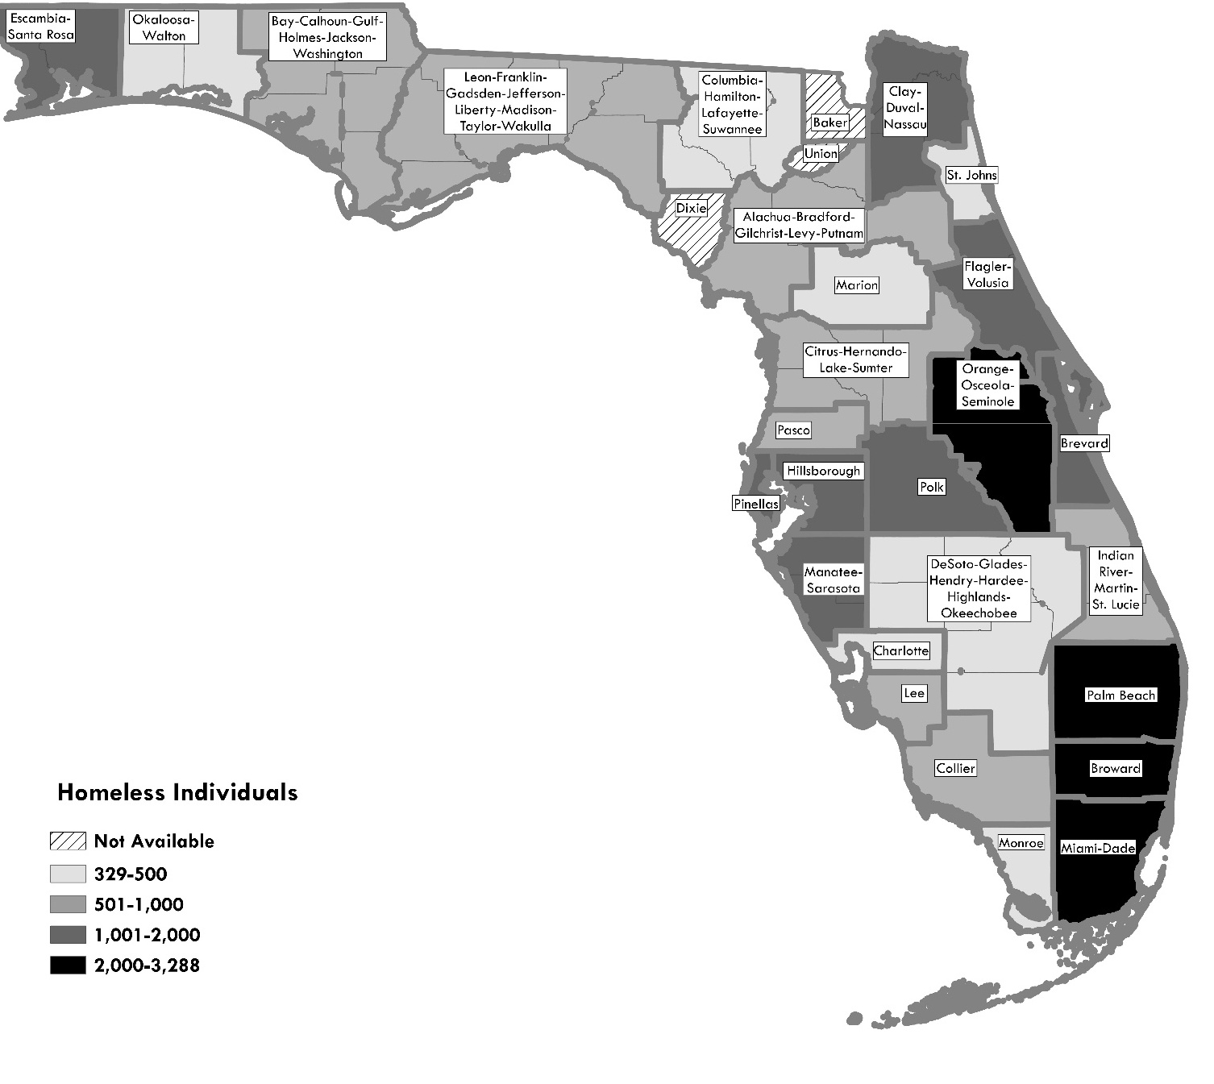
Source: Shimberg Center tabulation of U.S. Department of Housing and Urban Development, 2024 Annual Homeless Assessment; Florida Department of Education, 2022-2023 Counts of Homeless Students by District

Figure 5.2. Homeless Families by Region, 2024
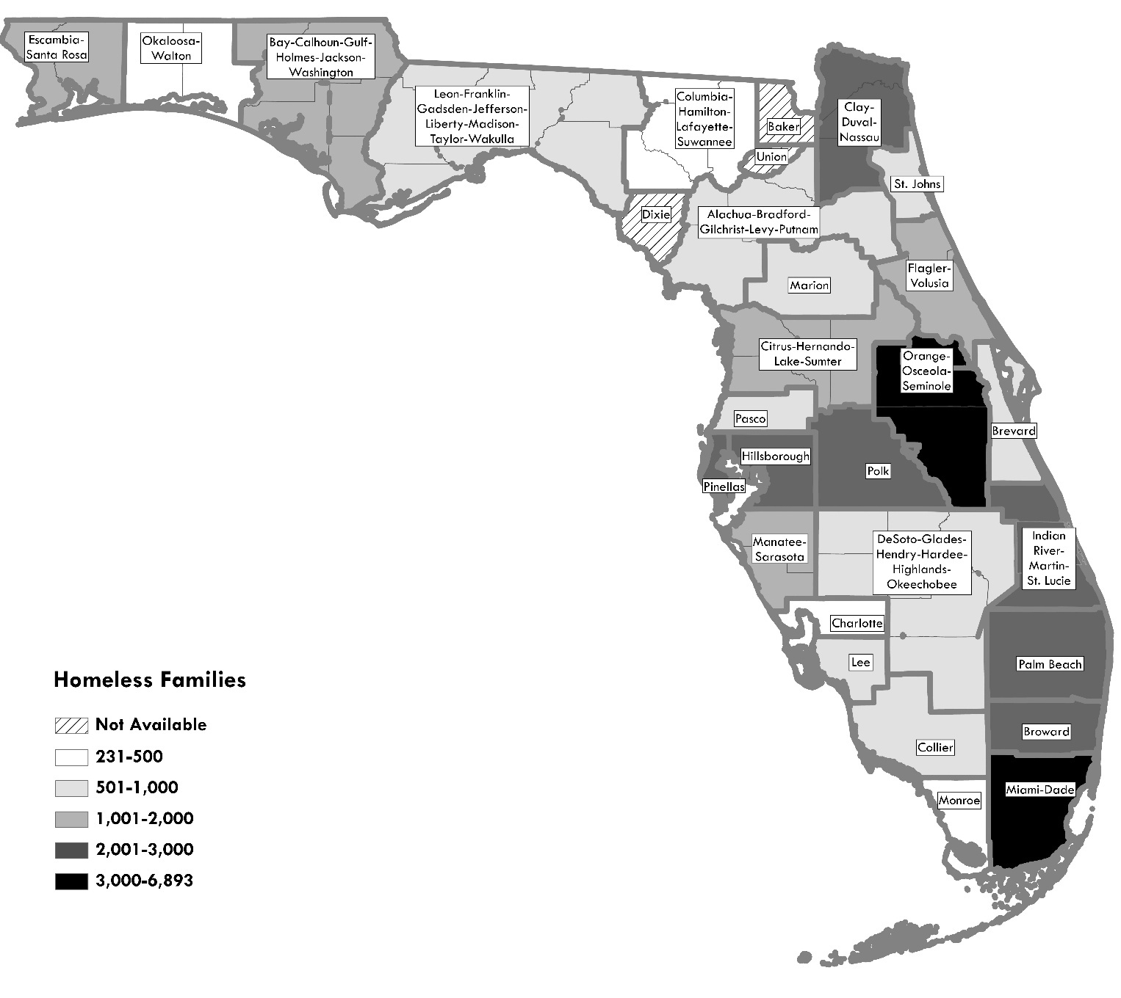

Source: Shimberg Center tabulation of U.S. Department of Housing and Urban Development, 2024 Annual Homeless Assessment; Florida Department of Education, 2022-2023 Counts of Homeless Students by District

Subpopulations
HUD’s Annual Homeless Assessment Report also includes counts of homeless persons by subpopulation. Table 5.2 lists the statewide subpopulation counts for 2024. Not all homeless persons are included in the list of subpopulations, and a person may appear in more than one category.

Table 5.2. Homeless Persons by Subpopulation, Florida, 2024
Subpopulation | Persons
Chronically Homeless | 6,860
Severely Mentally Ill | 5,916
Chronic Substance Abuse | 4,604
Veterans | 2,333
Persons with HIV/AIDS | 527
Victims of Domestic Violence | 2,454
Unaccompanied Youth (Under 18) | 232
Unaccompanied Youth (18-24) | 1,135
Parenting Youth | 198
Source: Shimberg Center tabulation of U.S. Department of Housing and Urban Development, HUD 2024 Continuum of Care Homeless Assistance Programs Homeless Populations and Subpopulations
For the Point in Time Count, HUD defines a chronically homeless person as one who is 1) Homeless and lives in a place not meant for human habitation, a safe haven, or in an emergency shelter; 2) Has been homeless and living or residing in a place not meant for human habitation, a safe haven, or in an emergency shelter continuously for at least 1 year or on at least four separate occasions in the last three years where the combined length of time homeless in those occasions is at least 12 months; and 3) Has a disability.” Of the 6,860 people reporting chronic homelessness, 89 percent (6,100) were individuals; the remaining 11 percent (760) were accompanied by family.

Transitional and Permanent Housing Supply
Florida has 16,221 transitional housing and permanent supportive housing beds for individuals. For families with children, there are 8,953 transitional and permanent supportive housing units statewide. These include beds and units listed in the Housing Inventory Counts plus units set aside for homeless populations and Link units from the Assisted Housing Inventory.
Table 5.3 below shows the supply of beds for individuals and units for families. Note that some of this supply is reserved for specific subpopulations, so not all beds and units are available to all people counted in the need tables.
The table also calculates each region’s “level of effort” in providing permanent supportive housing compared to the homeless population. The level of effort equals the number of permanent supportive housing units divided by the number of individuals or families who are currently homeless from Table 5.1. A level of effort ratio below 1.0 indicates that there are more homeless individuals or families than there are permanent supportive housing beds or units. A ratio greater than 1.0 would indicate that the region has more permanent supportive housing beds or units than individuals or families who are currently homeless.
Statewide, the level of effort ratio is 0.54 for housing for individuals and 0.20 for housing for families. This means that Florida has 54 permanent supportive housing individual beds for every 100 homeless individuals and 20 permanent supportive housing family units for every 100 homeless families. The level of effort for family units increased substantially over the 0.11 level from the 2022 Rental Market Study, as the Link program has added units in family developments.

Table 5.3. Transitional and Permanent Housing Supply by Region, 2024
HUD Continuum of Care | Counties | Individuals |  |  | Families
HUD Continuum of Care | Counties | Transitional Housing Beds: HIC | Total Individual PSH beds (AHI + HIC) | Permanent Supportive Housing Level of Effort | Transitional Housing Units: HIC | Total Family PSH Units (AHI + HIC) | Permanent Supportive Housing Level of Effort
FL-500 | Manatee, Sarasota | 222 | 435 | 0.38 | 52 | 234 | 0.21
FL-501 | Hillsborough | 41 | 1,225 | 0.80 | 3 | 515 | 0.24
FL-502 | Pinellas | 244 | 1,562 | 0.82 | 29 | 418 | 0.18
FL-503 | Polk | 144 | 99 | 0.09 | 37 | 312 | 0.13
FL-504 | Flagler, Volusia | 83 | 106 | 0.10 | 42 | 176 | 0.11
FL-505 | Okaloosa, Walton | 0 | 161 | 0.43 | 0 | 34 | 0.08
FL-506 | Franklin, Gadsden, Jefferson, Leon, Liberty, Madison, Taylor, Wakulla | 70 | 419 | 0.58 | 30 | 148 | 0.20
FL-507 | Orange, Osceola, Seminole | 360 | 2,203 | 0.74 | 105 | 1,280 | 0.19
FL-508 | Alachua, Bradford, Gilchrist, Levy, Putnam | 31 | 804 | 1.07 | 8 | 162 | 0.18
FL-509 | Indian River, Martin, St. Lucie | 2 | 368 | 0.51 | 12 | 95 | 0.05
FL-510 | Clay, Duval, Nassau | 375 | 1,421 | 1.00 | 20 | 559 | 0.24
FL-511 | Escambia, Santa Rosa | 256 | 247 | 0.20 | 10 | 80 | 0.06
FL-512 | St. Johns | 21 | 46 | 0.12 | 18 | 28 | 0.11
FL-513 | Brevard | 187 | 598 | 0.56 | 36 | 231 | 0.30
FL-514 | Marion | 31 | 262 | 0.72 | 27 | 66 | 0.11
FL-515 | Bay, Calhoun, Gulf, Holmes, Jackson, Washington | 82 | 78 | 0.13 | 0 | 97 | 0.08
FL-517 | Desoto, Glades, Hardee, Hendry, Highlands, Okeechobee | 5 | 76 | 0.16 | 0 | 38 | 0.04
FL-518 | Columbia, Hamilton, Lafayette, Suwannee | 27 | 91 | 0.23 | 0 | 12 | 0.02
FL-519 | Pasco | 127 | 375 | 0.53 | 20 | 239 | 0.28
FL-520 | Citrus, Hernando, Lake, Sumter | 138 | 146 | 0.18 | 36 | 212 | 0.13
FL-600 | Miami-Dade | 305 | 3,708 | 1.13 | 38 | 1,730 | 0.31
FL-601 | Broward | 35 | 1,004 | 0.42 | 50 | 563 | 0.24
FL-602 | Charlotte | 23 | 73 | 0.22 | 0 | 53 | 0.12
FL-603 | Lee | 0 | 111 | 0.13 | 0 | 602 | 0.71
FL-604 | Monroe | 132 | 159 | 0.35 | 0 | 82 | 0.36
FL-605 | Palm Beach | 136 | 340 | 0.15 | 15 | 949 | 0.34
FL-606 | Collier | 7 | 104 | 0.17 | 20 | 38 | 0.04
State of Florida Total |  | 3,084 | 16,221 | 0.54 | 608 | 8,953 | 0.20
Notes: A level of effort ratio below 1.0 indicates that there are more homeless individuals or families than permanent supportive housing beds or units. A ratio greater than 1.0 indicates more permanent supportive housing beds or units than individuals or families who are currently homeless.
Source: Shimberg Center tabulation of U.S. Department of Housing and Urban Development, 2024 Annual Homeless Assessment: Part 1 - Point in Time Estimates of Homelessness in the U.S.; Shimberg Center for Housing Studies, Assisted Housing Inventory

Data Limitations
Both sources of data on homeless individuals and families contain uncertainty. The Point in Time counts are difficult to perform accurately, particularly as coalitions attempt to identify unsheltered populations. Factors such as the weather on the day of the count and the coalitions’ familiarity with the locations most likely occupied by unsheltered persons affect the accuracy of the count.
For the FDOE data, only students whose homeless status is known by school districts’ homeless liaisons are included. Many students and their parents may not report their status because they are unaware of the services that could be available to them or because of the stigma attached to homelessness. Displacement by hurricanes may lead to temporary increases in counties affected by that year’s storms.
Moreover, the student data include only children enrolled in school. This excludes children who are too young to attend school and school age children who have dropped out of school. The exclusion of young children and others not in school will result in underestimates of families with children for two reasons. First, households with only children out of school are not counted at all. Second, the Florida average of 1.96 children per family includes both school age and younger children; a separate average for school age children is not available. Therefore, the average number of students per family is likely lower. That is, in the Families = (Students * Percentage of students in families)/(Students per family) equation, reducing the denominator (Students per family) would result in higher family counts.
Because they are based on counts of actual beds provided by local agencies, the supply estimates in the Continuum of Care plans are more precise. It is likely that Table 5.3 above includes most if not all of the state’s supply of transitional housing and permanent supportive housing. However, the supply data does not include housing for homeless persons other than the beds and units reserved specifically for them, such as Florida Housing’s family units.
Finally, housing facilities serving homeless persons often are directed toward a specific population. These facilities and their services may not be appropriate for other populations. For example, a supportive housing facility for single adults with HIV/AIDS is not interchangeable with a facility for youth aging out of foster care, but both would be counted in the general supply of housing for homeless individuals. Therefore, the aggregate supply numbers mask the need for a number of types of facilities matching the different types of services needed by homeless individuals and families.

Special Needs Households
This section of the Rental Market Study estimates the affordable rental housing needs of persons with special needs. Under Florida Statute, a person with special needs is defined as:
An adult person requiring independent living services in order to maintain housing or develop independent living skills and who has a disabling condition; a young adult formerly in foster care who is eligible for services under s. 409.1451(5); a survivor of domestic violence as defined in s. 741.28; or a person receiving benefits under the Social Security Disability Insurance (SSDI) program or the Supplemental Security Income (SSI) program or from veterans’ disability benefits. (Section 420.0004 (13), Florida Statutes)
No single data source provides counts of households that meet these precise conditions. The major source of data for statewide and county estimates of low-income, cost burdened renters, the American Community Survey (ACS), does include a number of relevant data components on disability and income from benefit programs. However, the ACS does not contain enough detail on disability types to provide a full picture of adults needing independent living services, and it contains no data on survivors of domestic violence or youth aging out of foster care.
Therefore, in this report we combine a series of approximations from the ACS and State administrative data to provide estimates of the number of households that most closely meet the State’s special needs definition. As elsewhere in the Rental Market Study, a household is considered to be “low income” if household income is at or below 60 percent of the area median income (AMI) and “cost burdened” if it pays more than 40 percent of income for gross rent.

Renter Households with Persons with a Disabling Condition Receiving Benefits
The first segment of the estimate includes cost burdened renter households with persons receiving Social Security, Supplemental Security Income (SSI), or veterans’ benefits related to disability. The main data source is the 2023 American Community Survey.
In addition to questions about tenure, income and housing costs, the ACS includes three sets of questions related to households with special needs:
- Disability. The ACS asks whether household members have any of six types of disabilities: hearing, vision, cognitive, ambulatory, self-care, and independent living. A respondent is considered a person with a disability if he/she reports at least one of the six disability types.
- Benefits. The ACS asks whether any member of the household receives income from Social Security. It does not distinguish between Social Security Disability Insurance (SSDI), which requires a disability determination from the Social Security Administration, and Social Security retirement benefits. A separate question asks whether any household members receive SSI.
- VA disability status. The ACS does not ask directly whether household members receive veterans’ disability benefits. Instead, it asks whether any household members are veterans and, if so, whether they have received a “service-connected disability rating” from U.S. Department of Veterans Affairs. Veterans with a disability rating of 10 percent or higher are entitled to monthly disability compensation.
Based on these variables, the following household estimate assumes that an adult receives disability-related benefits in accordance with Florida’s special needs definition if he/she meets at least one of the following conditions:
- Age 18-64, with a disability and receiving Social Security (as a proxy for SSDI receipt).
- Age 18 or older, with a disability and receiving SSI.
- Age 18 or older, with a VA service-related disability rating of 10 percent or more.
We cross-tabulated the households with at least one adult meeting this definition against low-income (at or below 60 percent area median income), cost burdened (paying more than 40 percent of income for gross rent) renter households in Florida. As in the county needs section, estimates were updated to 2025 figures using population projections produced by University of Florida’s Bureau of Economic and Business Research. This yielded an estimate of 92,545 cost burdened renter households receiving disability-related benefits statewide.

Survivors of Domestic Violence
No ACS data is available regarding incidence of domestic violence. Therefore, the second part of the core estimate relies on data on emergency shelter use reported to the Florida Department of Children and Families by the state’s 42 certified domestic violence centers. In the 2023-2024 fiscal year, these centers provided residential services to an estimated 7,147 households.

Youth Aging Out of Foster Care
The ACS does not include data on foster care arrangements or youth aging out of foster care. Instead, this segment of the core estimate relies on unduplicated counts of young adults receiving Aftercare, Extended Foster Care, and Postsecondary Education Services. In all, 2,066 young adults received at least one of these services in fiscal year 2023-2024.

Table 6.1. Estimates of Households with Persons with Special Needs, Florida
Category | Definition | Estimate | Data Sources
Disability-  related  benefits | Low-income (<=60% AMI), cost burdened (>40%) renter households with at least one household member who is: 1) age 18-64, with a disability, receiving Social Security; 2) age 18+, with a disability, receiving SSI; 3) age 18+ with a VA service-related disability rating of 10 percent or more | 92,545 (including 34,872 headed by someone under age 55 and 57,673 headed by someone 55 or older) | U.S. Census Bureau, 2023 American Community Survey Public Use Microdata Sample; University of Florida Bureau of Economic and Business Research, Population Estimates and Projections
Survivors  of  domestic  violence | Estimated number of households based on total number of persons using domestic violence emergency shelters | 7,147 | Florida Department of Children and Families, Domestic Violence Annual Report, 7/1/2023-6/30/2024. Based on 12,543 individuals receiving shelter and 2021-2022 estimated average household size of 1.8 persons (total recipients divided by adult recipients).
Youth  aging out  of foster  care | Estimate based on unduplicated count of young adults receiving Aftercare, Extended Foster Care, and Postsecondary Education Services | 2,066 | Florida Department of Children and Families
Total |  | 101,758

These data categories are drawn to minimize the likelihood of overlap, particularly as persons living in group quarters such as domestic violence shelters or youth shelters would not be counted as households in the Census. However, there may be a small amount of overlap. For example, a young person receiving SSI because of a disability might also appear in the category for youth aging out of foster care.

Farmworker Housing Needs in Florida
This segment of the Rental Market Study discusses the need for rental housing for Florida’s farmworkers. It compares the number of farmworkers and their households to the capacity of the state’s migrant labor housing and affordable farmworker housing developments. Some definitions are key to understanding the analysis:
- Migrant farmworkers travel more than 75 miles to find farm work.
- Seasonal farmworkers perform labor in agriculture but do not migrate.
- Accompanied farmworkers are those living with a spouse, children, or parents, or minor farmworkers living with a sibling.
- Unaccompanied farmworkers do not live with immediate family.
- Migrant camps receive permits from the Florida Department of Health (DOH) to house farmworkers.
- Farmworker multifamily developments provide affordable rental units to low-income farmworker households. They receive subsidies from Florida Housing or U.S. Department of Agriculture’s Rural Development (USDA RD) division.
See the Methodology for Farmworker Estimates section for techniques used to estimate the numbers of migrant and seasonal workers, accompanied and unaccompanied workers, households, and housing supply.
The farmworker count includes people working in the United States temporarily under the federal H-2A visa program. The H-2A program allows U.S. growers or contractors to bring foreign workers to the U.S. to fill temporary or seasonal agriculture jobs if they can “demonstrate that there are not sufficient U.S. workers who are able, willing, qualified, and available to do the temporary work.” The number of H-2A workers certified in Florida has grown quickly, increasing from 30,462 in 2018 to 47,396 in 2024.
Employers are required to provide housing for H-2A workers, but in some cases, employers may choose to lease existing affordable or other housing for this purpose. In Florida, H-2A worker housing is part of the DOH-licensed migrant camp inventory. In this report, H-2A workers are listed separately from other migrant worker counts. All H-2A workers are assumed to be unaccompanied.

Farmworker Population and Household Estimates

Statewide
Florida had an estimated 115,328 farmworkers in 2024, the most recent year for which full data are available. These workers are estimated to form 101,556 households: 68,577 single-person “households” of unaccompanied individuals and 32,978 family households including at least one accompanied worker. The totals reflect an increase in the share of H-2A workers over the 2022 Rental Market Study. The shares of other migrant workers and seasonal workers declined, both because of the increase in H-2A workers and because of an estimated increase in the number of hours worked per week by non-H-2A workers.

Table 7.1. Migrant and Seasonal Workers, Households and Household Members
 | Workers |  |  | Households |  |  | Household Members
 | Unaccomp. Workers | Accompanied Workers | Total  Workers | Unaccomp. Worker Households | Accompanied Worker Households | Total Households | Unaccomp. Worker Household Members | Accompanied Worker Household Members | Total Household Members
Migrant | 4,857 | 2,615 | 7,473 | 4,857 | 1,453 | 6,310 | 4,857 | 5,521 | 10,379
Seasonal | 16,324 | 44,136 | 60,460 | 16,324 | 31,525 | 47,849 | 16,324 | 119,796 | 136,121
H-2A | 47,396 | - | 47,396 | 47,396 | - | 47,396 | 47,396 | - | 47,396
Total | 68,577 | 46,751 | 115,328 | 68,577 | 32,978 | 101,556 | 68,577 | 125,318 | 193,895
Source: Shimberg Center tabulation of U.S. Bureau of Labor Statistics, 2023 Quarterly Census of Employment and Wages; U.S. Department of Labor, National Agricultural Workers Survey (multiple years); U.S. Department of Labor, Office of Foreign Labor Certification, 2024 H-2A Disclosure Data
See the Methodology for Farmworker Estimates section for a full description of the techniques used to estimate the numbers of farmworkers, households by type and household members.

Counties
Florida’s agricultural workforce is heavily concentrated in two areas. The major fruit and vegetable growing region is in central and southwestern Florida, ranging across Hillsborough, Manatee, Polk, DeSoto, Highlands, Hendry, and Collier Counties. Sugar cane and nursery operations are concentrated in the southeastern portion of the state, particularly Palm Beach and Miami-Dade Counties. Sixty percent of the state’s farmworkers are concentrated in these counties.
Table 7.2 and Figure 7.1 show the breakdown of all farmworkers and households by county of employment. Tables 7.3 and 7.4 show counts of migrant and seasonal unaccompanied workers and accompanied workers and households by county. Unaccompanied worker counts include H-2A workers.

Table 7.2. Farmworkers, Households and Household Members by County of Employment
County | Percentage of State's Farmworkers | Farmworkers | Farmworker Households | Farmworker Household Members
Alachua | 2.30% | 2,650 | 2,277 | 4,779
Baker | 0.00% | 0 | 0 | 0
Bay | 0.07% | 77 | 63 | 160
Bradford | 0.02% | 20 | 20 | 20
Brevard | 0.21% | 243 | 211 | 427
Broward | 0.76% | 874 | 768 | 1,483
Calhoun | 0.14% | 165 | 133 | 345
Charlotte | 0.59% | 678 | 613 | 1,052
Citrus | 0.18% | 208 | 189 | 315
Clay | 0.03% | 37 | 31 | 74
Collier | 3.88% | 4,477 | 4,027 | 7,040
Columbia | 0.22% | 255 | 217 | 475
DeSoto | 3.51% | 4,054 | 3,714 | 5,990
Dixie | 0.07% | 82 | 82 | 82
Duval | 0.68% | 783 | 624 | 1,688
Escambia | 0.10% | 110 | 89 | 232
Flagler | 0.75% | 869 | 813 | 1,189
Franklin | 0.00% | 0 | 0 | 0
Gadsden | 6.08% | 7,017 | 5,765 | 14,161
Gilchrist | 0.72% | 831 | 806 | 972
Glades | 2.65% | 3,055 | 3,020 | 3,257
Gulf | 0.00% | 2 | 2 | 2
Hamilton | 0.28% | 317 | 281 | 527
Hardee | 2.33% | 2,690 | 2,548 | 3,502
Hendry | 4.48% | 5,167 | 4,601 | 8,392
Hernando | 0.17% | 201 | 161 | 430
Highlands | 2.98% | 3,434 | 3,011 | 5,847
Hillsborough | 12.89% | 14,868 | 13,782 | 21,063
Holmes | 0.04% | 42 | 37 | 75
Indian River | 1.45% | 1,673 | 1,550 | 2,371
Jackson | 0.40% | 465 | 428 | 675
Jefferson | 0.24% | 279 | 224 | 589
Lafayette | 0.11% | 126 | 121 | 159
Lake | 2.98% | 3,436 | 2,883 | 6,590
Lee | 1.93% | 2,223 | 1,906 | 4,028
Leon | 0.09% | 102 | 83 | 208
Levy | 1.11% | 1,285 | 1,243 | 1,521
Liberty | 0.00% | 0 | 0 | 0
Madison | 0.15% | 171 | 150 | 291
Manatee | 5.96% | 6,877 | 6,253 | 10,435
Marion | 0.70% | 805 | 738 | 1,188
Martin | 0.58% | 669 | 590 | 1,118
Miami-Dade | 11.01% | 12,697 | 10,224 | 26,805
Monroe | 0.00% | 0 | 0 | 0
Nassau | 0.04% | 43 | 35 | 91
Okaloosa | 0.05% | 59 | 49 | 115
Okeechobee | 0.69% | 795 | 742 | 1,094
Orange | 2.95% | 3,403 | 2,751 | 7,117
Osceola | 0.67% | 771 | 726 | 1,028
Palm Beach | 11.38% | 13,128 | 11,510 | 22,360
Pasco | 0.50% | 576 | 465 | 1,210
Pinellas | 0.24% | 282 | 225 | 608
Polk | 3.88% | 4,471 | 4,041 | 6,924
Putnam | 0.64% | 741 | 640 | 1,311
St. Johns | 0.85% | 981 | 863 | 1,654
St. Lucie | 0.79% | 907 | 778 | 1,641
Santa Rosa | 0.26% | 301 | 246 | 612
Sarasota | 0.47% | 540 | 511 | 703
Seminole | 0.21% | 248 | 198 | 534
Sumter | 0.61% | 708 | 593 | 1,362
Suwannee | 1.04% | 1,203 | 1,142 | 1,555
Taylor | 0.00% | 0 | 0 | 0
Union | 0.05% | 60 | 60 | 60
Volusia | 1.64% | 1,894 | 1,539 | 3,920
Wakulla | 0.01% | 8 | 8 | 8
Walton | 0.01% | 13 | 10 | 27
Washington | 0.05% | 55 | 44 | 118
County Unknown | 0.11% | 129 | 103 | 279
Florida Total | 100.00% | 115,328 | 101,556 | 193,895
Source: Shimberg Center tabulation of U.S. Bureau of Labor Statistics, 2023 Quarterly Census of Employment and Wages; U.S. Department of Labor, National Agricultural Workers Survey (multiple years); U.S. Department of Labor, Office of Foreign Labor Certification, 2024 H-2A Disclosure Data

Figure 7.1. Farmworkers by County of Employment
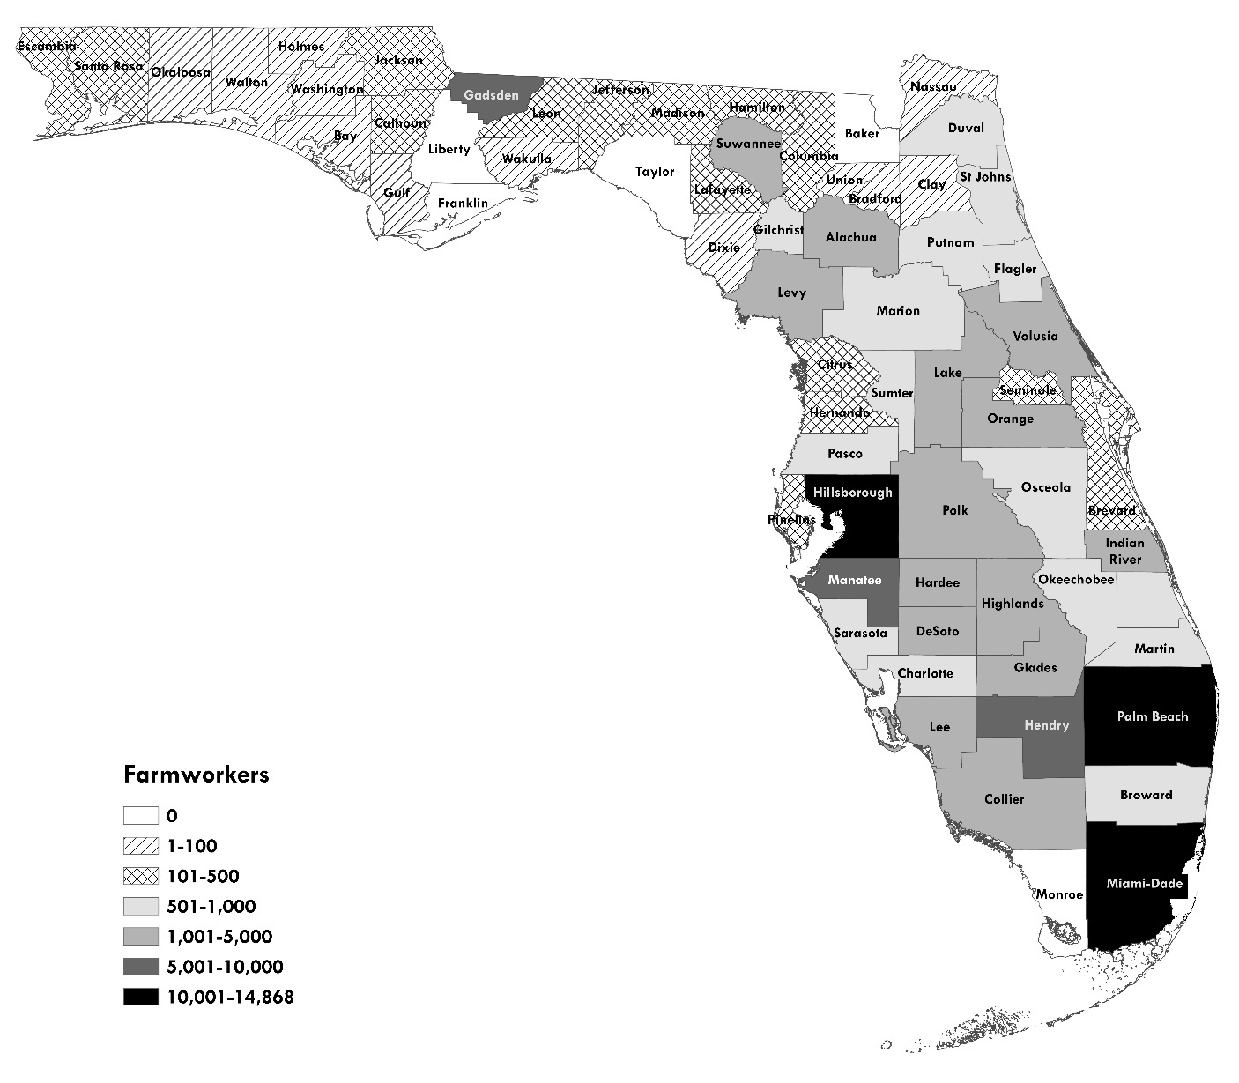
Source: U.S. Bureau of Labor Statistics, 2023 Quarterly Census of Employment and Wages; U.S. Department of Labor, National Agricultural Workers Survey (multiple years); U.S. Department of Labor, Office of Foreign Labor Certification, 2024 H-2A Disclosure Data

Table 7.3. Unaccompanied Farmworkers by County of Employment
County | Unaccompanied Migrant Workers | Unaccompanied Seasonal Workers | H-2A Workers | Total Unaccompanied Workers
Alachua | 132 | 442 | 809 | 1,383
Baker | 0 | 0 | 0 | 0
Bay | 5 | 17 | 6 | 28
Bradford | 0 | 0 | 20 | 20
Brevard | 11 | 38 | 84 | 134
Broward | 38 | 126 | 348 | 512
Calhoun | 11 | 37 | 9 | 58
Charlotte | 23 | 78 | 355 | 456
Citrus | 7 | 22 | 115 | 144
Clay | 2 | 8 | 6 | 16
Collier | 158 | 533 | 2,260 | 2,951
Columbia | 14 | 46 | 65 | 124
DeSoto | 120 | 402 | 2,379 | 2,901
Dixie | 0 | 0 | 82 | 82
Duval | 56 | 188 | 0 | 244
Escambia | 8 | 25 | 5 | 38
Flagler | 20 | 66 | 593 | 679
Franklin | 0 | 0 | 0 | 0
Gadsden | 442 | 1,484 | 840 | 2,766
Gilchrist | 9 | 29 | 709 | 747
Glades | 13 | 42 | 2,880 | 2,935
Gulf | 0 | 0 | 2 | 2
Hamilton | 13 | 44 | 136 | 193
Hardee | 50 | 169 | 1,988 | 2,207
Hendry | 199 | 670 | 2,378 | 3,248
Hernando | 14 | 48 | 3 | 65
Highlands | 149 | 501 | 1,347 | 1,998
Hillsborough | 383 | 1,287 | 9,512 | 11,182
Holmes | 2 | 7 | 14 | 23
Indian River | 43 | 145 | 1,069 | 1,257
Jackson | 13 | 44 | 283 | 340
Jefferson | 19 | 65 | 10 | 94
Lafayette | 2 | 7 | 98 | 107
Lake | 195 | 655 | 708 | 1,558
Lee | 112 | 375 | 662 | 1,149
Leon | 7 | 22 | 10 | 39
Levy | 15 | 49 | 1,080 | 1,144
Liberty | 0 | 0 | 0 | 0
Madison | 7 | 25 | 68 | 100
Manatee | 220 | 739 | 3,800 | 4,759
Marion | 24 | 80 | 473 | 576
Martin | 28 | 93 | 281 | 402
Miami-Dade | 872 | 2,931 | 499 | 4,302
Monroe | 0 | 0 | 0 | 0
Nassau | 3 | 10 | 2 | 15
Okaloosa | 3 | 12 | 10 | 25
Okeechobee | 19 | 62 | 536 | 617
Orange | 230 | 772 | 191 | 1,192
Osceola | 16 | 53 | 549 | 618
Palm Beach | 571 | 1,918 | 5,146 | 7,635
Pasco | 39 | 132 | 28 | 199
Pinellas | 20 | 68 | 0 | 88
Polk | 152 | 510 | 2,350 | 3,011
Putnam | 35 | 119 | 247 | 401
St. Johns | 42 | 140 | 399 | 580
St. Lucie | 45 | 153 | 272 | 470
Santa Rosa | 19 | 65 | 31 | 115
Sarasota | 10 | 34 | 398 | 442
Seminole | 18 | 60 | 0 | 77
Sumter | 40 | 136 | 142 | 318
Suwannee | 22 | 73 | 899 | 994
Taylor | 0 | 0 | 0 | 0
Union | 0 | 0 | 60 | 60
Volusia | 125 | 421 | 142 | 688
Wakulla | 0 | 0 | 8 | 8
Walton | 1 | 3 | 0 | 4
Washington | 4 | 13 | 0 | 17
County Unknown | 9 | 31 | 0 | 40
State of Florida | 4,857 | 16,324 | 47,396 | 68,577
Source: Shimberg Center tabulation of U.S. Bureau of Labor Statistics, 2023 Quarterly Census of Employment and Wages; U.S. Department of Labor, National Agricultural Workers Survey (multiple years); U.S. Department of Labor, Office of Foreign Labor Certification, 2024 H-2A Disclosure Data

Table 7.4. Accompanied Farmworkers, Households, and Household Members by County of Employment
County | Accomp. Migrant Workers | Accomp. Seasonal Workers | Total Accomp. Workers | Accomp. Migrant Households | Accomp. Seasonal Households | Total Accomp. Households | Accomp. Migrant Household Members | Accomp. Seasonal Household Members | Total Accomp. Household Members
Alachua | 71 | 1,196 | 1,267 | 39 | 854 | 894 | 150 | 3,246 | 3,396
Baker | 0 | 0 | 0 | 0 | 0 | 0 | 0 | 0 | 0
Bay | 3 | 46 | 49 | 2 | 33 | 35 | 6 | 126 | 132
Bradford | 0 | 0 | 0 | 0 | 0 | 0 | 0 | 0 | 0
Brevard | 6 | 103 | 110 | 3 | 74 | 77 | 13 | 281 | 294
Broward | 20 | 342 | 362 | 11 | 244 | 256 | 43 | 928 | 971
Calhoun | 6 | 101 | 107 | 3 | 72 | 76 | 13 | 275 | 288
Charlotte | 12 | 210 | 222 | 7 | 150 | 157 | 26 | 570 | 596
Citrus | 4 | 60 | 64 | 2 | 43 | 45 | 8 | 164 | 171
Clay | 1 | 20 | 22 | 1 | 15 | 15 | 3 | 55 | 58
Collier | 85 | 1,440 | 1,525 | 47 | 1,029 | 1,076 | 180 | 3,909 | 4,089
Columbia | 7 | 124 | 131 | 4 | 88 | 92 | 15 | 335 | 351
DeSoto | 64 | 1,088 | 1,152 | 36 | 777 | 813 | 136 | 2,953 | 3,089
Dixie | 0 | 0 | 0 | 0 | 0 | 0 | 0 | 0 | 0
Duval | 30 | 508 | 539 | 17 | 363 | 380 | 64 | 1,380 | 1,444
Escambia | 4 | 68 | 73 | 2 | 49 | 51 | 9 | 186 | 194
Flagler | 11 | 180 | 190 | 6 | 128 | 134 | 22 | 487 | 510
Franklin | 0 | 0 | 0 | 0 | 0 | 0 | 0 | 0 | 0
Gadsden | 238 | 4,013 | 4,251 | 132 | 2,867 | 2,999 | 502 | 10,893 | 11,395
Gilchrist | 5 | 79 | 84 | 3 | 57 | 59 | 10 | 215 | 225
Glades | 7 | 114 | 120 | 4 | 81 | 85 | 14 | 309 | 323
Gulf | 0 | 0 | 0 | 0 | 0 | 0 | 0 | 0 | 0
Hamilton | 7 | 118 | 125 | 4 | 84 | 88 | 15 | 320 | 334
Hardee | 27 | 456 | 483 | 15 | 326 | 341 | 57 | 1,238 | 1,295
Hendry | 107 | 1,812 | 1,919 | 60 | 1,294 | 1,354 | 227 | 4,918 | 5,145
Hernando | 8 | 129 | 136 | 4 | 92 | 96 | 16 | 349 | 365
Highlands | 80 | 1,356 | 1,436 | 45 | 968 | 1,013 | 170 | 3,680 | 3,849
Hillsborough | 206 | 3,480 | 3,686 | 115 | 2,486 | 2,600 | 435 | 9,445 | 9,881
Holmes | 1 | 18 | 20 | 1 | 13 | 14 | 2 | 50 | 52
Indian River | 23 | 392 | 415 | 13 | 280 | 293 | 49 | 1,065 | 1,114
Jackson | 7 | 118 | 125 | 4 | 84 | 88 | 15 | 321 | 335
Jefferson | 10 | 175 | 185 | 6 | 125 | 130 | 22 | 474 | 495
Lafayette | 1 | 19 | 20 | 1 | 13 | 14 | 2 | 50 | 53
Lake | 105 | 1,772 | 1,877 | 58 | 1,266 | 1,324 | 222 | 4,810 | 5,032
Lee | 60 | 1,014 | 1,074 | 33 | 724 | 758 | 127 | 2,753 | 2,879
Leon | 4 | 60 | 63 | 2 | 43 | 45 | 7 | 162 | 169
Levy | 8 | 133 | 141 | 4 | 95 | 99 | 17 | 361 | 377
Liberty | 0 | 0 | 0 | 0 | 0 | 0 | 0 | 0 | 0
Madison | 4 | 67 | 71 | 2 | 48 | 50 | 8 | 182 | 191
Manatee | 118 | 1,999 | 2,117 | 66 | 1,428 | 1,494 | 250 | 5,426 | 5,676
Marion | 13 | 216 | 228 | 7 | 154 | 161 | 27 | 585 | 612
Martin | 15 | 252 | 267 | 8 | 180 | 188 | 32 | 685 | 716
Miami-Dade | 470 | 7,925 | 8,395 | 261 | 5,661 | 5,922 | 991 | 21,512 | 22,503
Monroe | 0 | 0 | 0 | 0 | 0 | 0 | 0 | 0 | 0
Nassau | 2 | 27 | 29 | 1 | 19 | 20 | 3 | 73 | 76
Okaloosa | 2 | 32 | 33 | 1 | 23 | 24 | 4 | 86 | 90
Okeechobee | 10 | 168 | 178 | 6 | 120 | 126 | 21 | 457 | 478
Orange | 124 | 2,087 | 2,210 | 69 | 1,490 | 1,559 | 261 | 5,663 | 5,925
Osceola | 9 | 144 | 153 | 5 | 103 | 108 | 18 | 392 | 410
Palm Beach | 307 | 5,186 | 5,493 | 171 | 3,704 | 3,875 | 649 | 14,077 | 14,725
Pasco | 21 | 356 | 377 | 12 | 254 | 266 | 45 | 967 | 1,011
Pinellas | 11 | 183 | 194 | 6 | 131 | 137 | 23 | 497 | 520
Polk | 82 | 1,378 | 1,460 | 45 | 984 | 1,030 | 172 | 3,741 | 3,913
Putnam | 19 | 321 | 340 | 11 | 229 | 240 | 40 | 870 | 910
St. Johns | 22 | 378 | 400 | 12 | 270 | 282 | 47 | 1,026 | 1,073
St. Lucie | 24 | 413 | 437 | 14 | 295 | 308 | 52 | 1,120 | 1,171
Santa Rosa | 10 | 175 | 186 | 6 | 125 | 131 | 22 | 475 | 497
Sarasota | 5 | 92 | 97 | 3 | 66 | 69 | 12 | 250 | 261
Seminole | 10 | 161 | 171 | 5 | 115 | 120 | 20 | 437 | 457
Sumter | 22 | 368 | 389 | 12 | 263 | 275 | 46 | 998 | 1,044
Suwannee | 12 | 198 | 209 | 7 | 141 | 148 | 25 | 537 | 561
Taylor | 0 | 0 | 0 | 0 | 0 | 0 | 0 | 0 | 0
Union | 0 | 0 | 0 | 0 | 0 | 0 | 0 | 0 | 0
Volusia | 67 | 1,138 | 1,206 | 37 | 813 | 850 | 142 | 3,089 | 3,232
Wakulla | 0 | 0 | 0 | 0 | 0 | 0 | 0 | 0 | 0
Walton | 0 | 8 | 9 | 0 | 6 | 6 | 1 | 22 | 23
Washington | 2 | 36 | 38 | 1 | 25 | 27 | 4 | 97 | 101
County Unknown | 5 | 84 | 89 | 3 | 60 | 63 | 11 | 228 | 239
State of  Florida | 2,615 | 44,136 | 46,751 | 1,453 | 31,525 | 32,978 | 5,521 | 119,796 | 125,318
Source: Shimberg Center tabulation of U.S. Bureau of Labor Statistics, 2023 Quarterly Census of Employment and Wages; U.S. Department of Labor, National Agricultural Workers Survey (multiple years); U.S. Department of Labor, Office of Foreign Labor Certification, 2024 H-2A Disclosure Data

Farmworker Housing Supply
While farmworkers make a variety of housing arrangements, two types of housing are reserved specifically for them:
- Farmworker multifamily developments: Florida Housing devotes SAIL, HOME and LIHTC resources to construction and rehabilitation of privately owned farmworker rental housing. USDA RD subsidizes production of farmworker rental housing through its Section 514/516 program. In most cases, USDA RD also provides ongoing rent assistance to the tenants in these developments. Statewide, 70 multifamily developments set aside 3,730 affordable housing units for farmworkers.

- Migrant camps: The Florida Department of Health (DOH) issues permits for camps to house unaccompanied migrant and seasonal farmworkers. These include grower-provided housing for H-2A workers. Most provide housing for unaccompanied workers, often on a daily or weekly basis. The camps may consist of single-family homes, mobile homes, motels, multifamily units, or dormitory-style arrangements. In some cases, a development subsidized by Florida Housing or USDA RD also serves as a licensed camp. Individual “beds” are counted as the occupancy in the camps during DOH inspections. Statewide, DOH has identified 51,433 beds for individual workers, including 1,436 located in Florida Housing/RD multifamily developments.
Table 7.5 shows the supply of the two types of housing by county. Migrant camp beds located in Florida Housing/RD developments are counted in the Florida Housing/USDA RD column only.

Table 7.5. Multifamily Farmworker Units and Migrant Camp Beds by County 2025
County | Florida Housing & USDA RD Multifamily Units | DOH Permitted Camp Beds
Alachua | 0 | 3,569
Baker | 0 | 0
Bay | 0 | 6
Bradford | 0 | 127
Brevard | 0 | 94
Broward | 0 | 0
Calhoun | 0 | 12
Charlotte | 0 | 8
Citrus | 0 | 130
Clay | 0 | 16
Collier | 641 | 3,488
Columbia | 0 | 110
DeSoto | 53 | 3,626
Dixie | 0 | 0
Duval | 0 | 10
Escambia | 0 | 3
Flagler | 0 | 304
Franklin | 0 | 0
Gadsden | 0 | 198
Gilchrist | 0 | 0
Glades | 0 | 1,002
Gulf | 0 | 0
Hamilton | 0 | 282
Hardee | 69 | 3,212
Hendry | 66 | 3,222
Hernando | 0 | 196
Highlands | 61 | 4,173
Hillsborough | 352 | 8,075
Holmes | 0 | 0
Indian River | 134 | 535
Jackson | 0 | 126
Jefferson | 0 | 20
Lafayette | 0 | 0
Lake | 80 | 775
Lee | 78 | 761
Leon | 0 | 466
Levy | 0 | 4
Liberty | 0 | 0
Madison | 0 | 132
Manatee | 50 | 2,353
Marion | 124 | 282
Martin | 60 | 31
Miami-Dade | 977 | 205
Monroe | 0 | 0
Nassau | 0 | 0
Okaloosa | 0 | 10
Okeechobee | 15 | 1,269
Orange | 0 | 149
Osceola | 0 | 83
Palm Beach | 746 | 6,268
Pasco | 0 | 237
Pinellas | 0 | 0
Polk | 99 | 4,094
Putnam | 0 | 431
St. Johns | 0 | 274
St. Lucie | 74 | 228
Santa Rosa | 0 | 31
Sarasota | 0 | 0
Seminole | 0 | 30
Sumter | 0 | 8
Suwannee | 0 | 288
Taylor | 0 | 317
Union | 0 | 0
Volusia | 51 | 139
Wakulla | 0 | 0
Walton | 0 | 24
Washington | 0 | 0
State of Florida Total | 3,730 | 51,433
Source: Shimberg Center tabulation of Florida Department of Health migrant camp locations; Shimberg Center for Housing Studies, Assisted Housing Inventory

Need Estimate: Comparison of Supply and Households
The need for additional farmworker housing is estimated by comparing the supply of DOH-permitted migrant camp beds to the number of unaccompanied workers, and the supply of multifamily units assisted by Florida Housing and USDA RD to the number of accompanied worker households. Table 7.6 and Figures 7.2 and 7.3 show the need for unaccompanied worker beds and multifamily units by county. Statewide, there are 68,577 unaccompanied workers and 51,433 permitted migrant camp beds, yielding a need for 17,144 additional beds for single workers. There are 32,978 accompanied households and 3,730 multifamily farmworker set aside units, yielding a need for 29,248 additional multifamily units.
Note that groups of unaccompanied farmworkers also may share units in some multifamily developments. Therefore, a portion of the Florida Housing and Section 514/516 units that we have assigned to accompanied farmworker households may serve unaccompanied workers. Because unaccompanied workers share housing, the numbers of beds needed for them do not necessarily translate to the number of individual units needed. For example, typically a two-bedroom unit would provide four beds for unaccompanied farmworkers.
The top counties in need of single worker beds are Miami-Dade, Hillsborough, Gadsden, Manatee, and Glades. Miami-Dade, Palm Beach, Gadsden, Hillsborough, and Orange Counties have the largest needs for multifamily units. Orange County’s place on this list is notable because it is not one of the top counties for farm work in the state, but it has very few migrant camp beds and no Florida Housing/RD set-aside units for the agricultural labor force that does work in the county.

Table 7.6. Need for Farmworker Housing by Type and County
County | Total Unaccomp. Workers | DOH Permitted Camp Beds | Need for Single Worker Beds | Accompanied Migrant & Seasonal Households | USDA RD & Florida Housing Multifamily Units | Need for Multifamily Units
Alachua | 1,383 | 3,569 | -2,186 | 894 | 0 | 894
Baker | 0 | 0 | 0 | 0 | 0 | 0
Bay | 28 | 6 | 22 | 35 | 0 | 35
Bradford | 20 | 127 | -107 | 0 | 0 | 0
Brevard | 134 | 94 | 40 | 77 | 0 | 77
Broward | 512 | 0 | 512 | 256 | 0 | 256
Calhoun | 58 | 12 | 46 | 76 | 0 | 76
Charlotte | 456 | 8 | 448 | 157 | 0 | 157
Citrus | 144 | 130 | 14 | 45 | 0 | 45
Clay | 16 | 16 | 0 | 15 | 0 | 15
Collier | 2,951 | 3,488 | -537 | 1,076 | 641 | 435
Columbia | 124 | 110 | 14 | 92 | 0 | 92
DeSoto | 2,901 | 3,626 | -725 | 813 | 53 | 760
Dixie | 82 | 0 | 82 | 0 | 0 | 0
Duval | 244 | 10 | 234 | 380 | 0 | 380
Escambia | 38 | 3 | 35 | 51 | 0 | 51
Flagler | 679 | 304 | 375 | 134 | 0 | 134
Franklin | 0 | 0 | 0 | 0 | 0 | 0
Gadsden | 2,766 | 198 | 2,568 | 2,999 | 0 | 2,999
Gilchrist | 747 | 0 | 747 | 59 | 0 | 59
Glades | 2,935 | 1,002 | 1,933 | 85 | 0 | 85
Gulf | 2 | 0 | 2 | 0 | 0 | 0
Hamilton | 193 | 282 | -89 | 88 | 0 | 88
Hardee | 2,207 | 3,212 | -1,005 | 341 | 69 | 272
Hendry | 3,248 | 3,222 | 26 | 1,354 | 66 | 1,288
Hernando | 65 | 196 | -131 | 96 | 0 | 96
Highlands | 1,998 | 4,173 | -2,175 | 1,013 | 61 | 952
Hillsborough | 11,182 | 8,075 | 3,107 | 2,600 | 352 | 2,248
Holmes | 23 | 0 | 23 | 14 | 0 | 14
Indian River | 1,257 | 535 | 722 | 293 | 134 | 159
Jackson | 340 | 126 | 214 | 88 | 0 | 88
Jefferson | 94 | 20 | 74 | 130 | 0 | 130
Lafayette | 107 | 0 | 107 | 14 | 0 | 14
Lake | 1,558 | 775 | 783 | 1,324 | 80 | 1,244
Lee | 1,149 | 761 | 388 | 758 | 78 | 680
Leon | 39 | 466 | -427 | 45 | 0 | 45
Levy | 1,144 | 4 | 1,140 | 99 | 0 | 99
Liberty | 0 | 0 | 0 | 0 | 0 | 0
Madison | 100 | 132 | -32 | 50 | 0 | 50
Manatee | 4,759 | 2,353 | 2,406 | 1,494 | 50 | 1,444
Marion | 576 | 282 | 294 | 161 | 124 | 37
Martin | 402 | 31 | 371 | 188 | 60 | 128
Miami-Dade | 4,302 | 205 | 4,097 | 5,922 | 977 | 4,945
Monroe | 0 | 0 | 0 | 0 | 0 | 0
Nassau | 15 | 0 | 15 | 20 | 0 | 20
Okaloosa | 25 | 10 | 15 | 24 | 0 | 24
Okeechobee | 617 | 1,269 | -652 | 126 | 15 | 111
Orange | 1,192 | 149 | 1,043 | 1,559 | 0 | 1,559
Osceola | 618 | 83 | 535 | 108 | 0 | 108
Palm Beach | 7,635 | 6,268 | 1,367 | 3,875 | 746 | 3,129
Pasco | 199 | 237 | -38 | 266 | 0 | 266
Pinellas | 88 | 0 | 88 | 137 | 0 | 137
Polk | 3,011 | 4,094 | -1,083 | 1,030 | 99 | 931
Putnam | 401 | 431 | -30 | 240 | 0 | 240
St. Johns | 580 | 274 | 306 | 282 | 0 | 282
St. Lucie | 470 | 228 | 242 | 308 | 74 | 234
Santa Rosa | 115 | 31 | 84 | 131 | 0 | 131
Sarasota | 442 | 0 | 442 | 69 | 0 | 69
Seminole | 77 | 30 | 47 | 120 | 0 | 120
Sumter | 318 | 8 | 310 | 275 | 0 | 275
Suwannee | 994 | 288 | 706 | 148 | 0 | 148
Taylor | 0 | 317 | -317 | 0 | 0 | 0
Union | 60 | 0 | 60 | 0 | 0 | 0
Volusia | 688 | 139 | 549 | 850 | 51 | 799
Wakulla | 8 | 0 | 8 | 0 | 0 | 0
Walton | 4 | 24 | -20 | 6 | 0 | 6
Washington | 17 | 0 | 17 | 27 | 0 | 27
State of Florida Total | 68,577 | 51,433 | 17,144 | 32,978 | 3,730 | 29,248
Notes: Counties with negative need for single worker beds have higher than average shares of migrant workers and large supplies of migrant camp beds, which may serve workers during multiple harvesting periods.
Source: Shimberg Center tabulation of U.S. Bureau of Labor Statistics, 2023 Quarterly Census of Employment and Wages; U.S. Department of Labor, National Agricultural Workers Survey (multiple years); U.S. Department of Labor, Office of Foreign Labor Certification, 2024 H-2A Disclosure Data; Florida Department of Health; Shimberg Center for Housing Studies, Assisted Housing Inventory

Figure 7.2. Need for Beds for Unaccompanied Workers by County
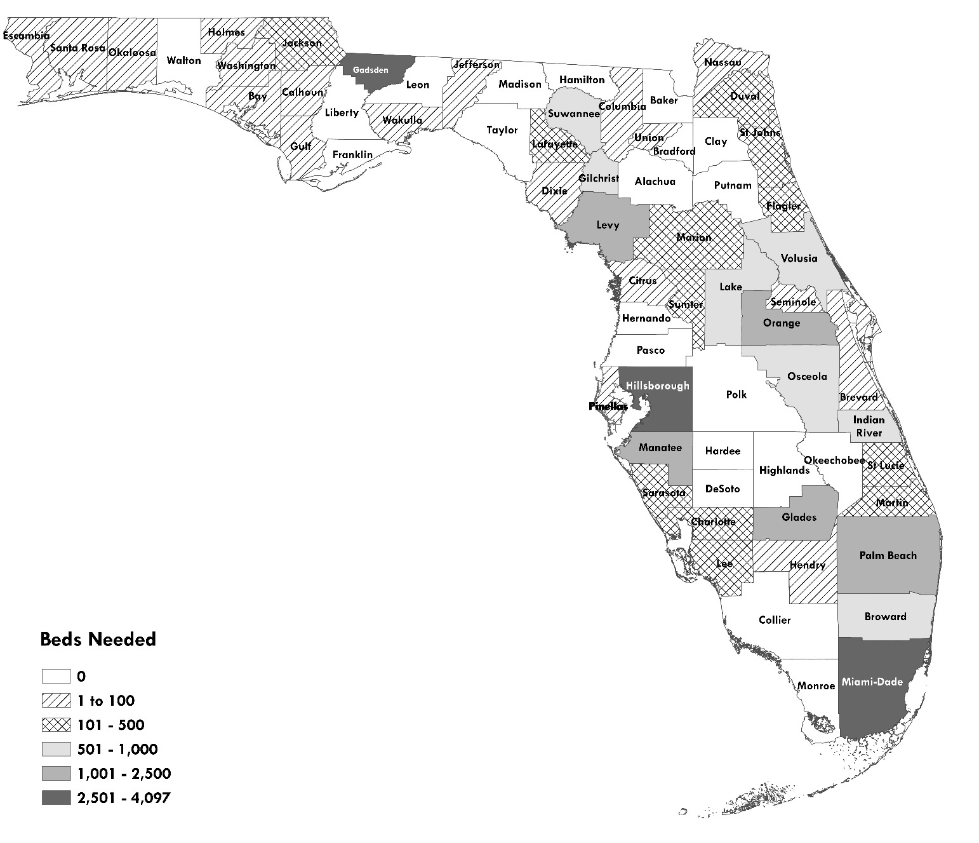
Source: U.S. Bureau of Labor Statistics, 2023 Quarterly Census of Employment and Wages; U.S. Department of Labor, National Agricultural Workers Survey (multiple years); U.S. Department of Labor, Office of Foreign Labor Certification, 2024 H-2A Disclosure Data; Florida Department of Health; Shimberg Center for Housing Studies, Assisted Housing Inventory

Figure 7.3. Need for Farmworker Multifamily Units by County
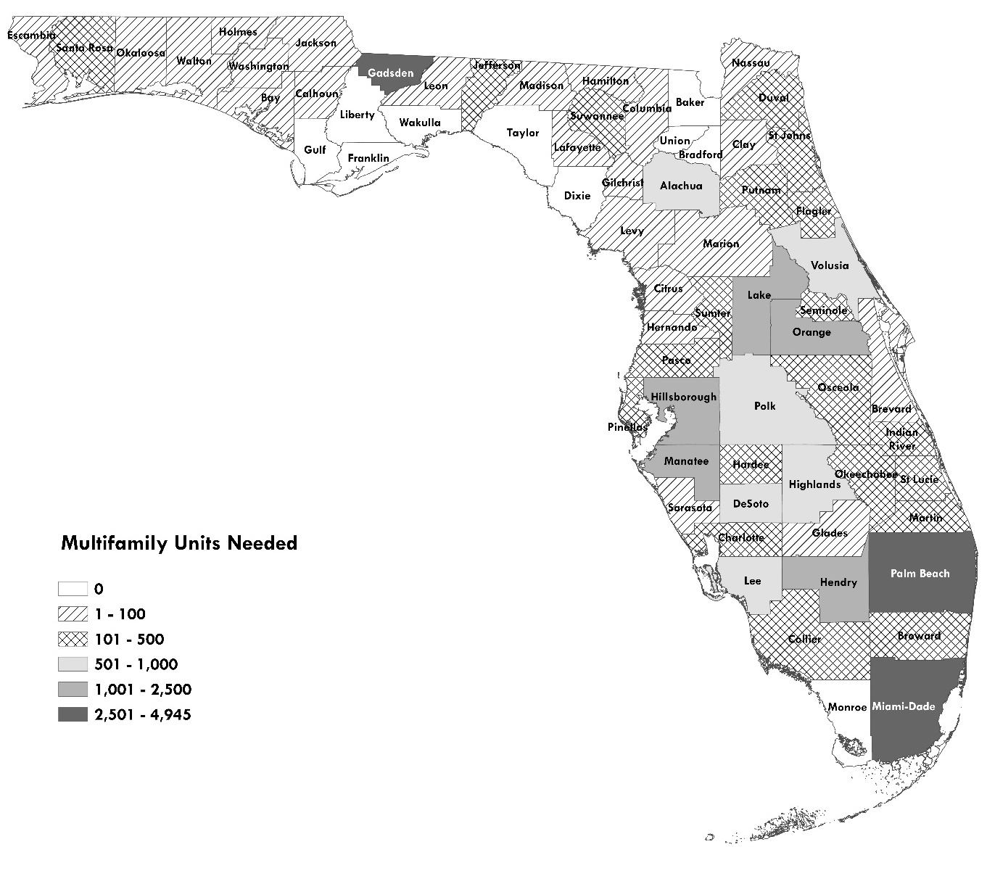
Source: U.S. Bureau of Labor Statistics, 2023 Quarterly Census of Employment and Wages; U.S. Department of Labor, National Agricultural Workers Survey (multiple years); U.S. Department of Labor, Office of Foreign Labor Certification, 2024 H-2A Disclosure Data; Florida Department of Health; Shimberg Center for Housing Studies, Assisted Housing Inventory

Methodology for Farmworker Estimates

Total Farmworker Counts
The state and county numbers of farmworkers are derived from two counts. For H-2A workers, the U.S. Department of Labor provides a direct count of workers. Specifically, this report uses the count of workers certified for sites in Florida published in the fourth quarter of 2024, downloaded from https://www.foreignlaborcert.doleta.gov/performancedata.cfm.
For other workers, there is no direct count. Instead, the number of workers is estimated using data from the U.S. Bureau of Labor Statistics’ Quarterly Census of Employment and Wages (QCEW) and the Department of Labor’s National Agricultural Workers Survey (NAWS). The QCEW “produces a comprehensive tabulation of employment and wage information for workers covered by State unemployment insurance (UI) laws” by industry, including total annual wages and average weekly wages.
- QCEW data are available by state and county as well as by NAICS (North American Industry Classification, formerly SIC) industrial code. 2023 is the most recent year for which full data are publicly available. H-2A workers are not included in QCEW data because they are not eligible for unemployment insurance. The farmworker counts are based on employment in two NAICS codes: 111, “Crop Production,” and 11511, “Support Activities for Crop Production.” These classifications include farms, orchards, groves, greenhouses and nurseries.
- NAWS: The NAWS “is an employment-based, random- sample survey of U.S. crop workers that collects demographic, employment, and health data” produced by the U.S. Department of Labor. It includes information about the demographic characteristics of workers and their households, employment history, and migration patterns. The Department of Labor provided special tabulations of the NAWS data for this report through contractor JBS International.
State and county-level estimates of non-H-2A workers are calculated using a three-step process:
- Use the QCEW data to calculate the total number of weeks worked by workers in NAICS codes 111 and 11511. For each code and geographic area,
Total number of weeks worked = Total annual wages/Average weekly wage
- Use the NAWS data to calculate the number of workers required to work that number of weeks in one year. The NAWS shows that farmworkers in Florida worked an average of 40 weeks during the 2019-2022 period, the most recent data available to the Shimberg Center. This allows us to translate the total number of weeks worked in a geographic area and NAICS code into an estimated number of workers: Workers = Total annual weeks worked/ Average weeks worked per year = Total annual weeks worked/40
- Sum the total workers for the two industrial codes in each geographic area. Total farmworkers = Workers in code 111 + Workers in code 11511
Using the QCEW to distribute farmworkers across counties introduces an error into the distribution. In this report, the sum of the number of farmworkers in all counties is lower than the statewide total. This is also true for the numbers of farmworker households and household members, which are derived directly from the number of farmworkers. This disparity has two causes. First, the QCEW includes a category of employment establishments for which counties cannot be identified based on data submitted by employers. There are 123 workers estimated in a “County Unknown” category. These workers and their household members are counted in Tables 7.2-7.4 but are not included in Table 7.6 comparing supply and demand by county.
Second, the Bureau of Labor Statistics suppresses wage data for establishments in some counties in order to protect confidentiality but includes the data in statewide totals. In these counties, the number of farmworkers is actually higher than the figures reported in this report. Statewide, this results in 2,936 farmworkers (4 percent) included in the state total that are not attributed to any county or to the “County Unknown” category. To account for those workers, we redistributed the workers among the counties and the “County Unknown” category based on the counties’ share of the workers for whom a county (or “County Unknown”) designation could be identified using the QCEW and NAWS data. This likely results in an underestimate of workers in some counties and an overestimate in others, since the wages and therefore workers at the suppressed establishments are unlikely to match the county-level distribution of wages and workers at other establishments.

Detailed Household and Member Counts
The NAWS dataset was used to stratify non-H-2A farmworkers by migrant/seasonal and accompanied/unaccompanied status, in order to estimate the number of farmworker households. To increase sample size, NAWS interviews were included from the most recent three-year period available (fiscal years 2019-2022; 225 respondents).
Steps to translate farmworker counts into households and household members were as follows:
- Divide non-H-2A workers into migrant and seasonal categories. In the NAWS interviews, 11 percent of workers were migrant and 89 percent were seasonal. These percentages were applied to the county and state total non-H-2A workers. For the statewide total of 67,932 non-H-2A workers, this meant that 7,473 were assumed to be migrant (67,932 * .11) and 60,460 (67,932 * .89) were assumed to be seasonal.
- Divide migrant and seasonal workers into accompanied and unaccompanied categories.
  - Migrant: 65 percent of migrant workers reported unaccompanied status and 35 percent reported being accompanied by family. This translates to 4,857 unaccompanied migrant workers (.65 * 7,473), to which we added the 47,396 H-2A workers. Accompanied migrant workers were estimated at .35 * 7,473, for a total of 2,615 accompanied migrant workers.
  - Seasonal: 27 percent of seasonal workers reported unaccompanied status and 73 percent reported being accompanied. This translates to 16,324 unaccompanied seasonal workers (.27 * 60,460) and 44,136 accompanied seasonal workers (.73 * 60,460).
- Translate the number of accompanied workers into households. The number of households should be smaller than the number of workers, since a household may have more than one worker.
  - Accompanied migrant households: The average accompanied migrant household contained 1.8 farmworkers. This translates to 1,453 accompanied migrant households (2,615 workers/1.8 workers per household).
  - Accompanied seasonal households: The average seasonal worker household contained 1.4 farmworkers. This translates to 31,525 accompanied seasonal worker households (44,136 workers/1.4 workers per household).
- Translate accompanied worker household counts into household members. Average household size for both migrant and seasonal accompanied worker households was 3.8 members. This translates to 5,521 accompanied migrant household members (1,453 * 3.8) and 119,796 accompanied seasonal household members (31,525 * 3.8).
- Because unaccompanied workers are by definition households of one, the counts of unaccompanied workers, households and household members are all the same.

Commercial Fishing Workers
This section of the Rental Market Study discusses the affordable housing needs of commercial fishing workers in Florida. County-level estimates are not available due to limitations of the data sources, as described below.

Methodology and Estimate
The method for producing an estimate of fishing workers’ rental housing needs is as follows:
1. Determine the number of low-income households in the American Community Survey with at least one worker in the industry categories that include fishing-related firms.
We used the 2023 ACS to estimate the number of households with incomes below 60 percent of AMI and at least one worker in these Census industry codes:
- Fishing, Hunting and Trapping (Industry Code 0280): 1,417 households up to 60 percent of AMI
- Animal Production and Aquaculture (Industry Code 0180): 3,373 households up to 60 percent of AMI
- Seafood and other miscellaneous foods, manufacturing (Industry Code 1280): 1,187 households up to 60 percent of AMI.
These are statewide numbers. The sample size and geographic categories of the ACS microdata do not permit estimates at the county level.
2. Estimate the share of workers in these industry categories working in fishing, aquaculture and seafood production.
The Census industry categories include workers other than fishing workers. For example, Animal Production and Aquaculture includes workers on cattle ranches and other livestock farms. The Census does not provide subcategories of these industry codes that separate out the fishing-related jobs.
However, the North American Industry Classification System (NAICS) from the Bureau of Labor Statistics (BLS) does provide subcategories, and a crosswalk between Census and NAICS codes is available. The 2023 Quarterly Census of Employment and Wages (QCEW) from the BLS provides an annual average count of employees by NAICS code for the state. Therefore, we used the NAICS subcategories in the QCEW to calculate the ratio of fishing-specific employees to total employees in each of the three Census industry categories from the QCEW:
- Fishing, hunting, & trapping: 78.81 percent of employees work in fishing.
- Animal production and aquaculture: 12.27 percent of employees work in aquaculture.
- Seafood and other miscellaneous foods (manufacturing): 18.06 percent of employees work in seafood product preparation & packaging.
Again, these are statewide percentages. While the QCEW does provide data at the county level, employment numbers from many firms are suppressed at the county level for privacy purposes. Using the county-level data would result in substantial undercounts of fishing workers.
3. Use estimated worker shares in each industry to estimate low-income, fishing worker households.
We applied the QCEW percentages from step 2 to the ACS household totals in step 1 to estimate the shares of low-income households that work in fishing-related industries, as a subset of households with workers in the three overall industry categories.

Table 8.1 Estimates of Low-Income, Fishing Worker Households, Florida
Industry | Households 0-  60% AMI (ACS) | Share of  Employees in  Fishing-Related  Industry (QCEW) | Est. Households 0-  60% AMI, Fishing  Workers Only  (A*B)
Fishing, Hunting and Trapping | 1,417 | 78.81% | 1,117
Animal Production and Aquaculture | 3,373 | 12.27% | 414
Seafood and other miscellaneous  foods, manufacturing | 1,187 | 18.06% | 214
Total Estimated Low Income Fishing Worker Households |  |  | 1,745
4. Subtract existing housing supply from demand to yield need for fishing worker units.
Florida Housing has 140 fishing worker set-aside units in the Atlantic Pines and Mariner’s Cove developments in Monroe County and the DeSoto Landing development in DeSoto county. Subtracting the supply (140 units) from the demand (1,745 fishing worker households) yields a need of 1,605 units.

Assisted Housing Supply
Florida’s public and assisted housing stock makes up one-tenth of the state’s total rental housing supply. Including units in the development pipeline, Florida has 314,200 units of public and assisted housing. These units are available at monthly rents that can range hundreds of dollars below market rates. Public housing developments are owned by local housing authorities funded by the U.S. Department of Housing and Urban Development (HUD). Other assisted housing developments may be owned by for-profit corporations, non-profit organizations, or public agencies. They receive subsidies such as low-interest development financing or ongoing rental assistance from HUD, U.S. Department of Agriculture’s Rural Development program (RD), Florida Housing Finance Corporation (Florida Housing), and local housing finance authorities (LHFAs). These two types of affordable housing can overlap, as public housing developments may also receive federal and state subsidies for preservation and redevelopment.

Table 9.1. Assisted Housing Developments and Units by Funder, Florida (Duplicated Count)
Funder | Developments | Assisted Units
Florida Housing | 2,079 | 240,525
HUD Multifamily | 829 | 68,811
Public Housing | 219 | 27,378
USDA Rural Development | 397 | 18,042
Local Housing Finance Authorities | 449 | 70,160
All Funders | 3,114 | 314,200
Notes: Unit counts include only rent- and income-restricted units. Developments may be counted under more than one funder’s totals.
Source: Shimberg Center for Housing Studies, Assisted Housing Inventory.
Assisted housing developments are subject to rent and income restrictions to ensure that their units are affordable and available to low-income tenants. In public housing and developments with HUD or RD rental assistance, the federal government also provides a rent supplement that typically enables tenants to pay no more than 30 percent of their income for rent.

County Locations of Assisted Housing
The county locations of assisted units closely mirror the locations of low-income, cost burdened renter households (see Table 9.2 and Figure 9.1 below). Sixty-five percent of the state’s units and 64 percent of cost burdened renters are located in large counties. The largest concentrations of assisted units are in Miami-Dade County (66,227 units, 21 percent of state total) and Orange County (32,007 units, 10 percent of state total).
Medium counties contain most of the rest of the units (30 percent) and cost burdened renters (33 percent). Five percent of units and less than three percent of cost burdened renters are located in small counties.

Table 9.2. Public and Assisted Housing Supply by County, Florida
 | Developments | Assisted Units | % of State's Assisted Units | % of State's Low-Income, Cost Burdened Renters
Large
Broward | 185 | 22,116 | 7.04% | 10.58%
Duval | 161 | 21,748 | 6.92% | 6.13%
Hillsborough | 186 | 21,549 | 6.86% | 7.62%
Lee | 77 | 6,623 | 2.11% | 3.18%
Miami-Dade | 552 | 66,227 | 21.08% | 14.68%
Orange | 209 | 32,007 | 10.19% | 7.89%
Palm Beach | 122 | 14,839 | 4.72% | 7.10%
Pinellas | 151 | 11,825 | 3.76% | 4.83%
Polk | 96 | 7,840 | 2.50% | 2.48%
Large Total | 1,739 | 204,774 | 65.17% | 64.48%
Medium
Alachua | 57 | 4,213 | 1.34% | 1.85%
Bay | 39 | 3,474 | 1.11% | 0.69%
Brevard | 59 | 5,971 | 1.90% | 2.77%
Charlotte | 24 | 2,270 | 0.72% | 0.71%
Citrus | 36 | 1,302 | 0.41% | 0.44%
Clay | 22 | 1,779 | 0.57% | 0.68%
Collier | 48 | 5,380 | 1.71% | 1.59%
Escambia | 62 | 5,276 | 1.68% | 1.35%
Flagler | 12 | 889 | 0.28% | 0.50%
Hernando | 31 | 2,096 | 0.67% | 0.61%
Highlands | 32 | 1,555 | 0.49% | 0.31%
Indian River | 28 | 2,754 | 0.88% | 0.51%
Lake | 76 | 5,059 | 1.61% | 1.75%
Leon | 48 | 5,492 | 1.75% | 1.78%
Manatee | 51 | 5,002 | 1.59% | 1.69%
Marion | 32 | 2,721 | 0.87% | 1.33%
Martin | 15 | 880 | 0.28% | 0.64%
Nassau | 17 | 800 | 0.25% | 0.20%
Okaloosa | 22 | 1,765 | 0.56% | 0.81%
Osceola | 58 | 8,787 | 2.80% | 2.19%
Pasco | 61 | 4,151 | 1.32% | 1.91%
Santa Rosa | 14 | 759 | 0.24% | 0.40%
Sarasota | 38 | 2,820 | 0.90% | 1.57%
Seminole | 46 | 5,679 | 1.81% | 2.13%
St. Johns | 23 | 1,461 | 0.46% | 0.75%
St. Lucie | 22 | 3,388 | 1.08% | 1.29%
Sumter | 11 | 447 | 0.14% | 0.43%
Volusia | 82 | 8,217 | 2.62% | 2.03%
Medium Total | 1,066 | 94,387 | 30.04% | 32.90%
Small
Baker | 5 | 234 | 0.07% | 5
Bradford | 11 | 530 | 0.17% | 11
Calhoun | 3 | 132 | 0.04% | 3
Columbia | 14 | 830 | 0.26% | 14
DeSoto | 21 | 1,117 | 0.36% | 21
Dixie | 3 | 58 | 0.02% | 3
Franklin | 8 | 316 | 0.10% | 8
Gadsden | 18 | 1,032 | 0.33% | 18
Gilchrist | 2 | 60 | 0.02% | 2
Glades | 2 | 78 | 0.02% | 2
Gulf | 5 | 189 | 0.06% | 5
Hamilton | 6 | 233 | 0.07% | 6
Hardee | 13 | 686 | 0.22% | 13
Hendry | 15 | 703 | 0.22% | 15
Holmes | 5 | 137 | 0.04% | 5
Jackson | 26 | 1,140 | 0.36% | 26
Jefferson | 4 | 172 | 0.05% | 4
Lafayette | 1 | 36 | 0.01% | 1
Levy | 14 | 575 | 0.18% | 14
Liberty | 0 | 0 | 0.00% | 0
Madison | 8 | 337 | 0.11% | 8
Monroe | 39 | 2,521 | 0.80% | 39
Okeechobee | 7 | 303 | 0.10% | 7
Putnam | 35 | 1,656 | 0.53% | 35
Suwannee | 13 | 640 | 0.20% | 13
Taylor | 6 | 251 | 0.08% | 6
Union | 3 | 202 | 0.06% | 3
Wakulla | 4 | 121 | 0.04% | 4
Walton | 11 | 541 | 0.17% | 11
Washington | 7 | 209 | 0.07% | 7
Small Total | 309 | 15,039 | 4.79% | 309
State Total | 3,114 | 314,200 | 100.00% | 3,114
Notes: Assisted unit counts include only rent/income-restricted units.
Source: Shimberg Center for Housing Studies, Assisted Housing Inventory

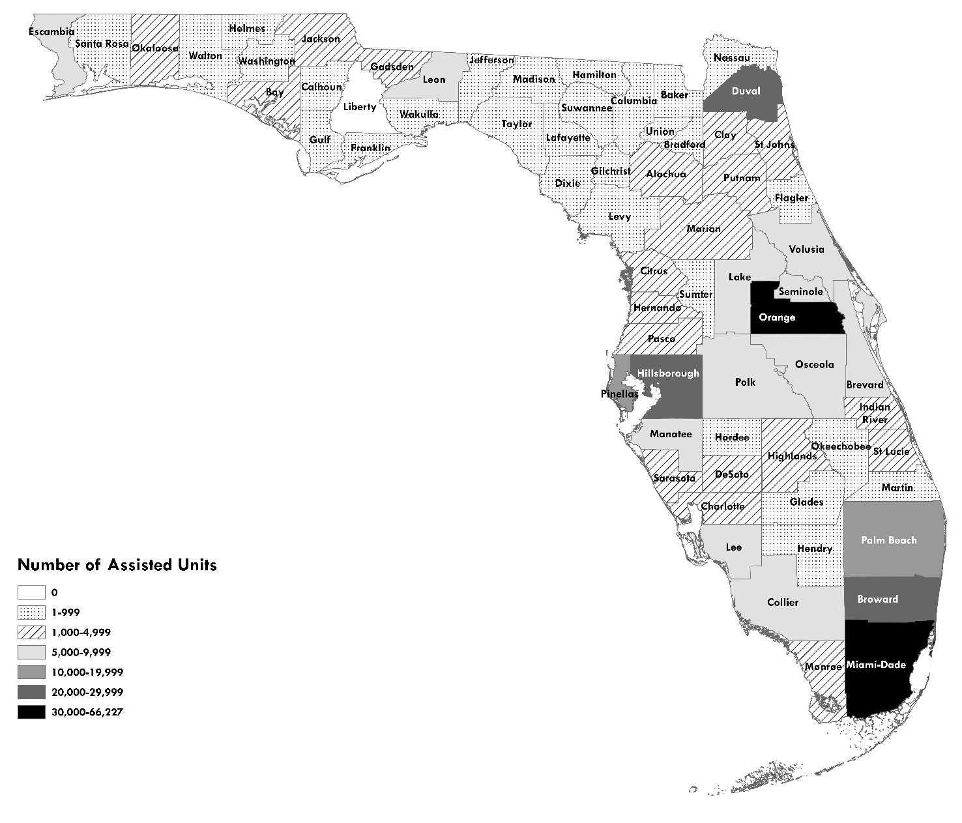
Figure 9.1. Public and Assisted Housing Units by County, Florida
Source: Shimberg Center for Housing Studies, Assisted Housing Inventory

Household and Unit Characteristics
Figures 9.2-9.7 compare household and unit characteristics for assisted housing with Florida’s renters as a whole. Developments are grouped by funder. The Florida Housing developments are further subdivided into two types of categories: 1) with and without rental assistance (combining tenant-based vouchers and project-based rental assistance), and 2) family versus elderly target population. Developments may fall into more than one category.
The “all renters” category combines non-student households in market-rate, public housing, and assisted rental units. It is not possible to separate out households in market-rate units only, although most units in this category will be market-rate. This category includes multifamily developments, single family homes, condominiums, and any other type of rental unit included in the American Community Survey.

Tenant Incomes
Assisted housing serves tenants with incomes below the state average, at rents well below market rate. The average income for all renters in Florida is $72,385. In contrast, average income in Florida Housing-sponsored developments is $30,442. Incomes in HUD multifamily and public units are lower still, ranging from $14,000 to $19,000 (Figure 9.2).

Figure 9.2. Average Annual Household Income ($)

Source: Shimberg Center for Housing Studies, Assisted Housing Inventory and U.S. Census Bureau, 2019 American Community Survey
Most residents of Florida Housing developments have incomes below $40,000. Approximately one-third have incomes below $20,000, mostly in units with rental assistance. Elderly units are heavily weighted toward tenants with incomes below $20,000. The residents of family units have a wider range of incomes, with tenants fairly evenly split across income categories ranging from under $20,000 to over $40,000.

Figure 9.3. Tenants by Household Income, Florida Housing-funded Developments

Notes: “With rental assistance” category includes several types of Florida Housing units with deep rental assistance: Florida Housing-funded projects that also have HUD or USDA RD rental assistance, public housing units renovated with Florida Housing funds, and Florida Housing’s LIHTC/SAIL/Bond units occupied by tenants with Housing Choice Vouchers.
Source: Shimberg Center for Housing Studies, Assisted Housing Inventory
Residents of HUD-assisted and public housing units commonly have incomes between $10,000 and $20,000. Tenant incomes are consistent with part-time, low-wage employment and SSI and Social Security benefit levels. In units with HUD rental assistance, most of which are targeted toward elderly residents and persons with disabilities, 81 percent of residents have incomes below $20,000. In public housing, which has more working-age residents, a larger share of households has incomes above $20,000 (33 percent). Income breakdowns above $20,000 are not available for HUD multifamily and public housing.

Figure 9.4. Tenants by Household Income, HUD Multifamily and Public Housing Developments

Source: U.S. Department of Housing and Urban Development, Picture of Subsidized Households
Most Florida Housing-sponsored units set maximum rents and incomes to the 60 percent of AMI level, but in practice most units serve tenants with incomes below that level. The average income in Florida Housing-sponsored units is 35 percent of AMI, and 42 percent of tenants have incomes below 30 percent of AMI. Another 42 percent of Florida Housing units are occupied by households at 30-50 percent of AMI. The remaining 16 percent have incomes above 50 percent of AMI. Most renters in the deeply subsidized units (public housing, HUD multifamily, Florida Housing units with project- or tenant-based rental assistance) have incomes below 30 percent of AMI.
The “all renters” category includes households with a far wider range of incomes. This category includes the state’s low-income renters but also a group of high-income renters who would be ineligible for assisted housing. On average, renters in Florida have incomes of 98 percent of AMI.

Rent Levels
Rents in the assisted housing inventory are well below statewide averages (Figure 9.5). The average gross rent for all Florida Housing units, including utilities, is $1,011 per month. In contrast, the average gross rent for all units in the state is $1,854. The average for market-rate units cannot be determined from American Community Survey data but would be even higher, since the $1,854 average includes public and assisted housing along with the market-rate stock.
Public housing and other units with rental assistance have by far the lowest average tenant-paid rents, near $330-420 per month. These figures include only rent and utility payments from tenants. Supplements such as federal rental assistance and landlord utility payments are not included.

Figure 9.5. Average Tenant-Paid Gross Rent (Rent + Utilities)

Notes: Data unavailable for RD units.
Source: Shimberg Center for Housing Studies, Assisted Housing Inventory and U.S. Census Bureau, 2023 American Community Survey.

Children and Elderly Residents
Forty percent of Florida Housing units include children, including half of family units), compared to 29 percent of all rental units (Figure 9.6).

Figure 9.6. Households with Children Under Age 18
Source: Shimberg Center for Housing Studies, Assisted Housing Inventory and U.S. Census Bureau, 2023 American Community Survey
Figure 9.7 shows the share of units with renters age 62 and older by funder. Florida Housing’s elderly set-aside units and HUD multifamily developments house elderly renters to a far greater degree than the rental stock as a whole. Seventy-eight percent of Florida Housing elderly set-aside units and 64 percent of HUD units house age 62+ renters, compared to 26 percent of the total rental stock.

Figure 9.7. Households with Persons Age 62 and Older

Source: Shimberg Center for Housing Studies, Assisted Housing Inventory and U.S. Census Bureau, 2023 American Community Survey

Risk to the Inventory: Expiring Affordability Restrictions
The 2019 and 2022 Rental Market Studies projected an increase in the loss of three types of assisted housing due to expiring rent restrictions. First, 30-year affordability restrictions for Florida Housing’s 1990s-era properties began expiring in the early 2020s. Most of these were developments financed by the Low Income Housing Tax Credit (“Housing Credits”). Second, HUD rental assistance contracts and use agreements continue to reach expiration dates. Third, RD mortgages and rental assistance for 1970s-80s era rural developments are set to expire, with few options to renew rental assistance.
Since 2022, Florida has lost 24 developments with 2,481 assisted units due to expiring restrictions in these types of housing. These included (overlapping counts): ten Florida Housing developments (1,198 units) with funding from the Housing Credit, SAIL, HOME, Bonds, or Elderly Housing Community Loan programs; seven properties (709 units) with HUD Section 202 Elderly Housing loans, Use Agreements, or rental assistance contracts; two USDA RD developments (65 units) with terminated mortgages; and six local bond-financed developments (829 units).
By the end of 2034, rent and income restrictions will expire for 402 developments with 33,284 assisted units. In some cases, these restrictions are renewable; in others, affordability restrictions will end unless new assisted financing is introduced (Figure 9.8).

Figure 9.8. Characteristics of Affordability Periods by Funding Type
 | Still Producing New Units | Affordability Period Expires | Affordability Period Is Renewable
Florida Housing LIHTC/Bonds/SAIL | X | X
HUD Rental Assistance |  | X | X
USDA Mortgage/Rental Assistance |  | X | * See Notes
Local Bonds | X | X
Notes: USDA has launched a pilot program to provide renewable rental assistance contracts for 1,000 units nationwide where RD mortgages have expired.
Table 9.3 summarizes the characteristics of units at risk of subsidy expiration. A development is identified as at risk only if it does not have other subsidies in place with later expiration dates. For example, many HUD-funded developments with expiring Rental Assistance contracts also received capital advances from HUD’s Section 202 and Section 811 programs. These advances carry 40-year affordability restrictions that will not expire until after 2034, so the properties are not counted in the expiring HUD properties list. See Table 9.8 at the end of this section for county-level totals of at-risk properties and units.

Table 9.3. Assisted Housing with Affordability Restrictions Expiring 2024-2034
 |  | Developments | Units | % of Units
Total Developments & Units |  | 402 | 33,284 | _
Funder (Duplicated) | Florida Housing | 196 | 19,946 | 60%
Funder (Duplicated) | LHFA | 32 | 4,628 | 14%
Funder (Duplicated) | HUD | 132 | 8,128 | 24%
Funder (Duplicated) | USDA RD | 58 | 2,384 | 7%
Most affected counties: Orange, Miami-Dade, Duval, Hillsborough, Palm Beach
Target Population | Family | 186 | 25,588 | 82%
Target Population | Elderly | 67 | 4,843 | 15%
Target Population | Elderly; Family | 4 | 929 | 3%
Target Population | Persons with Disabilities, Farmworker/Fishing Worker, Homeless | 145 | 1,924 | 6%
Owner Type | For-Profit | 140 | 23,672 | 71%
Owner Type | Non-Profit | 206 | 6,989 | 21%
Owner Type | Limited Dividend | 51 | 1,948 | 6%
Owner Type | not avail. | 5 | 675 | 2%
Notes: Developments and units may be listed under more than one funder. Percentages may not total to 100% due to rounding.
Source: Shimberg Center for Housing Studies, Assisted Housing Inventory

Florida Housing Expiring Properties
The Florida Housing inventory will have most expirations (196 properties, 19,946 units), largely in developments funded through the core Housing Credit, SAIL, HOME, and Bond programs. More than one-quarter of these units (5,751) are located in the four-county Orlando metropolitan area (Orange, Osceola, Seminole, and Lake). Other heavily affected counties include Miami-Dade (2,487 units), Palm Beach (1,732 units), and Hillsborough (1,520 units).
The expiration of Housing Credit restrictions is taking place in two phases (see Figure 9.9). Losses of early 1990s 9 percent Housing Credit developments began in 2020 and will continue through 2027. Because affordability periods for the competitive 9 percent credits were extended from 30 to 50 years in the mid-1990s, these losses will taper off. A second spike will begin in 2028 as a wave of 4 percent Housing Credit developments reaches the end of 30-year affordability restrictions. Expiration dates for restrictions associated with other Florida Housing programs are spread throughout the decade.

Figure 9.9. Florida Housing Units by Expiration Year and Program Type, 2024-2034

Notes: The “Other” category refers to units without Housing Credits that received SAIL, State Bonds, or HOME funding. Units in the 9% Credits and 4% Credits categories may also have funding from the other Florida Housing programs.
Source: Shimberg Center for Housing Studies, Assisted Housing Inventory
The losses over the next decade would have been greater if Florida Housing had not used financing tools to extend affordability for thousands of units that otherwise would have lost affordability at the 30-year mark. First, in the late 1990s and early 2000s, a number of properties received SAIL financing with 50 years of affordability alongside 4 percent Housing Credits with 30-year use restrictions. This led to an extra 20 years of affordability for Housing Credit developments that otherwise would have expired in the next decade, delaying their expiration from the early 2030s to the 2050s. Second, some 9 percent Housing Credit properties from the early 1990s have received a second infusion of 4 percent credits in recent years, extending their affordability by 15-30 years.

HUD Expiring Properties
HUD multifamily developments have the second largest share of expiring units: 132 developments with 8,128 assisted units, including most of the elder set-aside units that are at risk. Two counties account for 40 percent of the at-risk units: Miami-Dade (2,121 units) and Duval (1,115 units).
Table 9.4 shows expiring properties and units by program. The most common program is HUD’s project-based rental assistance. These properties will not automatically exit the subsidized inventory because rental assistance contracts may be renewed. If the owner opts out of renewing assistance, however, the affordability restrictions are lifted.
Several developments have HUD rental assistance in conjunction with Section 202 loans that will mature by 2034. Most are small group homes for persons with disabilities. While the rental assistance is renewable, the termination of the 202 loans provides a natural inflection point where properties might be at risk of loss due to opt-outs or the need for capital investment.
Four large properties in Miami-Dade, Duval, and Pinellas County operate under HUD Use Agreements expiring by the end of 2034. These agreements impose affordability requirements in formerly subsidized properties for a variety of reasons, such as refinancing of HUD debt. Because they do not have renewable rental assistance, these properties are at high risk of loss of affordability when the use agreements expire.

Table 9.4. Program Summary for HUD Properties and Units with Subsidies Expiring by 2034, Unduplicated Count
Rental Assistance, No Section 202 |  | Rental Assistance and Section 202 |  | HUD Use Agreement
Developments | Units | Developments | Units | Developments | Units
95 | 6,571 | 33 | 575 | 4 | 982
Source: Shimberg Center for Housing Studies, Assisted Housing Inventory

RD Expiring Properties
In the USDA RD inventory, mortgages will mature for 58 developments with 2,384 assisted units, including 2,008 units with rental assistance. Table 9.5 shows the at-risk RD properties and units by funding program: Section 515, which provides below-interest mortgages for multifamily housing in rural areas and small towns, and Section 514/516, which provides housing for farmworkers.
Unlike in HUD’s rental assistance program, RD rental assistance contracts cannot be renewed once the RD mortgage has matured or been prepaid. Therefore, developments with expiring RD mortgages are at severe risk of loss of affordability unless new subsidized financing is introduced. The expiring RD properties are scattered throughout the state, mostly in medium and small counties. Polk and Lake Counties are the most heavily affected, with 301 and 222 units at risk, respectively.

Table 9.5. Program Summary for RD Properties and Units with Subsidies Expiring by 2034, Unduplicated Count
Section 515 and Rental Assistance |  | Section 514/516 and Rental Assistance
Developments | Units | Developments | Units
53 | 2,064 | 5 | 320
Notes: Two Section 515 properties with 101 units receive rental assistance from HUD rather than from RD. HUD rental assistance contracts are renewable upon expiration even if the Section 515 mortgage is no longer active.
Source: Shimberg Center for Housing Studies, Assisted Housing Inventory.

Risk to the Inventory: Aging Housing Developments
Statewide, 936 developments with 67,694 units are at least 30 years old and 860 developments with 113,130 units are 15-29 years old. Older units in poor physical condition are at risk of “failing out” of the inventory, even if their rent and income restrictions are not expiring. Without infusions of capital for rehabilitation, deteriorating properties may face rental subsidy abatement by HUD or local code enforcement action.
The 30+ year old units make up one-fifth of all assisted units. Most deeply subsidized units fall in this age category, including public housing, HUD, and USDA RD units. For this reason, a disproportionate share of the units are non-profit owned and targeted toward elders. While still a minority of units, the 30+ year old Florida Housing stock also is growing rapidly as waves of 1990s Housing Credit developments with extended use periods reach the 30-year mark.
The 15-29 year old units were built at a time of rapid growth in the Housing Credit program and other Florida Housing initiatives; 92 percent of 15-30 year old units were funded by Florida Housing. Most are owned by for-profit organizations and are targeted toward families.
Table 9.6 provides more information about the characteristics of units in aging properties.

Table 9.6. Assisted Housing Developments and Units by Risk Due to Property Age
 |  | 30 or more years old |  |  | 15-29 years old
 |  | Dev. | Units | % of Units | Dev. | Units | % of Units
Total Developments & Units |  | 936 | 67,694 | _ | 860 | 113,130 | _
Funder (Duplicated) | Florida Housing | 118 | 7,829 | 12% | 697 | 103,635 | 92%
Funder (Duplicated) | LHFA | 49 | 5,719 | 8% | 146 | 26,213 | 23%
Funder (Duplicated) | HUD | 413 | 25,600 | 38% | 188 | 15,550 | 14%
Funder (Duplicated) | USDA RD | 285 | 12,569 | 19% | 66 | 3,277 | 3%
Funder (Duplicated) | Public Housing | 139 | 19,675 | 29% | 27 | 3,011 | 3%
Target Population | Family | 349 | 23,994 | 35% | 521 | 81,206 | 72%
Target Population | Elderly | 200 | 15,084 | 22% | 96 | 7,323 | 6%
Target Population | Elderly; Family | 138 | 15,101 | 22% | 110 | 13,237 | 12%
Target Population | Persons with Disabilities, Farmworker/Fishing Worker, Homeless | 135 | 4,538 | 7% | 130 | 11,296 | 10%
Target Population | not avail. | 114 | 8,977 | 13% | 3 | 68 | 0.10%
Owner Type | For-Profit | 198 | 16,236 | 24% | 580 | 92,713 | 82%
Owner Type | Non-Profit | 296 | 18,641 | 28% | 243 | 16,577 | 15%
Owner Type | Limited Dividend | 215 | 8,740 | 13% | 5 | 187 | 0.20%
Owner Type | Public Housing Authority | 140 | 19,725 | 29% | 28 | 3,277 | 3%
Owner Type | not avail. | 87 | 4,352 | 6% | 4 | 376 | 0.30%
Notes: Property age refers to year built for new construction projects and approximate year of rehabilitation for preservation or rehabilitation projects. Percentages refer to share of assisted units in age category unless otherwise noted. Funder totals may add up to more than 100 percent because developments can have funding from more than one agency.
Source: Shimberg Center for Housing Studies, Assisted Housing Inventory

Florida Housing’s Investment in Preservation
The most concerted effort to preserve assisted housing has been the use of Florida Housing’s LIHTC and SAIL programs and state and local bonds to preserve older buildings with HUD and USDA RD project-based rental assistance. Florida Housing has also supported the redevelopment of public housing units through the federal Rental Assistance Demonstration (RAD) program, through which older public housing developments are converted to project-based assistance and either rehabilitated or demolished and replaced with new housing.
To date, Florida Housing has funded the preservation of 276 federally subsidized developments with 30,220 assisted housing units, including 23,016 rental assistance units. As Table 9.7 shows, most of the preserved developments and units were originally funded by HUD multifamily programs.

Table 9.7. Florida Housing-Preserved Properties and Units by Federal Funder, Duplicated Count
HUD Multifamily |  | Public Housing |  | USDA RD
Properties | Units | Properties | Units | Properties | Units
182 | 22,567 | 43 | 5,238 | 61 | 2,901
Notes: Developments are included if they received Florida Housing funding at least five years after their initial allocation of federal funds or if Florida Housing funds were used for redevelopment of public housing under the RAD program.
Source: Shimberg Center for Housing Studies, Assisted Housing Inventory

Expiration and Aging Risk: County Detail
Table 9.8 below shows the number of developments and units with each risk factor by county. Developments can appear in more than one category; in particular, most HUD and RD properties with expiring subsidies are more than 30 years old.

Table 9.8. Developments and Units by Preservation Risk Factor and County
 | Florida Housing Risk |  |  | RD Maturing Mortgages |  |  | HUD Expiring Rental Assistance/Use Agreement |  |  | 30+ Year Old |  |  | 15-29 Year Old
 | Dev. | Units | % of State’s Units | Dev. | Units | % of State’s Units | Dev. | Units | % of State’s Units | Dev. | Units | % of State’s Units | Dev. | Units | % of State’s Units
Large
Broward | 10 | 775 | 3.89% | 0 | 0 | 0.00% | 9 | 634 | 7.80% | 48 | 4,268 | 6.30% | 48 | 7,929 | 7.01%
Duval | 8 | 988 | 4.95% | 0 | 0 | 0.00% | 11 | 1,115 | 13.72% | 49 | 4,886 | 7.22% | 40 | 6,885 | 6.09%
Hillsborough | 14 | 1,520 | 7.62% | 0 | 0 | 0.00% | 6 | 517 | 6.36% | 36 | 2,861 | 4.23% | 74 | 11,835 | 10.46%
Lee | 3 | 698 | 3.50% | 0 | 0 | 0.00% | 4 | 188 | 2.31% | 17 | 1,224 | 1.81% | 31 | 3,157 | 2.79%
Miami-Dade | 13 | 2,587 | 12.97% | 0 | 0 | 0.00% | 29 | 2,121 | 26.09% | 158 | 13,380 | 19.77% | 130 | 17,864 | 15.79%
Orange | 25 | 3,658 | 18.34% | 3 | 131 | 5.49% | 6 | 249 | 3.06% | 57 | 6,143 | 9.07% | 72 | 14,140 | 12.50%
Palm Beach | 12 | 1,732 | 8.68% | 0 | 0 | 0.00% | 3 | 287 | 3.53% | 24 | 2,299 | 3.40% | 39 | 5,884 | 5.20%
Pinellas | 3 | 364 | 1.82% | 0 | 0 | 0.00% | 13 | 506 | 6.23% | 52 | 4,003 | 5.91% | 27 | 2,161 | 1.91%
Polk | 1 | 220 | 1.10% | 10 | 368 | 15.44% | 5 | 348 | 4.28% | 38 | 2,124 | 3.14% | 22 | 2,653 | 2.35%
Large Total | 89 | 12,542 | 62.88% | 13 | 499 | 20.93% | 86 | 5,965 | 73.39% | 479 | 41,188 | 60.84% | 483 | 72,508 | 64.09%
Medium
Alachua | 7 | 92 | 0.46% | 2 | 52 | 2.18% | 6 | 152 | 1.87% | 21 | 1,023 | 1.51% | 11 | 1,078 | 0.95%
Bay | 2 | 46 | 0.23% | 0 | 0 | 0.00% | 0 | 0 | 0.00% | 7 | 715 | 1.06% | 8 | 869 | 0.77%
Brevard | 2 | 240 | 1.20% | 0 | 0 | 0.00% | 2 | 39 | 0.48% | 14 | 1,186 | 1.75% | 19 | 2,351 | 2.08%
Charlotte | 0 | 0 | 0.00% | 1 | 70 | 2.94% | 0 | 0 | 0.00% | 5 | 347 | 0.51% | 7 | 582 | 0.51%
Citrus | 8 | 50 | 0.25% | 2 | 68 | 2.85% | 3 | 32 | 0.39% | 18 | 538 | 0.79% | 7 | 416 | 0.37%
Clay | 4 | 319 | 1.60% | 1 | 54 | 2.27% | 0 | 0 | 0.00% | 10 | 422 | 0.62% | 6 | 781 | 0.69%
Collier | 7 | 1,127 | 5.65% | 0 | 0 | 0.00% | 1 | 100 | 1.23% | 10 | 802 | 1.18% | 23 | 3,057 | 2.70%
Escambia | 5 | 30 | 0.15% | 0 | 0 | 0.00% | 4 | 278 | 3.42% | 17 | 2,296 | 3.39% | 20 | 1,438 | 1.27%
Flagler | 1 | 5 | 0.03% | 0 | 0 | 0.00% | 0 | 0 | 0.00% | 5 | 260 | 0.38% | 1 | 128 | 0.11%
Hernando | 6 | 222 | 1.11% | 0 | 0 | 0.00% | 0 | 0 | 0.00% | 8 | 232 | 0.34% | 9 | 956 | 0.85%
Highlands | 1 | 6 | 0.03% | 3 | 131 | 5.49% | 1 | 36 | 0.44% | 13 | 533 | 0.79% | 8 | 509 | 0.45%
Indian River | 5 | 414 | 2.08% | 0 | 0 | 0.00% | 0 | 0 | 0.00% | 5 | 338 | 0.50% | 16 | 2,098 | 1.85%
Lake | 8 | 595 | 2.98% | 5 | 241 | 10.11% | 1 | 10 | 0.12% | 31 | 1,386 | 2.05% | 20 | 2,457 | 2.17%
Leon | 4 | 414 | 2.08% | 2 | 106 | 4.45% | 4 | 311 | 3.83% | 18 | 1,571 | 2.32% | 12 | 1,813 | 1.60%
Manatee | 2 | 618 | 3.10% | 0 | 0 | 0.00% | 2 | 189 | 2.33% | 13 | 876 | 1.29% | 16 | 2,040 | 1.80%
Marion | 1 | 6 | 0.03% | 1 | 30 | 1.26% | 0 | 0 | 0.00% | 10 | 699 | 1.03% | 11 | 1,155 | 1.02%
Martin | 4 | 24 | 0.12% | 0 | 0 | 0.00% | 0 | 0 | 0.00% | 8 | 396 | 0.58% | 3 | 290 | 0.26%
Nassau | 0 | 0 | 0.00% | 1 | 61 | 2.56% | 0 | 0 | 0.00% | 10 | 398 | 0.59% | 3 | 221 | 0.20%
Okaloosa | 2 | 12 | 0.06% | 0 | 0 | 0.00% | 0 | 0 | 0.00% | 9 | 720 | 1.06% | 4 | 508 | 0.45%
Osceola | 7 | 1,179 | 5.91% | 1 | 34 | 1.43% | 1 | 85 | 1.05% | 10 | 1,081 | 1.60% | 13 | 2,507 | 2.22%
Pasco | 2 | 69 | 0.35% | 2 | 75 | 3.15% | 1 | 51 | 0.63% | 27 | 1,098 | 1.62% | 10 | 939 | 0.83%
Santa Rosa | 0 | 0 | 0.00% | 2 | 103 | 4.32% | 1 | 50 | 0.62% | 9 | 368 | 0.54% | 3 | 226 | 0.20%
Sarasota | 2 | 19 | 0.10% | 0 | 0 | 0.00% | 1 | 75 | 0.92% | 8 | 370 | 0.55% | 12 | 1,053 | 0.93%
Seminole | 6 | 319 | 1.60% | 0 | 0 | 0.00% | 0 | 0 | 0.00% | 7 | 525 | 0.78% | 17 | 2,685 | 2.37%
St. Johns | 4 | 18 | 0.09% | 0 | 0 | 0.00% | 3 | 67 | 0.82% | 5 | 120 | 0.18% | 9 | 943 | 0.83%
St. Lucie | 4 | 560 | 2.81% | 0 | 0 | 0.00% | 0 | 0 | 0.00% | 4 | 830 | 1.23% | 10 | 1,641 | 1.45%
Sumter | 0 | 0 | 0.00% | 1 | 49 | 2.06% | 0 | 0 | 0.00% | 6 | 203 | 0.30% | 3 | 120 | 0.11%
Volusia | 5 | 892 | 4.47% | 0 | 0 | 0.00% | 4 | 179 | 2.20% | 21 | 1,459 | 2.16% | 26 | 3,495 | 3.09%
Medium Total | 99 | 7,276 | 36.48% | 24 | 1,074 | 45.05% | 35 | 1,654 | 20.35% | 329 | 20,792 | 30.71% | 307 | 36,356 | 32.14%
Small
Baker | 0 | 0 | 0.00% | 0 | 0 | 0.00% | 1 | 52 | 0.64% | 2 | 132 | 0.19% | 1 | 50 | 0.04%
Bradford | 0 | 0 | 0.00% | 2 | 87 | 3.65% | 0 | 0 | 0.00% | 5 | 193 | 0.29% | 1 | 120 | 0.11%
Calhoun | 0 | 0 | 0.00% | 0 | 0 | 0.00% | 0 | 0 | 0.00% | 3 | 132 | 0.19% | 0 | 0 | 0.00%
Columbia | 0 | 0 | 0.00% | 1 | 71 | 2.98% | 1 | 13 | 0.16% | 6 | 268 | 0.40% | 5 | 429 | 0.38%
DeSoto | 0 | 0 | 0.00% | 0 | 0 | 0.00% | 0 | 0 | 0.00% | 2 | 106 | 0.16% | 8 | 496 | 0.44%
Dixie | 0 | 0 | 0.00% | 0 | 0 | 0.00% | 0 | 0 | 0.00% | 1 | 26 | 0.04% | 0 | 0 | 0.00%
Franklin | 0 | 0 | 0.00% | 0 | 0 | 0.00% | 0 | 0 | 0.00% | 5 | 195 | 0.29% | 1 | 30 | 0.03%
Gadsden | 0 | 0 | 0.00% | 3 | 153 | 6.42% | 1 | 36 | 0.44% | 9 | 423 | 0.62% | 3 | 198 | 0.18%
Gilchrist | 0 | 0 | 0.00% | 0 | 0 | 0.00% | 0 | 0 | 0.00% | 1 | 36 | 0.05% | 0 | 0 | 0.00%
Glades | 0 | 0 | 0.00% | 0 | 0 | 0.00% | 0 | 0 | 0.00% | 1 | 28 | 0.04% | 0 | 0 | 0.00%
Gulf | 0 | 0 | 0.00% | 0 | 0 | 0.00% | 0 | 0 | 0.00% | 2 | 62 | 0.09% | 0 | 0 | 0.00%
Hamilton | 0 | 0 | 0.00% | 0 | 0 | 0.00% | 0 | 0 | 0.00% | 1 | 38 | 0.06% | 4 | 109 | 0.10%
Hardee | 0 | 0 | 0.00% | 0 | 0 | 0.00% | 0 | 0 | 0.00% | 3 | 154 | 0.23% | 5 | 380 | 0.34%
Hendry | 0 | 0 | 0.00% | 1 | 78 | 3.27% | 2 | 155 | 1.91% | 3 | 197 | 0.29% | 5 | 307 | 0.27%
Holmes | 0 | 0 | 0.00% | 0 | 0 | 0.00% | 0 | 0 | 0.00% | 5 | 137 | 0.20% | 0 | 0 | 0.00%
Jackson | 1 | 5 | 0.03% | 3 | 108 | 4.53% | 0 | 0 | 0.00% | 11 | 464 | 0.69% | 6 | 314 | 0.28%
Jefferson | 0 | 0 | 0.00% | 1 | 22 | 0.92% | 1 | 75 | 0.92% | 3 | 133 | 0.20% | 0 | 0 | 0.00%
Lafayette | 0 | 0 | 0.00% | 0 | 0 | 0.00% | 1 | 36 | 0.44% | 1 | 36 | 0.05% | 0 | 0 | 0.00%
Levy | 0 | 0 | 0.00% | 3 | 72 | 3.02% | 0 | 0 | 0.00% | 10 | 348 | 0.51% | 3 | 173 | 0.15%
Liberty | 0 | 0 | 0.00% | 0 | 0 | 0.00% | 0 | 0 | 0.00% | 0 | 0 | 0.00% | 0 | 0 | 0.00%
Madison | 0 | 0 | 0.00% | 0 | 0 | 0.00% | 0 | 0 | 0.00% | 3 | 81 | 0.12% | 1 | 72 | 0.06%
Monroe | 1 | 78 | 0.39% | 0 | 0 | 0.00% | 1 | 3 | 0.04% | 5 | 618 | 0.91% | 11 | 692 | 0.61%
Okeechobee | 0 | 0 | 0.00% | 0 | 0 | 0.00% | 0 | 0 | 0.00% | 2 | 60 | 0.09% | 3 | 195 | 0.17%
Putnam | 4 | 34 | 0.17% | 4 | 139 | 5.83% | 3 | 139 | 1.71% | 21 | 956 | 1.41% | 9 | 502 | 0.44%
Suwannee | 1 | 6 | 0.03% | 0 | 0 | 0.00% | 0 | 0 | 0.00% | 9 | 407 | 0.60% | 1 | 110 | 0.10%
Taylor | 0 | 0 | 0.00% | 0 | 0 | 0.00% | 0 | 0 | 0.00% | 3 | 101 | 0.15% | 0 | 0 | 0.00%
Union | 0 | 0 | 0.00% | 1 | 32 | 1.34% | 0 | 0 | 0.00% | 2 | 80 | 0.12% | 0 | 0 | 0.00%
Wakulla | 0 | 0 | 0.00% | 0 | 0 | 0.00% | 0 | 0 | 0.00% | 0 | 0 | 0.00% | 2 | 64 | 0.06%
Walton | 0 | 0 | 0.00% | 0 | 0 | 0.00% | 0 | 0 | 0.00% | 4 | 133 | 0.20% | 0 | 0 | 0.00%
Washington | 1 | 5 | 0.03% | 2 | 49 | 2.06% | 0 | 0 | 0.00% | 5 | 170 | 0.25% | 1 | 25 | 0.02%
Small Total | 8 | 128 | 0.64% | 21 | 811 | 34.02% | 11 | 509 | 6.26% | 128 | 5,714 | 8.44% | 70 | 4,266 | 3.77%
State Total | 196 | 19,946 | 100% | 58 | 2,384 | 100% | 132 | 8,128 | 100% | 936 | 67,694 | 100% | 860 | 113,130 | 100%
Source: Shimberg Center for Housing Studies, Assisted Housing Inventory

Index of Tables and Figures

Figure 2.1. Households by Tenure, Florida, 2019 & 2023 4

Figure 2.2. Household (Tax Filer) Inflow and Outflow, Florida, 2018-2022 5

Figure 2.3. Origin States for Households (Filers) Moving to Florida, 2018-2020 and 2020-2022 5

Figure 2.4. Top Counties for Net Inflow/Outflow, 2018-2022 6

Figure 2.5. Renter-Occupied Units by Units in Structure, Florida, 2019 & 2023 7

Figure 2.6. Median Gross Rent, Florida, 2019-2023 8

Figure 2.7. Units by Gross Rent Above/Below $1,200 (2023 $), Florida, 2013-2023 8

Figure 2.8. Median Gross Rent vs. 2 Bedroom 30/50/60% AMI Rents, Orlando-Kissimmee-Sanford Metropolitan Statistical Area, 1990-2023 9

Figure 2.9. Renter Households by Age/Disability and Work Status, Florida, 2023 10

Figure 2.10. Renter Households by Age/Disability, Work Status, and Income (% AMI) Florida, 2023 11

Table 2.1. Top Ten Occupations for 0-60 Percent of AMI Renters and All Renters, Florida 12

Table 3.1. Low-Income (≤60% AMI), Cost Burdened (>40%) Renter Households by County in Florida, 2025 15

Figure 3.1. Number of Low-Income (≤60% AMI), Cost Burdened (>40%) Renter Households by County in Florida, 2025 18

Figure 3.2. Low-Income (≤60% AMI), Cost Burdened (>40%) Renter Households by County Size in Florida, 2025 19

Table 3.2. Low-Income (≤60% AMI), Cost Burdened (>40%) Renter Households by Size, 2025 20

Table 3.3. Low-Income (≤60% AMI), Cost Burdened (>40%) Renter Households by Age and County Size, 2025 22

Table 3.4. Low-Income (≤60% AMI), Cost Burdened (>40%) Renter Households by Age of Households and Region in Florida, 2025 23

Table 3.5 Renter Households by Detailed Income and Cost Burden by County, Florida, 2025, Part I (0-30% AMI, 30.01-60% AMI, 60.01-80% AMI) 25

Table 3.6. Renter Households by Detailed Income and Cost Burden by County, Florida, 2025, Part II (80.01-100% AMI, 100.01-120% AMI, 120.01-140% AMI) 29

Figure 3.3. 60.01-80% AMI, Cost Burdened (>40%) Renter Households by County in Florida, 2025 33

Figure 3.4. 80.01-100% AMI, Cost Burdened (>40%) Renter Households by County in Florida, 2025 34

Figure 3.5. 100.01-120% AMI, Cost Burdened (>40%) Renter Households by County in Florida, 2025 35

Figure 4.1. Number of Affordable Units, Affordable/Available Units, and Renter Households by Income, Florida, 2023 39

Table 4.1. Difference Between Affordable and Available Rental Housing Units and Renter Households by Income, Florida Regions, 2023 41

Table 4.2. Affordable and Available Rental Units per 100 Renters, Florida Regions, 2023 43

Figure 4.2. Affordable and Available Housing Units per 100 Renter Households at 0-30% AMI, Modified MSA/HMFA and Non-Metropolitan Areas, 2023 45

Figure 4.3. Affordable and Available Housing Units per 100 Renter Households at 0-40% AMI, Modified MSA/HMFA and Non-Metropolitan Areas, 2023 46

Figure 4.4. Affordable and Available Housing Units per 100 Renter Households at 0-50% AMI, Modified MSA/HMFA and Non-Metropolitan Areas, 2023 Estimate 47

Figure 4.5. Affordable and Available Housing Units per 100 Renter Households at 0-60% AMI, Modified MSA/HMFA and Non-Metropolitan Areas, 2023 Estimate 48

Figure 4.6. Affordable and Available Housing Units per 100 Renter Households at 0-80% AMI, Modified MSA/HMFA and Non-Metropolitan Areas, 2023 Estimate 49

Figure 4.7. Affordable and Available Housing Units per 100 Renter Households at 0-100% AMI, Modified MSA/HMFA and Non-Metropolitan Areas, 2023 Estimate 50

Figure 4.8. Affordable and Available Housing Units per 100 Renter Households at 0-120% AMI, Modified MSA/HMFA and Non-Metropolitan Areas, 2023 Estimate 51

Figure 4.9. Affordable and Available Housing Units per 100 Renter Households at 0-140% AMI, Modified MSA/HMFA and Non-Metropolitan Areas, 2023 Estimate 52

Table 4.3. Affordable/Available Detail Table for 0-30% AMI, Florida Regions, 2023 Estimate 54

Table 4.4. Affordable/Available Detail Table for 0-40% AMI, Florida Regions, 2023 Estimate 57

Table 4.5. Affordable/Available Detail Table for 0-50% AMI, Florida Regions, 2023 Estimate 60

Table 4.6. Affordable/Available Detail Table for 0-60% AMI, Florida Regions, 2023 Estimate 63

Table 4.7. Affordable/Available Detail Table for 0-80% AMI, Florida Regions, 2023 Estimate 66

Table 4.8. Affordable/Available Detail Table for 0-100% AMI, Florida Regions, 2023 Estimate 69

Table 4.9. Affordable/Available Detail Table for 0-120% AMI, Florida Regions, 2023 Estimate 72

Table 4.10. Affordable/Available Detail Table for 0-140% AMI, Florida Regions, 2023 Estimate 75

Table 5.1. Homeless Individuals and Families by Region, 2024 82

Figure 5.1. Homeless Individuals by Region, 2024 84

Figure 5.2. Homeless Families by Region, 2024 85

Table 5.2. Homeless Persons by Subpopulation, Florida, 2024 86

Table 5.3. Transitional and Permanent Housing Supply by Region, 2024 88

Table 6.1. Estimates of Households with Persons with Special Needs, Florida 93

Table 7.1. Migrant and Seasonal Workers, Households and Household Members 95

Table 7.2. Farmworkers, Households and Household Members by County of Employment 96

Figure 7.1. Farmworkers by County of Employment 98

Table 7.3. Unaccompanied Farmworkers by County of Employment 99

Table 7.4. Accompanied Farmworkers, Households, and Household Members by County of Employment 101

Table 7.5. Multifamily Farmworker Units and Migrant Camp Beds by County 2025 105

Table 7.6. Need for Farmworker Housing by Type and County 107

Figure 7.2. Need for Beds for Unaccompanied Workers by County 110

Figure 7.3. Need for Farmworker Multifamily Units by County 111

Table 8.1 Estimates of Low-Income, Fishing Worker Households, Florida 116

Table 9.1. Assisted Housing Developments and Units by Funder, Florida (Duplicated Count) 117

Table 9.2. Public and Assisted Housing Supply by County, Florida 118

Figure 9.1. Public and Assisted Housing Units by County, Florida 121

Figure 9.2. Average Annual Household Income ($) 122

Figure 9.3. Tenants by Household Income, Florida Housing-funded Developments 122

Figure 9.4. Tenants by Household Income, HUD Multifamily and Public Housing Developments 123

Figure 9.5. Average Tenant-Paid Gross Rent (Rent + Utilities) 124

Figure 9.6. Households with Children Under Age 18 124

Figure 9.7. Households with Persons Age 62 and Older 125

Figure 9.8. Characteristics of Affordability Periods by Funding Type 126

Table 9.3. Assisted Housing with Affordability Restrictions Expiring 2024-2034 126

Figure 9.9. Florida Housing Units by Expiration Year and Program Type, 2024-2034 127

Table 9.4. Program Summary for HUD Properties and Units with Subsidies Expiring by 2034, Unduplicated Count 128

Table 9.5. Program Summary for RD Properties and Units with Subsidies Expiring by 2034, Unduplicated Count 129

Table 9.6. Assisted Housing Developments and Units by Risk Due to Property Age 130

Table 9.7. Florida Housing-Preserved Properties and Units by Federal Funder, Duplicated Count 131

Table 9.8. Developments and Units by Preservation Risk Factor and County 132

Because it is based on prior years’ tax filing address, the IRS dataset contain limited information about international migration to U.S. counties. However, U.S. Census data indicates that in-migration from international origins outweighed domestic population loss in Broward and Orange Counties in 2018 and 2019, and in Miami-Dade, Broward, and Orange Counties in 2022. International migration flows include movement of non-U.S.-born persons, U.S. citizens living abroad, migration between states and Puerto Rico, and movement of the Armed Forces population. U.S. Census Bureau, Annual Resident Population Estimates, Estimated Components of Resident Population Change, and Rates of the Components of Resident Population Change for States and Counties, https://www.census.gov/data/tables/time-series/demo/popest/2020s-counties-total.html
In several cases, we have modified the PSA county groupings from the boundaries used Department of Elder Affairs due to American Community Survey data limitations. Table 3.4 lists the counties included in each modified PSA.
The ACS offers limited data on substandard conditions. Units were removed from the analysis if they lacked complete kitchens, plumbing, or heating. Statewide, 136,951 units (4.4%) were removed. Renters in these units were included in household counts, since they still need affordable/available units in sound condition.
Household median incomes are computed from ACS data and adjusted for household size in a manner similar to HUD’s Median Family Income calculations. Unit affordability is adjusted by number of bedrooms based on adjustment factors provided in HUD’s Housing Affordability Data System documentation; see https://www.huduser.gov/portal/datasets/hads/HADS_doc.pdf, p. 11.
U.S. Department of Housing and Urban Development. HUD 2024 Continuum of Care Homeless Assistance Programs Homeless Populations and Subpopulations.
Estimates of student homelessness by county fluctuate from year to year because of displacement by hurricanes. School year 2023-2024 will reflect the effects of Hurricane Idalia; school year 2024-2025 will reflect the effects of Hurricanes Helene and Milton.
U.S. Department of Housing and Urban Development, “Notice for Housing Inventory Count (HIC) and Point-in-Time (PIT) Data Collection for Continuum of Care (CoC) Program and the Emergency Solutions Grants (ESG) Program,” November 18, 2015. https://www.hudexchange.info/resources/documents/Notice-CPD-15-010-2016-HIC-PIT-Data-Collection-Notice.pdf
The assisted housing counts are based on set-aside estimates for homeless households and Link units from Florida Housing records. Units are assumed to be for families in developments that contain units with 2 bedrooms or more, and for individuals in developments with only studio and 1-bedroom apartments. For pipeline developments where the unit breakdown is unknown, units are assumed to be for families if “family” is one of the target populations and for individuals in developments with only homeless, elderly, or persons with disabilities as target populations. In practice, some of the units for “families” are likely to serve homeless individuals, either alone or in shared units.
The Census Bureau defines the six disability types as follows: 1) Hearing Difficulty: deaf or having serious difficulty hearing; 2) Vision Difficulty: blind or having serious difficulty seeing, even when wearing glasses; 3) Cognitive Difficulty: because of a physical, mental, or emotional problem, having difficulty remembering, concentrating, or making decisions; 4) Ambulatory Difficulty: having serious difficulty walking or climbing stairs; 5) Self-care Difficulty: having difficulty bathing or dressing; 6) Independent Living Difficulty: because of a physical, mental, or emotional problem, having difficulty doing errands alone such as visiting a doctor’s office or shopping. See https://www.census.gov/topics/health/disability/guidance/data-collection-acs.html.
Persons age 65 and older are excluded because they would receive Social Security retirement benefits rather than Social Security Disability Insurance, regardless of disability. The disability benefits are automatically converted to retirement benefits when the recipient reaches full retirement age.
Definitions of migrant vs. seasonal and accompanied vs. unaccompanied farmworkers come from the Department of Labor’s National Agricultural Workers Survey (NAWS).
U.S. Citizenship and Immigration Services, H-2A Temporary Agricultural Workers. Retrieved from http://www.uscis.gov/working-united-states/temporary-workers/h-2a-agricultural-workers/h-2a-temporary-agricultural-workers.
Many developments set aside a portion of units for farmworkers rather than the entire complex. The 3,730 unit figure includes only the farmworker set-aside units rather than all affordable units in farmworker developments. Owners of several farmworker developments have received temporary or permanent waivers from Florida Housing and USDA RD to reduce the farmworker set-aside requirements.
Some of the migrant bed occupancy counts likely reflect short-term beds during a harvest season that may serve more than one worker per year. Therefore, areas with high levels of migrant workers such as Collier and Alachua Counties may show disproportionately high levels of migrant camp beds, resulting in an underestimate of the need for housing units.
United States Bureau of Labor Statistics. QCEW Overview. http://www.bls.gov/cew/cewover.htm
United States Department of Labor Employment and Training Administration. The National Agricultural Workers Survey. https://doleta.gov/naws.
H-2A workers were assumed to be unaccompanied.
See https://www2.census.gov/programs-surveys/demo/guidance/industry-occupation/census-2012-final-code-list.xls.
The share of households with members age 62 and older in the Florida Housing/Elderly category is less than 100 percent for two reasons. First, the category includes elderly-only developments but also includes elderly/family developments that set aside just a portion of their units for elderly residents. Second, the minimum age for the head of household in Florida Housing’s elderly set-aside units is 55, so some “elderly” units are occupied by households headed by someone age 55-61. When age 55-61 households are added, the share of units in elderly developments occupied by an older household rises to 88 percent.

